

|| ´ÉÉÏ kÉÉluuÉÉÇÇÇÇiÉÉUUrÉÉåååå lÉÉqÉÉÈ ||



**“zÉ**ÇÇÇÇ**ZÉ**ÇÇÇÇ **cÉ¢**ÇÇÇÇ**ü eÉsÉÉ**ææææ**MüÉ**ÇÇÇÇ **SkÉiÉqÉqÉ**××××**iÉbÉO**ÇÇÇÇûû **cÉÉÂSÉ**åååå**ÍpÉ**ïïïï**¶ÉiÉ**ÑÑÑÑ**ÍpÉ**ïïïï**È | xÉ**ÔÔÔÔ**¤qÉxuÉc** N ûû**ÉÌiÉW**ØØØØûû**±É**ÇÇÇÇ**zÉ**ÑÑÑÑ**MümÉËUÌuÉsÉxÉlqÉÉ**ææææ**ÍsÉqÉqpÉÉ**åååå**eÉ lÉ**åååå**§ÉqÉ**çççç **||**

**MüÉsÉÉqpÉÉ**åååå**SÉ**åååå**euÉsÉÉ…**¡¡¡¡ÇÇÇÇûû **MüÌO**ûû**iÉO**ûû**ÌuÉsÉxÉiÉ**çççç **cÉÉÂmÉÏiÉÉqoÉUÉžqÉ**çççççççç **| uÉlS**åååå **kÉluÉliÉËU**ÇÇÇÇ **iÉ**ÇÇÇÇ **ÌlÉÎZÉsÉaÉSuÉlÉ mÉ**ëëëë**É**ææææ**R**ûû **SÉuÉÉÎalÉsÉÏsÉqÉ**çççç **||”**

**“Role of Bhumikushmanda Churna in Stanya Kshaya”**

**By**

Dr.Satish Jallihal

***A dissertation submitted to the***

**Rajiv Gandhi University of Health Sciences, Karnataka, Bangalore .**



***In partial fulfillment of the requirements for the degree of***

**AYURVEDA VACHASPATHI - M.S (AYURVEDA)**

**In**

**Prasuti Tantra & Stree Roga**

**Co-Guide Dr.Sheela Halli**

**M.S.(PTSR)**

**Guide Dr.Sukhada Devi**

**M.S. (PTSR)**

**Post Graduate Department Of Prasuti Tantra & Stree Roga**

**N.K.J. Ayurvedic Medical College & PG Centre, Bidar.**

**2010**



***Declaration by the candidate***

*I, hereby declare that this dissertation/thesis entitled “Role of Bhumikushmanda Churna in Stanya Kshaya” Is a bonafide and genuine research work carried out by me under the guidance of* ***Dr.Sukhada Devi,****M.S.(PTSR) Assist. Professor Department of Prasuti Tantra & Stree Roga.*

*Date: Signature of the candidate*

*Place: Bidar* ***Dr.Satish Jalihal***



***Copyright***

***Declaration by the candidate***

*I here by declare that the Rajiv Gandhi University of Health Sciences, Karnataka shall declare the rights to preserve, use and disseminate this dissertation/thesis in print or electronic format for academic/research purpose.*

*Date: Place: Bidar*

*Signature of the candidate*

***Dr. Satish Jalihal***

**© Rajiv Gandhi University of Health Sciences, Karnataka**



**CERTIFICATE BY THE GUIDE**

*This is to certify that the dissertation entitled “Role of Bhumikushmanda Churna in Stanya Kshaya****”*** *is a bonafide research work done by* ***Dr.Satish Jalihal,*** *in partial fulfillment of the requirement for the degree of* ***Ayurveda Vachaspathi - M.S. (Ayurveda).***

*Signature of the Co-Guide*

***Dr.Sheela Halli***

*M.S.(PTSR)*

*Lecturer,*

*Department of Prasuti tantra & Stree Roga NKJ Ayurvedic Medical College & P G Centre Bidar – 585403*

*Signature of the Guide*

***Dr. Sukhada Devi***

*MS (PTSR)*

*Professor,*

*Department of Prasuti tantra & Stree Roga NKJ Ayurvedic Medical College & P G Centre*

*Bidar – 585403*

*Date: Date:*

*Place: Bidar Place: Bidar*

**ENDORSEMENT BY THE HOD, PRINCIPAL/ HEAD OF THE INSTITUTION**

*This is to certify that the dissertation entitled “Role of Bhumikushmanda Churna in Stanya Kshaya****”*** *is a bonafide research work done by* ***Dr. Satish Jalihal*** *under the guidance of* ***Dr.Sukhada Devi****. Prof department of Prasuti tantra & Stree Roga.*

*Seal and signature of H.O.D.*

***Dr .L. V. Rathnakar***

*MD (PSB) (BHU)*

*Prof & H.O.D*

*Dept. Of Post Graduate Studies In*

*Prasuti tantra & Stree Roga*

*N.K.J. A.M.C. & PG Centre, Bidar – 585403 Karnataka.*

*Seal and signature of the Principal/Dean*

***Dr.K.V.L.N Acharyulu.***

*M.D. (Ayu)*

*Principal & Dean*

*N.K.J. A.M.C. & PG Centre, Bidar – 585403 Karnataka.*

*Date: Date:*

*Place: Bidar. Place: Bidar.*

Acknowledgement

This is the greatest moment to me to acknowledge the respected personalities who has given this opportunity and helped in doing my dream work of dissertation.

First and foremost I have to acknowledge to my parents ***Shri. Srinivas Rao Jalihal***

and ***Smt. Sujata Jalihal.***

I am very much indebted to my esteemed and cherished Guide ***Dr.Sukhada Devi*** M.S. (Ayu) (PTSR) Asst, Professor**,** P.G. Department of Prasooti Tantra and Stree Roga. N.K.J. Ayurvedic Medical College and P.G. Center, Bidar for providing an opportunity to carry out this work under her proficient guidance. I will be ever grateful for her invaluable guidance, constructive suggestions, thought provoking ideas in every stage of this work to achieve this milestone.

It is a great privilege to record my esteemed & deepest sense of gratitude to my ***Co-guide Asst Prof. Dr Sheela Halli*** M.S. (Ayu) (PTSR) for her able guidance, all time support, generous help & affection throughout my work.

I consider it a great privilege to record my deepest sense of gratefulness to our H.O.D Professor. **Dr. L.V. Rathanakar** M.D. (PSB) (B.H.U), for his all time support, during this work.

I also express my sincere gratitude to and offer my sincere thankfulness to my beloved teacher ***Dr.Sinivas Vadeyar, M.D.(Rasa Shastra)*** who is my well wisher, inspirer and helped during preparation of my trial drug.

I wish to extend my heartiest thanks to the Principal ***Pro****f* ***Dr.K.V.L.N Acharyulu.***

N.K.J Ayurvedic Medical College & P.G. Centre for providing the necessary facilities in the college for conducting research work.

Any amount of thankfulness will be inadequate for all the department teachers namely ***Dr Sridevi Swamy and Dr Manisha K*** for providing all possible guidance and support. I take an opportunity to be grateful to my family physician **Dr.Sarvottam Joshi** for his encouragement and providing me to achieve this movement.

I also express my sincere gratitude to I wish to extend my heartiest thanks to the ***Vice Principal Dr. Prasanna V. Savanur*** for his active guidance during my dissertation work.

Sri. Vinod Bagali office supdt. , Sri. Lakshmikanth Reddy accountant, Shri Vidyanand kulkarni, Mr.Ramesh Chirdi, Mr Chandrakant, Mr Kaddi, Sri. R.J. Kadam Librarian,Mr Rajkumar and Smt. Sakubai. Department assistant Mr. Sabeer, Mr. Abdul and all the other technical and non technical staff of the college for their cooperation and help.

In addition this I am also very grateful to my batchmates *Dr.Shivasharanayya, Dr.Vivek Kulkarni, Dr.Sukesh, ,Dr.Meenu W, Dr. Shikha Shukla & Dr. Bhagyashree Bhirud &* I extend my regards to my seniors *Dr. Mahesh Sable & Dr .Gourish Asuti* and *all my seniors.* I take this opportunity to convey my thanks to my junior friend *Dr.Mohan Goldsmith, Dr. Mallikarjun.*

I pick up this precious moment for appreciation of my wife Dr. Deepa Jalihal, my brother K.Raghavendra & Sudarshan Jalihal, my sister Sumalata and my brother in law Raghavendra. S.

Lastly I acknowledge my thanks to those who have directly or indirectly extended their support for completion of my work.

Date: Signature of the candidate

Place: Bidar

(Dr. Satish Jalihal)

# LIST OF ABBREVIATIONS

**ACCORDING TO REFERENCE BOOKS (AYURVEDIC)**

|  |  |  |
| --- | --- | --- |
| A.H | › | Astanga Hridaya |
| A.S | › | Astanga Samgraha |
| B.P | › | Bhavaprakasha |
| B.P.Ni | › | Bhavaprakasha Nigantu |
| C.P.Chakra | › | Chakrapanidatta |
| C.S | › | Charaka Samhita |
| H.S | › | Harita Samhita |
| K.S | › | Kashyapa Samhita |
| M.N | › | Madhava Nidana |
| Raj.N | › | Raja Nigantu |
| Sus.S | › | Sushruta Samhita |
| So.Ni | › | Sodhala Nighantu |
| Y.R | › | Yogaratnakara |

**ACCORDING TO STHANA OF SAMHITA**

|  |  |  |
| --- | --- | --- |
| Su | › | Sutra Sthana |
| Chi | › | Chikitsa Sthana |
| Khi | › | Khila Sthana |
| Ni | › | Nidana Sthana |
| Sha | › | Shareera Sthana |
| U | › | Uttar Stana |
| Vi | › | Vimana Sthana |
| P.K | › | Purva Khanda |

**LIST OF ABBREVIATIONS (MODERN)**

|  |  |  |
| --- | --- | --- |
| GH | › | Growth Harmone |
| PCOS | › | Poly Cystic Ovarian Syndrome |
| FDA | › | Food and Drug Administration |
| HIV | › | Human Immune Deficiency Virus |
| IUD | › | Intra Uterine Fetal Death |
| AIDS | › | Acquired Immune Deficiency Syndrome |
| MGR | › | Mental Growth Retardation |
| LBW | › | Low Birth Weight |
| CNS | › | Central Nervous System |
| CT | › | Computed tomography |

|  |  |  |
| --- | --- | --- |
| TORCH | › | Toxoplasmosis, Rubella, Cytomegalovirus, Herpes  Simplex virus. |
| ANC | › | Ante Natal Care |
| MAS | › | Meconium Aspiration Syndrome |
| HIE | › | Hypoxic Ischemic Encephalopathy |
| WHO | › | World Health Organization |
| PMR | › | Perinatal Mortality Rate |
| NMR | › | Neonatal Mortality Rate |
| BT | › | Before Treatment |
| AT | › | After Treatment |
| F | › | Follow-up |
| S.D | › | Standard Deviation |
| S.E | › | Standard Error |
| D.F | › | Degree of Freedom |
| t | › | Test of Significance |

**ABSTRACT**

## Introduction:

Stanya kshaya is the common problem noticed in about 40% patients in our clinical practice. Due to adaptation of Western culture, women get exposed to stress and strain. Lactation is the process associated with psychosomatic condition and life style. Breast milk is the perfect food for a normal neonate. It is the best gift a mother can give her baby. Breast feeding is the ideal form of infant feeding and is crucial for lifelong health and well being.

## Objectives of study:

1. To assess the efficacy of Bhumikushmanda suggested by Acharya Yoga Rathnakara in reference to Stanya kshaya.
2. To study the Stanya kshaya condition in detail.

.

## Materials and Methods:

Patient were selected according to inclusion criteria and divided into two groups of 15 each and findings were recorded before treatment and after each follow up.

Group-A: - Will be given trial drug treatment,i.e.,Churna of Bhumikushmanda.

Duration: 3 months (Follow-up – on every 15 days).

Group-B: - Will be given Placebo treatment for 3 months,i.e., Standard Ayurvedic Treatment given.

Sample procedure: - Simple random sampling method.

A special case-sheet will be designed and entries are made in it from time to time.

## Results and Interpretation:

Owning to its soumya guna, madhura rasa, sheeta veerya and madhura vipaka a hypothesis designed as it should increase Stanya due to samana guna.

## Conclusion:

Trial drug is a better remedy for Stanya vriddhi. It has no side-effect, most- economical. So it can be accepted as a drug of choice for stanyajanana.

## Key Words:

Stanyajanana, Bhumikushmanda, Lactation.

# INDEX

|  |  |  |
| --- | --- | --- |
| **SL**  **NO** | **CONTENTS** | **PAGE NO** |
| **1** | **INTRODUCTION** | **1 – 2** |
| **2** | **OBJECTIVES** | **3** |
| **3** | **CONCEPTUAL STUDY** | **4 – 67** |
|  | a. Ayurvedic concept | 4 – 21 |
|  | b. Modern concept | 22 – 48 |
|  | c. Drug review | 49 – 67 |
| **4** | **CLINICAL STUDY** | **68– 107** |
|  | a. Material and Methodology | 68 – 81 |
|  | b. Observation and Result | 82 – 107 |
| **5** | **DISCUSSION** | **108 – 112** |
| **6** | **CONCLUSION** | **113** |
| **7** | **SUMMARY** | **114-115** |
| **8** | **BIBLIOGRAPHY** | **116-120** |
| **9** | **A) REFERENCES (AYURVEDIC REVIEW)** | **I – XIII** |
|  | **B) REFERENCES (MODERN REVIEW)** | **I – IX** |
|  | **C) REFERENCES (DRUG REVIEW)** | **I – III** |
| **10** | **ANNEXURE** | **i – vi** |

|  |  |  |
| --- | --- | --- |
| **TABLE**  **NO** | **NAME OF THE TABLE** | **PAGE**  **NO** |
| **1** | Compilation of properties of stanya, acc. to different Acharyas. | **13** |
| **2** | Qualities of stanya according to complexion of mother. | **14** |
| **3** | Stanya dusti bheda. | **15** |
| 4 | Milk vitiated due to vata. | **16** |
| **5** | Milk vitiated due to pitta. | **16** |
| **6** | Milk vitiated due to kapha. | **17** |
| **7** | Asta-kshira dosha | **19** |
| **8** | Pancha-kshira dosha. | **19** |
| **9** | Distribution of 30 pts, according to age. | **83** |
| **10** | Distribution of 30 pts, according to marital life. | **84** |
| **11** | Distribution of 30 pts, according to parity. | **85** |
| **12** | Distribution of 30 pts, according to education. | **86** |
| **13** | Distribution of 30 pts, according to occupation. | **87** |
| **14** | Distribution of 30 pts, according to socio-economic-status. | **88** |
| **15** | Comparing the Results at First Follow up | **90** |
| **16** | Comparing the Results at second Follow up | **91** |
| **17** | Comparing the Results at Third Follow up | **92** |
| **18** | Comparing the Results at Fourth Follow up | **93** |
| **19** | Comparing the Results at Fifth Follow up | **94** |
| **20** | Comparing the Results at Sixth Follow up | **95** |

|  |  |  |
| --- | --- | --- |
| **Figure.**  **No.** | **Figure** | **Page No.** |
| **1.** | Stanya utpatti according to different Acharyas. | **10** |
| **2.** | Anatomy of breast (Lateral view) | **25** |
| **3.** | Anatomy of breast (Front view) | **29** |
| **4.** | Myoepithelial tissue of lactating & non-lactating  woman. | **29** |
| **5.** | Lactation reflex | **36** |
| **6.** | Schematic representation of hormones responsible for  Lactation | **37** |
| **7.** | Bhumikushmanda Drug | **67** |
| **8.** | Bhumikushmanda Churna | **67** |

**LIST OF GRAPHS**

|  |  |  |
| --- | --- | --- |
| **Graph No** | **Graph** | **Page. No** |
| 1 | Distribution of 30 pts, according to age. | **83** |
| 2 | Distribution of 30 pts, according to marital life. | **84** |
| 3 | Distribution of 30 pts, according to parity. | **85** |
| 4 | Distribution of 30 pts, according to education. | **86** |
| 5 | Distribution of 30 pts, according to occupation. | **87** |
| 6 | Distribution of 30 pts, according to socio-economic-status. | **88** |

**INTRODUCTION**

# INTRODUCTION

Breast milk is the nector to the child, which gives many benefits to both mother and child. Ayurveda Classics praised the breast milk very much and proposed the exclusive breast feeding up to 6 months and continuation up to 1yr or more. The WHO recommends exclusive breastfeeding for the first six months of life, after which "infants should receive nutritionally adequate and safe complementary foods while breastfeeding continues for up to two years of age or beyond. The AAP recommends exclusive breastfeeding for the first six months of life. Furthermore, "breastfeeding should be continued for at least the first year of life and beyond for as long as mutually desired by mother and child.

Due to adaptation of Western life style and more expose towards stress and strain, the women facing many problems. Amongst these, Stanya Kshaya is major problem, which seems to be very simple condition but pertaining to children’s health it is a major problem. In Asian & Tropical countries like India prevalence of lactational deficiency may be 30-40%.

Breast feeding promotes close physical and emotional bonding between the mother and child leading to better parent-child adjustment. It is clean, uncontaminated, contains several anti infective factors that protect baby from infection. It enhances development and intelligence. Breast feed infants have higher intelligence, social & psychomotor capabilities.

Many formulations told to solve this problem, Ayurveda stands on the basis of Trisutra (Hetu, Linga and Oushadha). Based on this trisutra if we apply treatment with major sutra i.e. ‘Nidana Parivarjana’, Stanya Kshaya subsides completely. Yoga Rathnakara proposed a single drug therapy i.e. use of Bhumikushmanda (Vidari),

which is well known and easy available drug categorized under Stanyajanaka Drugs. It is an attempt to verify the claim that Bhumikushmanda is a Galactogogue.



**AIM & OBJECTIVES**

*Aims and Objectives*

# AIMS AND OBJECTIVES OF THE STUDY

1. To assess the efficacy of Bhumi Kushmanda suggested by Acharya Yoga Ratnakara in reference to Stanyakshaya.
2. To study the Stanyakshaya condition in detail.

Role of Bhumikushmanda churna in Stanya Kshaya 4



**REVIEW OF LITERATURE**

# 

# AYURVEDIC REVIEW

## STANA (BREAST):

**Paryaya-**

Kucha, Payodhara, Dugdhotpadaka granthi.

## Anatomy of stana:

Stanas are the stanyashaya1. They are the place of the stanya. Ashaya2 is defined as the spaces, where the dhatus are located in normal conditions. Stanyashaya is a reservoir of stanya or breast-milk3.

## Number:

Kashyapa while describing the organs of abdominal cavity mentioned that, breasts are two in number and are considered as sub-parts of the body4.

## Peshi:

Peshi is a complex structure made-up of mamsa5. Twenty additional peshis are

present in female. Five in each breast, which develop during the youth.

## Dhamani:

There are two stanyavaha dhamanis in relation to stanya6.

## Srotas:

Srotas are defined as the channel in which dhatus like rasa flow7. These are of two kinds. They are- 1. Antarmukha srotas

2. Bahirmukha srotas

There are nine external apertures (bahirmukh srotas) are present in both male and female. In female three more external apertures are counted as two stana and one garbhashaya mukha8.

## Marma:

Marma is the seat for jeeva9. Charak explained that the marmas are such points, where the sense of pain is felt more intensively comparing to other parts of the body10.

Stana moola and Stanarohita two marmas are found in the breast.

## Stanamoola11:

These are two in number, one on either side. According to effect on it, it is kalantara prana-hara marma and as per structural classification, it is mamsa marma. These marmas are located below the stana on both sides and measures about two anguli. On injury, they lead to kapha poorna koshta, kasa, swasa and consequently death.

## Stanarohita11:

These are two in number, one on either side. According to its effect it is kalantara prana-hara marma and according to structural classification it is sira marma. These are located above the nipple on both sides and measures about 2 angulis. Injury to this leads to lohita poorna koshta, kasa, swasa and consequently death.

## According to Pramana Shareera:

Breast areola (Chuchuka) measures two angula in length. The width between two breasts is 12 angulas12. Anguli is the unit of measurement. It is fixed as swanguli, length of one’s own middle phalanx of middle finger.

## Importance of stana:

Bhavamishra divided 6 parts of the body (Shadangatwam) for descriptive purposes on the basis of their importance. Shiras is the seat for sensory organs. Hridaya, phuppusa, and stana are important structures in the ura (thoracic) region13.

## Stana-Sampat (Features of ideal breast):

The excellence of breasts consists of, breasts not too highly positioned, not too long, not too corpulent, not too thin, having nipples of appropriate size, presence of black mole, nipples not retracted and easy for suckling. Thus is the excellence breast14.

## STANYA (Breast-milk) Paryaya:

Dugdha, Kshira, Payas, Stanya, Balajivana15.

## Formation of Stanya:

After digestion of food the rasa is formed. Sweet essence, a part of this rasa, circulating though entire body by the action of vyana vata reaches breasts and is termed as stanya. Rasa and stanya both are derived from essence of rasadhatu. This is the opinion of Acharya Sushruta16.

Acharya Bhavamisra17 and Yogaratnakara18 have same view. In the concept of garbhaposhana Acharya Charak19 and Acharya Bhela20 opine that, the ahara consumed by garbini serves three functions. They are-

1. Matru pusti
2. Garbha pusti
3. Stana pusti

It is accepted by Sushruta Acharya21 also. According to Charak22 rasadhatu nourishes, stanya. Sarangadhara consider stanya as updhatu of rasa dhatu23, Harita explains that what-so-ever is ingested by the woman; same traveling through kshiravahisira and getting mixed with pitta reaches jathara. There it gets digested by

agni, reaches the siras of breast and is ultimately discharged. The secretion having association of agni and soma is known as milk.

The blood due to action of pitta gets suppurated and becomes white. In young girls due to less strength of dhatu and in vandhya women due to filling-up of

a milk-carrying channel by vayu, the milk is not formed24.

In Astangasangraha while describing garbhaposhana, said that from the ahararasa itself stanya is formed25. Raja and stanya both are the derived from the essence part of rasa and stanya is upadhatu of rasadhatu26.

So in the above description, formation of stanya from ahara-rasa and rasa dhatu is mentioned. But Maharshi Kashyapa while describing raktagulma says, some quantity of blood of mother nourishes the body- parts of fetus, some is for the production of breast-milk and remaining part for the nourishment of the mother’s body. So he explains about the formation of stanya from rakta. Further he explains, in the same way raja\blood after delivery of fetus immediately forms the breast-milk. The left over part in the form of blood circulates in the body and yoni. After replenishment of dhatu and steadiness of body, thus accumulated blood, leaves the yoni in appropriate time27. So he explains formation of stanya from raja.

In Astanga Sangraha Acharya Vagbhata, describe that the channels of menstrual blood get blocked by the fetus. Therefore, there will be no flow of menstrual blood. Thus being blocked in the downward path it goes, into the formation of the apara, some other say it forms jarayu, with the cessation of menstrual flow there will be appearance of lines of romaraji (linea nigra).

The blood remaining after the formation of the jarayu moves still-up and makes for increase in size of the cheeks and breasts and black colouration of the lips and nipples.

Getting localized in the breasts and associated with kapha, it helps in the production of the breast-milk which gets nourished by the food the women takes after delivery. So he describes formation of stanya from raja28.

Bhela has included stanya amongst ten pranayatanas (seat of life) 29.

To conclude according to different Acharyas stanya utpatti is described as follows-

* 1. From rasa and from ahararasa.
  2. From rakta.
  3. From raja.

## Causes of stanya pravrutti:

Stanya flows out by the sight, thought or touch of the child (sucking reflex).

Even the remembrance of child, pravrutti of stanya takes place30. After delivery on 3rd or 4th day, the dhamanis or siras situated in hridaya region get dilated and initiate milk ejection (ejection reflex)31.

Harita explains that due to the force used during bearing down efforts by the delivering (parturient) women, her srotases get clears, leading to sudden milk ejection. However, this milk is thick due to dominance of kapha, hence should be discarded32. Bhavaprakasha33 and Madhavanidana34 and Susruta have same opinions about the stanya pravrutti.

## Stanya pramana (Quantity of stanya):

Amount of stanya is two anjali35.

Fig. No.1 Stanya utpatti according to different Acharyas.

## Stanya-Utpatti in Garbhini stree:

Ahara

Action of Pachaka pitta

Action of Samana- vata Action Avalambaka kapha

Pachakagni

Kshiravaha Srotas Ahararasa Soma + Agni (Acc.to Harita)

(Sus,BP,YR,Charak,AS)

Vyana vata

Prasada bhaga Stana Stanya

Rasadhatwagni Rasadhatu

Prasada bhaga

Rakta dhatu Rasa dhatu

Stanya (Acc.B.P.P& Sh.sam.Ch.Sam. AS)

Stanya Garbhashaya (Upadhatu) Acc.Kashyapa

Artava

In pregnant woman, being obstructed

below by the- -fetus

Goes upward in stana

Stanya (Acc. Kashyapa, Acc.AS)

## Stanya Sampat:

1. **According to Charak:**

The excellent milk has normal colour, smell, taste and touch. Dissolves completely in water if milked in a water pot because of its (watery) nature. Such milk is nourishing and health giving. Thus is the excellence of breast milk36.

The woman’s milk promotes longevity and nourishment. It is wholesome and unctuous. Its nasal instillation cures raktapitta. When used in akshi-tarpana therapy it cures pain in the eyes used in netravisyanda37.

## According to Sushruta:

The breast-milk, which put in water becomes one with it, is pale, sweet and free from abnormal colour, and should be known as normal38.

Sushruta says that the pure milk is cold, clean or free from impurities, whitish yellow or white just like the colour of conch-shell, sweet in taste and free from discolouration, when put in water it mixes evenly, neither produces froth nor streaks, neither floats nor settles down. This type of milk produces good health, growth, and development of body as well as gives strength to the child39.

## According to Astanga Sangraha and Astanga Hridaya:

Both the Vagbhatas agreeing with above say that it should not be vitiated by doshas40.

## According to Kashyapa:

Kashyapa without mentioning any physical characters says that the pure milk is that which provides unobstructed, easy and good growth of strength, different body

parts, longevity as well as good health too the child and does not cause any pain or trouble to the child and wet-nurse41.

## According to Bhavaprakash:

That milk is considered pure which mixes evenly with water, which is not discoloured, not having threads inside, white in colour, thin and cold42.

Woman’s milk is easily digestible, cold in potency, increases digestive fire, mitigates vata and pitta, cures pain and injury of the eyes and is best for nasal medication, eye drops therapy43.

## According to Madhava nidana:

That which mixes evenly with water, not vitiated, which has yellow colour, free from discolouration, pleasant sweet in taste is said to be pure44.

## According to Harita:

Harita defining mruduksira as pure milk adds satwa and beauty also in the list which are achieved by using pure milk45.

Harita has explained properties of stanya according to the complexion of the mother46.

## Table No.1 Stanya (Breast milk) Compilation of all properties:

|  |  |  |  |  |  |  |  |  |  |
| --- | --- | --- | --- | --- | --- | --- | --- | --- | --- |
| **No** | **Properties** | **C.S** | **Sus.S** | **A.S** | **A.H** | **K.S** | **H.S** | **BP** | **YR** |
| 1 | Panduvarna |  | + |  |  |  |  | + |  |
| Shankavabhasam | + |  |
| Vivarnatarahita | + | + |
| 2 | Madhura rasa |  | + |  |  |  |  |  |  |
| 3 | Prakruta gandha and Sparsha | + |  |  |  |  |  |  |  |
| 4 | Sheeta Virya |  |  |  |  |  |  | + | + |
| 5 | Variparikshnam |  | + | + | + |  |  | + |  |
| 6 | Balakara | + | + | + |  | + |  |  |  |
| Pushtikar | + | + |
| Bruhana |  | + |
| 7 | Ayukara, | + |  | + |  | + | + |  |  |
| Jeevaneeya |  |
| Amruta | + |
| 8 | Agnivardhaka |  |  |  |  |  | + |  | + |
| 9 | Vrishya Rasayana |  |  |  |  |  |  | + |  |
| 10 | Tridosha shamaka |  |  |  |  |  | + |  |  |
| 11 | Dosha rahita |  |  | + | + |  |  |  |  |
| 12 | Srotoshudhikara |  |  |  |  |  | + |  |  |
| 13 | Phena-tantu rahita |  |  |  |  |  |  | + |  |
| 14 | Tanu |  |  |  |  |  |  | + |  |
| 15 | Laghu |  |  |  |  |  |  | + | + |
| 16 | Vatapittahara |  |  |  | + |  |  | + | + |
| 17 | Satmya | + | + |  |  |  | + |  |  |
| 18 | Snehana | + |  |  |  |  |  |  |  |
| 19 | Chakshushya | + |  |  | + |  | + | + |  |

**Table No.2 Qualities of stanya as per the complexion of the mother.**

## According to Harita.

|  |  |  |
| --- | --- | --- |
| **No** | **Complexion of Mother** | **Properties** |
| 1 | Krishna | Gives strength, vatashamaka, good for health. |
| 2 | Gaura | Produces kapha. |
| 3 | Rakta | Vatakaraka. |
| 4 | Peeta | Pittashamaka and considered as best. |

**Stanya dusti:**

If stanya is abnormal in colour, smell, taste, touch and having other abnormal gunas, it will be impure. This stanya can’t provide nourishment and good health to child. This stanya may be called dusta.

It is necessary to identify the difference between prakruta and dusta stanya. Due to indigestion, consumption of non-congenial, excessive salty, sour, hot, kshareeya food, diseases of body and mind, awaking in the night, over worry, suppression of natural urges and attempt to excrete faeces etc. in absence of their urges; use of dishes made of jaggery, oleo, curd, slowly formed curd, fish, abhishyandi articles, meat and wine, absence of exercise, trauma, anger, the doshas gets vitiated. These vitiated doshas moving through kshiravaha siras vitiate the milk and produce eight types of milk disorders47. Sushruta48, Vagbhata49, Madhava nidana50, Bhavaprakash51 and Yogaratnakar52 have also given similar causes.

## Table No.3 STANYA DUSTI BHEDA

|  |  |  |  |
| --- | --- | --- | --- |
| **No** | **Disorders of Milk** | **Subject Described** | **Authors** |
| 1-3 | Vataja, pittaja and kaphaja | Etiology, physical characters of milk symptoms of the child | C.S  A.S  A.H  M.N B.P Y.R |
| 4 | Dwandawaja | - DO - | A.H  M.N  B.P Y.R C.P |
| 5 | Sannipataja | - DO - | A.S  A.H  M.N  B.P Y.R C.P S.S |
| 6 | Kshataja | Etiology and clinical features | Madhukosha |
| 7 | Abhighataja | Name only | Sha.Sam. |
| 8 | Ashta kshira dosha | Etiopathogenesis, physical character  symptoms of the child and treatment | Charaka |
| 9 | Tikta- kashaya anurasa, phenila, vishada, plavamana, tanu, sandra  and granthila | Only treatment | Astanga- samgraha |
| 10 | Tamra- avabhasa, amla and katukanurasa, bhrishoshna, lavan-anurasa, tantumata  and guru | Symptoms and treatment | Astanga-samgraha |
| 11 | Milk affected with sasthi,  skandha, putana and sakuni graham | Symptoms of the child | Kashyapa |
| 12 | Swadu and kashaya | Only symptoms | Kashyapa |
| 13 | Ghana, ushna, amla, alpa kshara | Only symptoms on baby | Harita |

**Table No.4. 1. Milk vitiated due to Vata** – In the vata dusti, stanya has following properties according to different authors53.

|  |  |  |  |  |  |  |
| --- | --- | --- | --- | --- | --- | --- |
| **No** | **Properties** | **Charaka** | **Susruta** | **A.S** | **A.H** | **MN BP YR** |
| 1 | Aruna shyava varna | + | - | + | - | - |
| 2 | Kashaya rasa/ anurasa | + | + | + | + | + |
| 3 | Gandharahita | + | - | + | - | - |
| 4 | Vishada | + | - | + | - | - |
| 5 | Ruksha | + | - | + | + | - |
| 6 | Phenila | + | - | + | + | - |
| 7 | Laghu | + | - | - | - | - |
| 8 | Atruptikara | + | - | + | - | - |
| 9 | Karshyakara | + | - | - | - | - |
| 10 | Plavana | - | + | + | + | + |
| 11 | Adhmankara | - | - | + | + | + |
| 12 | Baby having vata vyadhi | - | - | - | - | + |

## Table No.5. 2. Milk vitiated due to pitta54-

|  |  |  |  |  |  |  |
| --- | --- | --- | --- | --- | --- | --- |
| **No** | **Properties** | **Charaka** | **Susruta** | **A.S** | **A.H** | **MN BP**  **YR** |
| 1 | Neela, peeta, tamra varna | + |  | + |  |  |
| 2 | Tikta, amla, katu anurasa | + | + | + | + | + |
| 3 | Rudhira gandha | + |  | + |  |  |
| 4 | Pitta vikarakara | + |  |  | + | + |
| 5 | Yellow streaks in water |  | + | + | + |  |
| 6 | Ushna |  |  | + | + |  |
| 7 | Baby having pittaja- vyadhi |  |  |  |  | + |

**Table No. 6. 3. Milk vitiated due to Kapha55.**

|  |  |  |  |  |  |  |
| --- | --- | --- | --- | --- | --- | --- |
| **No** | **Properties** | **Charaka** | **Susruta** | **A.S** | **A.H** | **MN BP**  **YR** |
| 1 | Ati shwetatwa | + |  | + |  |  |
| 2 | Ati madhura | + |  | + |  | + |
| 3 | Lavana anurasa | + |  | + |  |  |
| 4 | Pichhila | + | + | + | + | + |
| 5 | Tantuyukta | + |  | + | + |  |
| 6 | Settles down in the water | + | + | + |  |  |
| 7 | Ghana |  | + | + |  | + |
| 8 | Guru |  |  | + |  | + |
| 9 | Kaphaja vikara | + |  |  |  | + |
| 10 | Baby having kaphaja  Vyadhi |  |  |  |  | + |

## Milk vitiated by two doshas together or dwandwaja56:

When the milk is vitiated by two dosha, physical characters of both the doshas appears and child also manifests the symptoms of both doshas.

## Milk vitiated by all three doshas57:

Milk vitiated by all the three doshas together exhibits physical characters as well as symptomatology of all doshas. Child becomes lame and dumb by consuming milk vitiated with tridoshas. Due to this the child passes stool mixed with ama, has various colours.

## Abhighataja stanya dusti58:

Milk vitiated due to trauma. Madhukosha commentary has explained that this causes similar symptoms as with milk vitiated due to vata.

## Milk vitiated by grahas59:

Milk vitiated by shakuni graha will be hot and bitter. Milk vitiated by shakuni and shasthi graham will have characters of tridoshas. Milk vitiated by putana graham will be sweet and hot. Milk vitiated by other grahas will have features of two doshas.

## Effect of consumption of milk of different colours and taste upon child:

* 1. Disorders produced due to specific taste (Kashyapa) 60
     1. Kashaya rasa - Retention of urine and feces.
     2. Madhura rasa - Excessive excretion of urine and feces.
  2. Disorders produced by pitta (Vagbhata I) 61
     1. Tamravabhasa- Feeling of compression, cramps or pain in cardiac region.
     2. Amla anurasa- Amlapitta.
     3. Katu anurasa- Vomiting, diarrhoea, cough and dyspnoea.
     4. Bhrusoshana- Burning, fever and diarrhoea.
  3. Disorders produced by kapha (Vagbhata I) 62
     1. Lavan anurasa- Visarpa, kotha and kandu.
     2. Tantumata- Weakness, dyspnoea and cough.
     3. Guru- Lethargy, coryza and kshiralasaka.

## Table No. 7 Asta-ksheera dosha:

All these disorders are caused by vatadi three doshas. However this description is based on different physical characters of milk which inspite of having dominance of some doshas, produce entirely different symptoms in the child63.

|  |  |  |
| --- | --- | --- |
| **No** | **Type** | **Effect on Baby** |
| 1 | Vairasya | Baby becomes emaciated does not feel any taste of milk and  decreased growth. |
| 2 | Phenasanghatha | Weak cry, retention or suppression of faces, urine and flatus,  pinasa. |
| 3 | Ruksha | Loss of Energy. |
| 4 | Vaivarnya | Discolouration of body, excessive perspiration, thirst and  diarrhoea hot body. |
| 5 | Daurgandha | Discolouration of body, excessive perspiration, thirst, diarrhoea. |
| 6 | Atisnigdha | Vomiting, tenesmus, excessive salivation, tiredness,  dyspnoea, cough and expectoration. |
| 7 | Picchila | Excessive salivation, odema of eyes, face and dullness. |
| 8 | Guru | Hridayaroga |

## Table No. 8 Panch kshira dosha (Mentioned by Harita):

All five types of milk cause diseases and produce following symptoms64.

|  |  |  |
| --- | --- | --- |
| **No** | **Abnormality** | **Diseases produced in sucking child** |
| 1 | Ghana | Excessive flatulence, suppression of faeces, urine and flatus,  dyspnoea, cough, distension of abdomen. |
| 2 | Alpa | May suffer from emaciation, dyspnoea, diarrhoea and becomes  aphonic. |
| 3 | Ushna | Fever, emaciation, growth, development retardation and  diarrhoea with fever. |
| 4 | Kshara | Eye disorders, itching, ulcers, excessive mucoid discharge from  mouth and nose. |
| 5 | Amla | Not described. |

## CONTRA-INDICATION FOR BREAST FEEDING ACC. TO AYURVEDA:

In Ayurveda classics, certain conditions are mentioned where breast- feeding is contraindicated.

## According to Sushruta Samhita:

The child should not be made to suck the breast of one is hungry, aggrieved, tried, has vitiated dhatus is present, suffering from fever, excessively emaciated or obese and using semi-cooked and incompatible food. Moreover the child should not suck the breasts when drug taken by him is not digested. Because there is risk of aggravation by doshas, dhatu and malas65.

## According to Astanga Sangraha:

The child should not be fed with the breast milk of the women who is hungry, grief stricken, tired, exhausted, and angry, whose tissues are diseased, who is pregnant, and who is in habit of taking unhealthy foods. The women should not breast-feed the body when drug administered to the child is not digested.

## According to Astanga Hridaya:

Breast-milk of those who indulge in incompatible food, who are hungry (due to either fasting or starvation) unconscious, having vitiation of the tissues (suffering from disease) are pregnant, may produce disease in children67.

## WEANING:

1. **According to Astanga-sangraha: Stanyapanayana**

After the eruption of the teeth, the baby should be taken away from the breast slowly (Over long period). It should then be fed with milk described earlier(the child

should drink the milk of a goat or a cow, possessing similar qualities, boiled and drugs of laghu panchamoola or with the two, shaliparni and prisniparni and anna(boiled rice or other solid foods). Which is easily digestible and stoutening the body68.

## According to Astanga-hridaya: Stanapanayana

With the eruption of the teeth, the child should be gradually weaned from the breast. Other kinds of milk (milk of goats and milk of cow) and boiled rice and such foods which are easily digestible and nourishing should be given69.



**MODERN**

**REVIEW**

# MODERN REVIEW

The class Mammalia is remarkable for the evolution of modified skin appendages that provide complete nourishment and immunologic protection for the young. In humans, paired mammary glands rest on the pectoralis muscle on the upper chest wall. The breast is composed of specialized epithelium and stroma that give rise to both benign and malignant lesions specific to the organ.

Six to ten major ductal systems originate at the nipple. The keratinizing squamous epithelium of the overlying skin continues into the ducts and then abruptly changes to a double-layered cuboidal epithelium. A small keratin plug is often found at the duct orifice. The surrounding areolar skin is pigmented and supported by smooth muscle. Successive branching of the large ducts eventually leads to the terminal duct lobular unit (TDLU).

In the adult woman, the terminal duct branches into a grapelike cluster of small acini to form a lobule. Each ductal system typically occupies over a quarter of the breast, and the systems extensively overlap each other. In some women, ducts extend into the subcutaneous tissue of the chest wall and into the axilla.

## Anatomy of the Female Breast1:-

The breasts are secondary reproductive glands of ectodermal modified sweat gland origin. Each breast lies on the superior midsurface of the chest wall. In women the breasts are the organs of lactation.

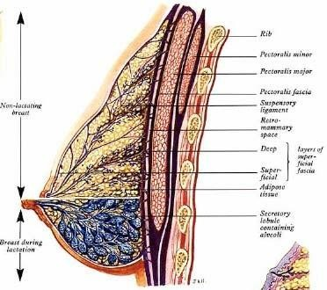

Fig No.2 Anatomy of Breast (Lateral View)

## Histology:-

The adult female breast contains glandular and ductal tissue, a stroma of fibrous tissue that binds the individual lobes together and fatty tissue within and between the lobes. Each breast consists of 12-20 conical lobes. The base of each lobe is close to the ribs. The apex, which contains the major excretory duct of the lobe, is situated close to the areola and nipple. Each lobe consists of a group of lobules and the many lactiferous ducts in each lobule as it converge towards the areola. Each of the major ducts widens to form an ampulla as it reaches the areola and then narrows for its individual opening on the nipple. The lobules are held in place by a meshwork of fatty areolar tissue. The fatty tissue increases toward the periphery of the lobule and gives the breast its bulk and its hemispheric shape.

About 80-85% of the normal breast is fat. The breast tissues are joined to the overlying skin and subcutaneous tissue by fibrous strands. In the non pregnant,

non-lactating breast, the alveoli are small and tightly packed. During pregnancy the alveoli enlarge and their lining cells increase in number.

During lactation the alveolar cells secrete milk proteins and lipids. The deep surface of the breast lies on the fascia that covers the chest muscle. The fascial stroma, derived from the superficial fascia of the chest wall, is condensed into multiple fascial bands that run from the breast into subcutaneous tissue and the corium of the skin overlying the breast. These fascial bands-Cooper’s ligaments- Support the breast in its upright position on the chest wall. These bands may be distorted by a tumor, resulting in skin dimpling.

## Histological changes in the female breast during pregnancy:-

During pregnancy in response to progesterone, breast size and turgidity increase markedly. These changes are accompanied by deepening nipple and areolar pigmentation, nipple enlargement, areolar widening and an increase in the number and size of the lubricating glands in the areola. The breast ductal system branches markedly and the individual ducts widen. The acini increase in number and size. In late pregnancy, the fatty tissues of the breast are almost completely replaced by cellular breast parenchyma.

## Gross Anatomy:-

The adult female breast usually forms an almost hemispheric protrusion on each side of the second of the chest wall, usually extending from just below the level of the second rib inferiorly to the sixth or seventh rib. The gland is usually situated between the lateral sternal border and the anterior axillary fold. The superior surface

of the breast emerges gradually from the chest wall. Where as the lateral and inferior borders are quite well defined.

The major portion of the breast, lying atop the pectoralis major muscle, projects ventrally, smaller portions extended laterally and inferiorly to lie atop the serratus anterior and external oblique muscles and as far cauded as the rectus abdominis. A triangular tongue shaped tail of breast tissue (the axillary tail of Spence) extends superiorly and laterally toward the axilla, perforates the deep axillary fascia and enters the axilla.

## The Nipple and Areola:-

The areola is a circular pigmented zone 2-6 cms in diameter at the tip of the breast. Its colour varies from pale pink to deep brown depending on age, parity and skin pigmentation. The skin of the areola contains multiple small elevated nodules beneath which lie the sebaceous glands (glands of Montgomerry). The glands are responsible for lubrication of the nipple and help to prevent nipple and areola cracks and fissures. During the third trimester of pregnancy, the sebaceous glands hypertrophy markedly.

A circular smooth muscles band surrounds the base of the nipple. Longitudinal smooth muscle fibres branch out from the ring of circular smooth muscle to encircle the lactiferous ducts as they converge toward the nipple. The many small punctuate opening situated at the tip of the nipple are the terminals of the major lactiferous ducts. The ampullae of the lactiferous ducts lie just deep to the nipple and the areola. **Blood Supply:**

## Arterial Supply-

* 1. Lateral thoracic- branches of the axillary artery.
  2. Internal mammary artery.
  3. Inter-costal arteries.

## Veins-

1. The veins follow the courses of the arteries.

## Lymphatics-

1. Lateral hemisphere – anterior axillary nodes.
2. Upper convexity – infraclavicular group
3. Medial convexity – mediastinal glands (cross connection between

the two breasts). There is no contra lateral drainage of lymph, until and unless three is ipsilaternal obstruction.

1. Inferior convexity – mediastinal glands.

## Nerve Supply-

The nerve supply is from fourth, fifth and sixth intercostals nerves.

## LACTATION:

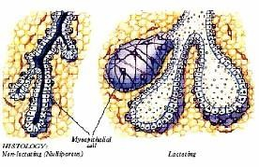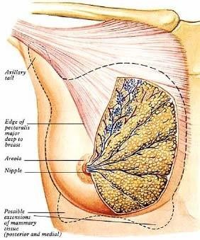

Fig No.3 Anatomy of Breast (Front view) Fig No.4 Myoepithelial Tissue in Lactating and Non Lactating Breast

Main function of breasts is lactation. Although lactation starts following delivery, the preparation for effective lactation starts during pregnancy2.

1. Mammogenesis- Preparation of breasts.
2. Lactogenesis- Synthesis and secretion from the breast alveoli.
3. Galactokinesis- Ejection of milk.
4. Galactopoiesis- Maintenance of lactation.

**PHYSIOLOGY OF LACTATION3,4:**

# Mammogenesis:

1. **Development of the Breasts :**

The breasts, shown in Figure, begin to develop at puberty. This development is stimulated by the estrogens of the monthly female sexual cycle; estrogens stimulate growth of the breasts’ mammary glands plus the deposition of fat to give the breasts mass. In addition, far greater growth occurs during the high estrogen state of pregnancy, and only then does the glandular tissue become completely developed for the production of milk.

1. **Growth of the Ductal System—Role of the Estrogens :**

All through pregnancy, the large quantities of estrogens secreted by the placenta cause the ductal system of the breasts to grow and branch. Simultaneously, the stroma of the breasts increases in quantity, and large quantities of fat are laid down in the stroma. Also important for growth of the ductal system are at least four other hormones: growth hormone, prolactin*,* the adrenal glucocorticoids*,* and insulin*.* Each of these is known to play at least some role in protein metabolism, which presumably explains their function in the development of the breasts.

1. **Development of the Lobule-Alveolar System—Role of Progesterone :**

Final development of the breasts into milk secreting organs also requires *progesterone.* Once the ductal system has developed, progesterone—acting synergistically with estrogen, as well as with the other hormones just mentioned— causes additional growth of the breast lobules, with budding of alveoli and development of secretory characteristics in the cells of the alveoli. These changes are analogous to the secretory effects of progesterone on the endometrium of the uterus during the latter half of the female menstrual cycle.

# Lactogenesis

## Initiation of Lactation—Function of Prolactin5 :

As a member of the somatortropin, family prolactin is related structurally to GH and placental lactogen. The human prolactin gene on chromosome 6 encodes a 23000- dalfon polypeptide of 199 amino acids.

## Secretion:

Prolactin is synthesized in lactotropes. Prolactin synthesis and secretion in the fetal pituitary start in the first few weeks of gestation. Serum prolactin levels decline shortly after birth. Whereas serum prolactin level remains low throughout life in normal males, they are elevated somewhat in normal cycling females

. Prolactin level rise markedly during pregnancy, reach a maximum at term and decline there after unless the mother breast-feeds the child. In nursing mother, prolactin secretion is stimulated by the suckling stimulus or breast manipulation and circulating prolactin levels can rise 10 to 100 fold within 30 minutes of stimulation. This response becomes less pronounced after several months of breast feeding and prolactin concentrations eventually decline to prepregnancy levels.

Prolactin detected in maternal and fetal blood originates from maternal and fetal pituitaries. Prolactin is also synthesized by decidual cells near the end of the luteal phase of the menstrual cycle and early in pregnancy, the latter source is responsible for the very high levels of prolactin in aminiotic fluid during the first trimester.

Many of the physiological factors that influence prolactin secretion are similar to those that affect GH secretion. Like other anterior-pituitary harmone, prolactin is secreted in a pulsatile manner

. Prolactin is unique among the anterior pituitary harmones in that hypothalamic regulation inhibits its secretion. The major regulator of prolactin secretion is dopamine. Which is released by tuberoinfundibular neurons and interacts with the D2 receptor on lactotropes to inhibit secretion of prolactin.

## Molecular and Cellular Bases of Prolactin Action:

The effects of prolactin results from interactions with specific receptors that are widely distributed among a variety of cell types within many tissues whereas prolactin binds specifically to the prolactin receptors and has no GH like (somatotropic) activity, human GH and placental lactogen bind to the prolactin receptors and are lactogenic.

The prolactin receptor is related structurally to receptors for GH and several cytokines and uses similar signaling mechanisms. The prolactin receptor is encoded by a single gene located on chromosome 5. Alternative splicing of this gene give rise to multiple forms of the receptors.

Although estrogen and progesterone are essential for the physical development of the breasts during pregnancy, a specific effect of both these hormones is to inhibit the actual secretion of milk*.* Conversely, the hormone prolactin has exactly the opposite effect on milk secretion—promoting it. This hormone is secreted by the mother’s anterior pituitary gland, and its concentration in her blood rises steadily from the fifth week of pregnancy until birth of the baby, at which time it has risen to 10 to 20 times the normal nonpregnant level. In addition, the placenta secretes large quantities of human chorionic somatomammotropin, which probably has lactogenic properties, thus supporting the prolactin from the mother’s pituitary during pregnancy. Even so, because of the suppressive effects of estrogen and progesterone,

no more than a few milliliters of fluid are secreted each day until after the baby is born. The fluid secreted during the last few days before and the first few days after parturition is called **colostrum**; it contains essentially the same concentrations of proteins and lactose as milk, but it has almost no fat, and its maximum rate of production is about 1/100 the subsequent rate of milk production. Immediately after the baby is born, the sudden loss of both estrogen and progesterone secretion from the placenta allows the lactogenic effect of prolactin from the mother’s pituitary gland to assume its natural milk promoting role, and over the next 1 to 7 days, the breasts begin to secrete copious quantities of milk instead of colostrum. This secretion of milk requires an adequate background secretion of most of the mother’s other hormones as well, but most important are growth hormone, cortisol, parathyroid hormone*,* and insulin*.* These hormones are necessary to provide the amino acids, fatty acids, glucose, and calcium required for milk formation. After birth of the baby, the basal level of prolactin secretion returns to the nonpregnant level over the next few weeks. However, each time the mother nurses her baby, nervous signals from the nipples to the hypothalamus cause a 10- to 20-fold surge in prolactin secretion that lasts for about 1 hour. This prolactin acts on the mother’s breasts to keep the mammary glands secreting milk into the alveoli for the subsequent nursing periods. If this prolactin surge is absent or blocked as a result of hypothalamic or pituitary damage or if nursing does not continue, the breasts lose their ability to produce milk within 1 week or so. However, milk production can continue for several years if the child continues to suckle, although the rate of milk formation normally decreases considerably after 7 to 9 months.

# Galactokinesis :

**Function of Oxytocin6 :**

## Functions:

Its major functions are:

1. To cause contraction of the uterine muscle.
2. To cause contraction of the myoepithelial cells of the matured female breast, so that milk ejection occurs.

Regarding the uterine contraction, 1 Oxytocin causes uterine contraction during labour. This helps in the delivery of the fetus. 2 After coitus, at list in some animals, the spermatozoa with a tremendous speed to reach the lateral end of the Fallopian tubes, where fertilization occurs. It is possible, that at this time, the uterus contracts due to action of oxytocin- produces a suction effect- the spermatozoa are drawn by the suction into the uterus very rapidly.

Regarding, the breast the smooth muscle cells (the myoepithelial cells) so surround the alveoli that their contraction leads to expulsion of the accumulated milk inside them. Oxytocin therefore, causes explosion the milk.

## Control of oxytocin secretion

* 1. During suckling, impulses arise at the nipple, which initiates a reflex ultimately culminating into oxytocin secretion leading to the ejection.
  2. Rubbing of the female external genitalia also causes the initiation of a reflex ultimately ending in oxytocin secretion.
  3. Although it cannot be said definitely that during parturition, serum oxytocin level rises, yet it is a possibility that during parturition neural signals arise from uterine cervix which ultimately results in oxytocin release from the posterior pituitary.

**Ejection (or “Let-Down”) Process in Milk Secretion :-**

Milk is secreted continuously into the alveoli of the breasts, but milk does not flow easily from the alveoli into the ductal system and, therefore, does not continually leak from the breast nipples. Instead, the milk must be ejected from the alveoli into the ducts before the baby can obtain it. This is caused by a combined neurogenic and hormonal reflex that involves the posterior pituitary hormone oxytocin*,* as follows. When the baby suckles, it receives virtually no milk for the first half minute or so. Sensory impulses must first be transmitted through somatic nerves from the nipples to the mother’s spinal cord and then to her hypothalamus, where they cause nerve signals that promote oxytocin secretion at the same time that they cause prolactin secretion. The oxytocin is carried in the blood to the breasts, where it causes myoepithelial cells (which surround the outer walls of the alveoli) to contract, thereby expressing the milk from the alveoli into the ducts at a pressure of +10 to 20 mm Hg. Then the baby’s suckling becomes effective in removing the milk. Thus, within 30 seconds to 1 minute after a baby begins to suckle, milk begins to flow. This process is called milk ejection or milk let-down*.* Suckling on one breast causes milk flow not only in that breast but also in the opposite breast. It is especially interesting that fondling of the baby by the mother or hearing the baby crying often gives enough of an emotional signal to the hypothalamus to cause milk ejection.

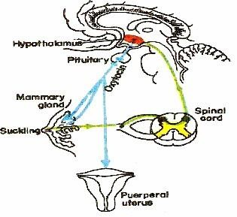

# Galactopoiesis :

Fig. No. 5 Lactation Reflex

Removal (Discharge) of milk from gland (milk ejection) occurs following infants sucking → Neuroendocrine reflex to hypothalamus in brain → Oxytocin release in blood posterior pituitary → Myoepithelial cells contact in alveoli → Milk ejection into lactiferous duct → further milk production. Milk is available to baby on suckling and on squeezing the breasts.

With delivery, there is as abrupt and profound decrease in the levels of progesterone and estrogen, which removes the inhibitory influence of progesterone on the production of α-lactalbumin by the rough endoplasmic reticulum. The increased α- lactalbumin serves to stimulate lactose syntheses and to increase milk lactose. Progesterone withdrawal also allows prolactin to act unopposed in its stimulation of α-lactalbumin production.

The intensity and duration of subsequent lactation are controlled in large part by the repetitive stimulus of nursing. Prolactin is essential for lactation. For example, women with extensive pituitary necrosis or Sheehan’s syndrome do not lactate. Although plasma prolactin falls after delivery to levels lower than during pregnancy,

each act of sucking triggers a rise in levels (Mc.Neilly & associates 1983). Presumably a stimulus from the breast curtails the release of prolactin-inhibiting factor from the hypothalamus and thus, in turn transiently induces increased prolactin secretion.

## Fig. No.6. The Hormones responsible are schematically represented as;

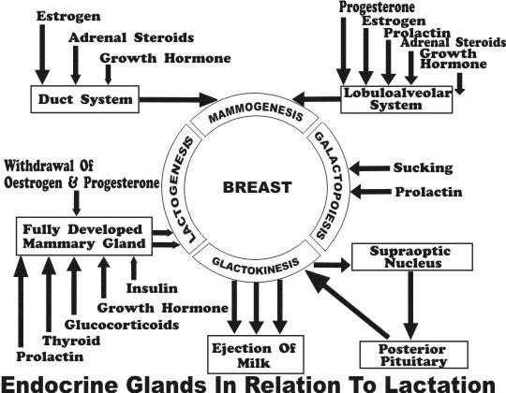

**DOPAMINE7:**

Dopamine is secreted by neurons that originate in the substantia nigra. The termination of these neurons is mainly in the striatal region of the basal ganglia. The effect of dopamine is usually inhibition (Gyaton and Hall- Text book of medical physiology- 10th Edition).

# Suppression of the Female Ovarian Cycles in Nursing Mothers for Many Months after Delivery.

In most nursing mothers, the ovarian cycle (and ovulation) does not resume until a few weeks after cessation of nursing. The reason seems to be that the same nervous signals from the breasts to the hypothalamus that cause prolactin secretion during suckling—either because of the nervous signals themselves or because of a subsequent effect of increased prolactin—inhibits secretion of gonadotropin-releasing hormone by the hypothalamus. This, in turn, suppresses formation of the pituitary gonadotropic hormones—luteinizing hormone and follicle-stimulating hormone. However, after several months of lactation, in some mothers, especially in those who nurse their babies only some of the time, the pituitary begins to secrete sufficient gonadotropic hormones to reinstate the monthly sexual cycle, even though nursing continues.

# BREASTFEEDING8:

Breastfeeding is the feeding of an [infant](http://en.wikipedia.org/wiki/Infant) or young [child](http://en.wikipedia.org/wiki/Child) with [breast milk](http://en.wikipedia.org/wiki/Breast_milk) directly from female human [breasts](http://en.wikipedia.org/wiki/Breasts) (i.e., via [lactation](http://en.wikipedia.org/wiki/Lactation)) rather than from a [baby bottle](http://en.wikipedia.org/wiki/Baby_bottle) or other container. Babies have a [sucking reflex](http://en.wikipedia.org/wiki/Sucking_reflex) that enables them to suck and swallow milk. Most mothers can breastfeed for six months or more, without the addition of [infant formula](http://en.wikipedia.org/wiki/Infant_formula) or solid food.

Human [breast milk](http://en.wikipedia.org/wiki/Breast_milk) is the healthiest form of milk for human babies9. There are few [exceptions,](http://en.wikipedia.org/wiki/Breastfeeding_complications#When_breastfeeding_might_harm_the_breast) such as when the mother is taking certain [drugs](http://en.wikipedia.org/wiki/Drug) or is infected with [Human T-lymphotropic virus,](http://en.wikipedia.org/wiki/Human_T-lymphotropic_virus) [HIV](http://en.wikipedia.org/wiki/HIV), or has active untreated [tuberculosis](http://en.wikipedia.org/wiki/Tuberculosis). Breastfeeding promotes health, helps to prevent disease, and reduces health care and feeding costs[.[2][3](http://en.wikipedia.org/wiki/Breastfeeding#cite_note-Riordan_1997-1)[][4]](http://en.wikipedia.org/wiki/Breastfeeding#cite_note-3) Artificial feeding is associated with more deaths from [diarrhea](http://en.wikipedia.org/wiki/Diarrhea) in infants in both [developing](http://en.wikipedia.org/wiki/Developing_country) and [developed countries](http://en.wikipedia.org/wiki/Developed_country)10. Experts agree that breastfeeding is beneficial, but may disagree about the length of breastfeeding that is most beneficial, and about the risks of using artificial formulas11,12,13.

The [World Health Organization](http://en.wikipedia.org/wiki/World_Health_Organization) (WHO) and the [American Academy of](http://en.wikipedia.org/wiki/American_Academy_of_Pediatrics) [Pediatrics](http://en.wikipedia.org/wiki/American_Academy_of_Pediatrics) (AAP) emphasize the value of breastfeeding for mothers as well as children. Both recommend exclusive breastfeeding for the first six months of life and then supplemented breastfeeding for at least one year and up to two years or more.[[9][10]](http://en.wikipedia.org/wiki/Breastfeeding#cite_note-WHO2003-8) While recognizing the superiority of breastfeeding, regulating authorities also work to minimize the risks of artificial feeding12.

# Breast milk

Not all the properties of [breast milk](http://en.wikipedia.org/wiki/Breast_milk) are understood, but its [nutrient](http://en.wikipedia.org/wiki/Nutrient) content is relatively stable. Breast milk is made from nutrients in the mother's [bloodstream](http://en.wikipedia.org/wiki/Bloodstream) and bodily stores. Breast milk has just the right amount of [fat](http://en.wikipedia.org/wiki/Fat), [sugar](http://en.wikipedia.org/wiki/Sugar), [water](http://en.wikipedia.org/wiki/Water), and [protein](http://en.wikipedia.org/wiki/Protein) that is needed for a baby's growth and development.14 Because breastfeeding uses an

average of 500 [calories](http://en.wikipedia.org/wiki/Calories) a day it helps the mother lose weight after giving birth.15 The composition of breast milk changes depending on how long the baby nurses at each session, as well as on the age of the child. The quality of a mother's breast milk may be compromised by [smoking,](http://en.wikipedia.org/wiki/Smoking) [alcoholic beverages,](http://en.wikipedia.org/wiki/Alcoholic_beverage) [caffeinated drinks,](http://en.wikipedia.org/wiki/Caffeinated_drink) [marijuana,](http://en.wikipedia.org/wiki/Marijuana) [methamphetamine,](http://en.wikipedia.org/wiki/Methamphetamine) [heroin,](http://en.wikipedia.org/wiki/Heroin) and [methadone.](http://en.wikipedia.org/wiki/Methadone)16

# Benefits for the infant

Scientific research, such as the studies summarized in a 2007 review for the

U.S. [Agency for Healthcare Research and Quality](http://en.wikipedia.org/wiki/Agency_for_Healthcare_Research_and_Quality) (AHRQ)17 and a 2007 review for the WHO18, has found many benefits to breastfeeding for the infant. These include: **Greater immune health**

During breastfeeding [antibodies](http://en.wikipedia.org/wiki/Antibody) pass to the baby19. This is one of the most important features of [colostrum,](http://en.wikipedia.org/wiki/Colostrum) the breast milk created for newborns. Breast milk contains several anti-[infective](http://en.wikipedia.org/wiki/Infection) factors such as [bile salt stimulated lipase](http://en.wikipedia.org/wiki/Bile_salt_dependent_lipase) (protecting against [amoebic](http://en.wikipedia.org/wiki/Amoeba) infections), [lactoferrin](http://en.wikipedia.org/wiki/Lactoferrin) (which binds to iron and inhibits the growth of [intestinal bacteria](http://en.wikipedia.org/wiki/Gut_flora))20,21 and [immunoglobulin A](http://en.wikipedia.org/wiki/Immunoglobulin_A) protecting against [microorganisms](http://en.wikipedia.org/wiki/Microorganism).22 **Fewer infections**

Among the studies showing that breastfed infants have a lower risk of infection than non-breastfed infants are:

1. In a 1993 [University of Texas Medical Branch](http://en.wikipedia.org/wiki/University_of_Texas_Medical_Branch) study, a longer period of breastfeeding was associated with a shorter duration of some middle ear infections ([otitis media with effusion](http://en.wikipedia.org/wiki/Otitis_media#Otitis_media_with_effusion)) in the first two years of life.23
2. A 1995 study of 87 infants found that breastfed babies had half the incidence of diarrheal illness, 19% fewer cases of any [otitis media](http://en.wikipedia.org/wiki/Otitis_media) infection, and 80% fewer prolonged cases of otitis media than formula fed babies in the first twelve months of life.24
3. Breastfeeding appeared to reduce symptoms of [upper respiratory tract](http://en.wikipedia.org/wiki/Upper_respiratory_tract_infection) [infections](http://en.wikipedia.org/wiki/Upper_respiratory_tract_infection) in premature infants up to seven months after release from hospital in a 2002 study of 39 infants.25
4. A 2004 [case-control study](http://en.wikipedia.org/wiki/Case-control_study) found that breastfeeding reduced the risk of acquiring [urinary tract infections](http://en.wikipedia.org/wiki/Urinary_tract_infection) in infants up to seven months [of age,](http://en.wikipedia.org/wiki/Post-partum) with the protection strongest immediately after birth.26
5. The 2007 review for AHRQ found that breastfeeding reduced the risk of acute otitis media, non-specific gastroenteritis, and severe lower respiratory tract infections.27

## Protection from SIDS

Breastfed babies have better arousal from sleep at 2–3 months. This coincides with the peak incidence of [sudden infant death syndrome.](http://en.wikipedia.org/wiki/Sudden_infant_death_syndrome)27 A study conducted at the [University of Münster](http://en.wikipedia.org/wiki/University_of_M%C3%BCnster) found that breastfeeding halved the risk of sudden infant death syndrome in children up to the age of 1.28

## Higher intelligence

Studies examining whether breastfeeding in infants is associated with higher [intelligence](http://en.wikipedia.org/wiki/Intelligence) later in life include:

1. Horwood, Darlow and Mogridge (2001) tested the [intelligence quotient](http://en.wikipedia.org/wiki/Intelligence_quotient) (IQ) scores of 280 low [birthweight](http://en.wikipedia.org/wiki/Birthweight) children at seven or eight years of age.29 Those who were breastfed for more than eight months had verbal IQ scores 6 points higher (which was [significantly higher](http://en.wikipedia.org/wiki/Statistical_significance)) than comparable children breastfed for less time.30 They concluded "These findings add to a growing body of evidence to suggest that breast milk feeding may have small long term benefits for child cognitive development."30
2. A 2005 study using data on 2,734 sibling pairs from the [National](http://en.wikipedia.org/wiki/National_Longitudinal_Study_of_Adolescent_Health) [Longitudinal Study of Adolescent Health](http://en.wikipedia.org/wiki/National_Longitudinal_Study_of_Adolescent_Health) "provide[d] persuasive evidence of a causal connection between breastfeeding and intelligence." The same data "also suggests that nonexperimental studies of breastfeeding overstate some of [breastfeeding's] other long-term benefits, even if controls are included for race, ethnicity, income, and education." 31
3. In 2006, Der and colleagues, having performed a [prospective cohort](http://en.wikipedia.org/wiki/Prospective_cohort_study) [study,](http://en.wikipedia.org/wiki/Prospective_cohort_study) sibling pairs analysis, and [meta-analysis,](http://en.wikipedia.org/wiki/Meta-analysis) concluded that "Breast feeding has little or no effect on intelligence in children."32 The researchers found that "Most of the observed association between breast feeding and cognitive development is the result of [confounding](http://en.wikipedia.org/wiki/Confounding) by maternal intelligence."32
4. The 2007 review for the AHRQ found "no relationship between breastfeeding in term infants and cognitive performance."[25](http://en.wikipedia.org/wiki/Breastfeeding#cite_note-AHRQ2007-13)
5. The 2007 review for the WHO "suggests that breastfeeding is associated with increased cognitive development in childhood." The review also states that "The issue remains of whether the association is related to the properties of breastmilk itself, or whether breastfeeding enhances the bonding between mother and child, and thus contributes to intellectual development."26
6. Two initial [cohort studies](http://en.wikipedia.org/wiki/Cohort_study) published in 2007 suggest babies with a specific version of the [FADS2](http://en.wikipedia.org/wiki/FADS2) gene demonstrated an IQ averaging 7 points higher if breastfed, compared with babies with a less common version of the gene who showed no improvement when breastfed.33 FADS2 affects the metabolism of polyunsaturated fatty acids found in human breast milk, such as [docosahexaenoic acid](http://en.wikipedia.org/wiki/Docosahexaenoic_acid) and arachidonic acid, which are known to be linked to early brain development.33 The researchers were quoted as saying "Our

findings support the idea that the nutritional content of breast milk accounts for the differences seen in human IQ. But it's not a simple all-or-none connection: it depends to some extent on the genetic makeup of each infant."[[30]](http://en.wikipedia.org/wiki/Breastfeeding#cite_note-29) The researchers wrote "further investigation to replicate and explain this specific gene–environment interaction is warranted."34

1. In "the largest randomized trial ever conducted in the area of human lactation," between 1996 and 1997 maternity hospitals and [polyclinics](http://en.wikipedia.org/wiki/Polyclinic) in [Belarus](http://en.wikipedia.org/wiki/Belarus) were randomized to receive or not receive breastfeeding promotion modeled on the [Baby Friendly Hospital Initiative](http://en.wikipedia.org/wiki/Baby_Friendly_Hospital_Initiative).35 Of 13,889 infants born at these hospitals and polyclinics and followed up in 2002-2005, those who had been born in hospitals and polyclinics receiving breastfeeding promotion had IQs that were 2.9-7.5 points higher (which was significantly higher). Since (among other reasons) a randomized trial should control for maternal IQ, the authors concluded in a 2008 paper that the data "provide strong evidence that prolonged and exclusive breastfeeding improves children's cognitive development."

## Less diabetes

Infants exclusively breastfed have less chance of developing [diabetes mellitus](http://en.wikipedia.org/wiki/Diabetes_mellitus_type_1) [type 1](http://en.wikipedia.org/wiki/Diabetes_mellitus_type_1) than peers with a shorter duration of breastfeeding and an earlier exposure to cow milk and solid foods. 36 Breastfeeding also appears to protect against [diabetes](http://en.wikipedia.org/wiki/Diabetes_mellitus_type_2) [mellitus type 2,](http://en.wikipedia.org/wiki/Diabetes_mellitus_type_2) at least in part due to its effects on the child's weight.36

## Less childhood obesity

Breastfeeding appears to reduce the risk of extreme [obesity](http://en.wikipedia.org/wiki/Obesity) in children aged 39 to 42 months.37 The protective effect of breastfeeding against obesity is consistent,

though small, across many studies, and appears to increase with the duration of breastfeeding.38

## Less tendency to develop allergic diseases (atopy)

In children who are at risk for developing allergic diseases (defined as at least one parent or sibling having [atopy](http://en.wikipedia.org/wiki/Atopy)), atopic syndrome can be prevented or delayed through exclusive breastfeeding for four months, though these benefits may not be present after four months of age.39 However, the key factor may be the age at which non-breastmilk is introduced rather than duration of breastfeeding.40 [Atopic](http://en.wikipedia.org/wiki/Atopic_dermatitis) [dermatitis,](http://en.wikipedia.org/wiki/Atopic_dermatitis) the most common form of [eczema,](http://en.wikipedia.org/wiki/Eczema) can be reduced through exclusive breastfeeding beyond 12 weeks in individuals with a family history of atopy, but when breastfeeding beyond 12 weeks is combined with other foods incidents of eczema rise irrespective of family history.41

## Less necrotizing enterocolitis in premature infants

[Necrotizing enterocolitis](http://en.wikipedia.org/wiki/Necrotizing_enterocolitis) (NEC) is an acute inflammatory disease in the intestines of infants. Necrosis or death of intestinal tissue may follow. It is mainly found in [premature births.](http://en.wikipedia.org/wiki/Premature_birth) In one study of 926 preterm infants, NEC developed in 51 infants (5.5%). The death rate from necrotizing enterocolitis was 26%. NEC was found to be six to ten times more common in infants fed formula exclusively, and three times more common in infants fed a mixture of breast milk and formula, compared with exclusive breastfeeding. In infants born at more than 30 weeks, NEC was twenty times more common in infants fed exclusively on formula.42 A 2007 meta- analysis of four randomized controlled trials found "a marginally statistically significant association" between breastfeeding and a reduction in the risk of NEC.

## Other long term health effects

In one study, breastfeeding did not appear to offer protection against [allergies.](http://en.wikipedia.org/wiki/Allergy)43However, another study showed breastfeeding to have lowered the risk of [asthma,](http://en.wikipedia.org/wiki/Asthma) protect against allergies, and provide improved protection for babies against respiratory and intestinal infections.44

A review of the association between breastfeeding and [celiac disease](http://en.wikipedia.org/wiki/Celiac_disease) (CD) concluded that breast feeding while introducing [gluten](http://en.wikipedia.org/wiki/Gluten) to the diet reduced the risk of CD. The study was unable to determine if breastfeeding merely delayed symptoms or offered life-long protection.45

An initial study at the [University of Wisconsin](http://en.wikipedia.org/wiki/University_of_Wisconsin) found that women who were breast fed in infancy may have a lower risk of developing [breast cancer](http://en.wikipedia.org/wiki/Breast_cancer) than those who were not breast fed.46

Breastfeeding may decrease the risk of [cardiovascular disease](http://en.wikipedia.org/wiki/Cardiovascular_disease) in later life, as indicated by lower [cholesterol](http://en.wikipedia.org/wiki/Cholesterol) and [C-reactive protein](http://en.wikipedia.org/wiki/C-reactive_protein) levels in adult women who had been breastfed as infants.47 Although a 2001 study suggested that adults who had been breastfed as infants had lower arterial distensibility than adults who had not been breastfed as infants48, the 2007 review for the WHO concluded that breastfed infants "experienced lower mean blood pressure" later in life. Nevertheless, the 2007 review for the AHRQ found that "the relationship between breastfeeding and cardiovascular diseases was unclear".

# Benefits for mothers

Breastfeeding is a cost effective way of feeding an infant, providing nourishment for a child at a small cost to the mother. Frequent and exclusive breastfeeding can delay the return of fertility through [lactational amenorrhea,](http://en.wikipedia.org/wiki/Lactational_amenorrhea_method) though breastfeeding is an imperfect means of [birth control.](http://en.wikipedia.org/wiki/Birth_control) During breastfeeding beneficial

[hormones](http://en.wikipedia.org/wiki/Hormone) are released into the mother's body and the maternal bond can be strengthened. Breastfeeding is possible throughout [pregnancy,](http://en.wikipedia.org/wiki/Pregnancy) but generally milk production will be reduced at some point.49

## Bonding

Hormones released during breastfeeding help to strengthen the [maternal bond.](http://en.wikipedia.org/wiki/Maternal_bond) Teaching partners how to manage common difficulties is associated with higher breastfeeding rates.50 Support for a mother while breastfeeding can assist in [familial](http://en.wikipedia.org/wiki/Human_bonding) [bonds](http://en.wikipedia.org/wiki/Human_bonding) and help build a [paternal bond](http://en.wikipedia.org/wiki/Paternal_bond) between father and child.51

If the mother is away, an alternative caregiver may be able to feed the baby with expressed breast milk. The various [breast pumps](http://en.wikipedia.org/wiki/Breast_pump) available for sale and rent help working mothers to feed their babies breast milk for as long as they want. To be successful, the mother must produce and store enough milk to feed the child for the time she is away, and the feeding caregiver must be comfortable in handling breast milk.

## Hormone release

Breastfeeding releases [oxytocin](http://en.wikipedia.org/wiki/Oxytocin) and [prolactin,](http://en.wikipedia.org/wiki/Prolactin) hormones that relax the mother and make her feel more nurturing toward her baby.52 Breastfeeding soon after giving birth increases the mother's oxytocin levels, making her uterus contract more quickly and reducing bleeding. Pitocin, a synthetic hormone used to make the uterus contract during and after labour, is structurally modelled on oxytocin.53

## Weight loss

As the fat accumulated during pregnancy is used to produce milk, extended breastfeeding—at least 6 months—can help mothers lose weight.54 However, weight loss is highly variable among lactating women; monitoring the diet and increasing the amount/intensity of exercise are more reliable ways of losing weight.55 The 2007

review for the AHRQ found "The effect of breastfeeding in mothers on return-to-pre- pregnancy weight was negligible, and the effect of breastfeeding on postpartum weight loss was unclear."

## Natural postpartum infertility

Breastfeeding may delay the return to fertility for some women by suppressing ovulation. A breastfeeding woman may not [ovulate](http://en.wikipedia.org/wiki/Ovulate), or have regular periods, during the entire lactation period. The period in which ovulation is absent differs for each woman. This [Lactational amenorrhea](http://en.wikipedia.org/wiki/Lactational_amenorrhea) has been used as an imperfect form of natural contraception, with a greater than 98% effectiveness during the first six months after birth if specific nursing behaviors are followed.56 It is possible for some women to ovulate within two months after birth while fully breastfeeding.

## Long-term health effects

For breastfeeding women, long-term health benefits include:

* 1. Less risk of [breast cancer](http://en.wikipedia.org/wiki/Breast_cancer), [ovarian cancer,](http://en.wikipedia.org/wiki/Ovarian_cancer) and [endometrial cancer](http://en.wikipedia.org/wiki/Endometrial_cancer).57,58
  2. A 2009 study indicated that lactation for at least 24 months is associated with a 23% lower risk of coronary heart disease.59
  3. Although the 2007 review for the AHRQ found "no relationship between a history of lactation and the risk of [osteoporosis](http://en.wikipedia.org/wiki/Osteoporosis)", mothers who breastfeed longer than eight months benefit from bone re- mineralisation.60
  4. Breastfeeding [diabetic](http://en.wikipedia.org/wiki/Diabetes) mothers require less insulin.61
  5. Reduced risk of post-partum [bleeding.](http://en.wikipedia.org/wiki/Bleeding)
  6. According to a [Malmö University](http://en.wikipedia.org/wiki/Malm%C3%B6_University) study published in 2009, women who breast fed for a longer duration have a lower risk for contracting

[rheumatoid arthritis](http://en.wikipedia.org/wiki/Rheumatoid_arthritis) than women who breast fed for a shorter duration or who had never breast fed.62

## World Health Organization

The WHO recommends exclusive breastfeeding for the first six months of life, after which "infants should receive nutritionally adequate and safe complementary foods while breastfeeding continues for up to two years of age or beyond.

## American Academy of Pediatrics

The AAP recommends exclusive breastfeeding for the first six months of life. Furthermore, "breastfeeding should be continued for at least the first year of life and beyond for as long as mutually desired by mother and child.



**DRUG**

**REVIEW**

# Bhumikshmanda (Vidari- Tuberous Root)

For the treatment of stanya kshaya many formulations are mentioned in classics, among them **Yoga Ratnakara** in **Ksheeradosha chikitsa** had mentioned that;

“The ksheera bhavita churna of Bhumikushmanda if ingested with milk and sugar increases the breast milk”.

Vidari consists of sliced and dried pieces of tuberous root of *Pueraria tuberosa DC.* (Fam. Fabaceae); a perennial climber with very large tuberous root, distributed nearly throughout the country except in very humid or very arid regions and ascending upto 1200m.

## SYNONYMS

Sanskrit : Vidari, Vidarika, Bhumikshmanda Assamese : Bhedeleton, Bhuikumra

Bengali : Vidari, Bhumikusmanda, Bhuinkumra

Gujrati : Vidarikanta, Bhonykoru, Eagio, Bhoikolu, Sakharvel Hindi : Vidarikanda

Kannada : Nelagumbala Gudde, Nelagumbala, Gumadi belli, Nelagumbula, Gumadigida

Malayalam : Mudakku

Marathi : Bhuikohala, Ghodvel Oriya : Bhuiankakharu

Tamil : Nilapoosani

Telugu : Nelagummuda, Darigummadi English- Indian Kudzu

## DESCRIPTION

1. **Macroscopic**

Drug available in the form of longitudinally sliced pieces of variable size; outer surface reddish-brown, smooth except for protuberances at some places; cut surface creamish-brown, starchy and somewhat porous; usually does not break, but pliable; taste, sweetish.

## Microscopic

Tuberous Root - Mature tuber shows 20-30 layers of cork consisting of rectangular, thin walled, tangentially elongated and radially arranged cells filled with dark reddish-brown content except in a few inner layers; secondary cortex consists of 6-15 layers of circular, oval to rectangular and tangentially elongated, thin-walled cells, yellow band of 2-6 layers of compactly arranged stone cells present towards inner side of cortex; stone cells moderately thick-walled, varying in shape and size and having well marked striations 183 and pits; a number of prismatic crystals of calcium oxalate found in parenchymatous cells, and also rarely in stone cells; secondary phloem consists of sieve elements and phloem parenchyma having a number of strands of phloem fibres and a few stone cells; sieve elements somewhat collapsed in outer region forming tangential bands; phloem fibres much elongated, highly thickened, lignified with narrow lumen; a number of tanniniferous ducts filled with brown content, distributed throughout this region; xylem forms whole of inner white spongy zone, consisting of several concentric rings of one or a few xylem vessels associated with a few xylem elements; vessels mostly drum-shaped having reticulate thickening; xylem rays multi seriate and well marked consisting of thin walled, radially elongated cells, a few latex duct also present; plenty of starch grains mostly simple, somewhat round, angular to oval, having central hilum and striations,measuring 5.5 - 13.75 μ in dia. present in all parenchymatous cells.

**Powder -** Buff coloured; shows plenty of starch grains with central hilum and striations measuring 5.5 - 13.75 μ in dia., fragments of cork, prismatic crystals of calcium oxalate, a few xylem vessels with reticulate thickening and phloem fibres.

## IDENTITY, PURITY AND STRENGTH

Foreign matter Not more than 2 per cent, Appendix 2.2.2. Total Ash Not more than 17 per cent, Appendix 2.2.3. Acid-insoluble ash Not more than 4.5 per cent, Appendix 2.2.4. Alcohol-soluble extractive Not less than 4 per cent, Appendix 2.2.6. Water-soluble extractive Not less than 24 per cent, Appendix 2.2.7.

**CONSTITUENTS -** Gluconic and Malic acids.

## Phyto-chemical Analysis :

Puerarin (a C-glucoside with the structure 4’,6-dihydroxy-7-glucosyl isoflavone) or Diadzein, (7,4’-dihydroxy-isoflavone) or daidzin and

4’,6’’-di-O-acetylpuerarin. In addition to other materials are reported ß-sitosterol and sigmasterol, with the methanolic extract being reported as containing sophoradiol, cantoniensistriol, soya-sapogenols A& B and other complex sterols.

## PROPERTIES AND ACTION

Rasa : Madhura Guna : Guru, Snigdha Virya : Sheeta Vipaka : Madhura

Karma : Shukrala, Balya, Mutrala, Pittahara, Rasayana, Svarya, Vatahara, Varnya, Stanyada, Jeevaniya, Brimhaneeya

**THERAPEUTIC USES -** Daha, Raktapitta, Angmarda, Daurbalya, Shosha.

The root is used for hypertensive conditions and has been shown to reduce the blood sugar in rats as well as demonstrating an estrogenic activity [Thakur].

**DOSE -** 3-6 g. of the drug in powder form.

**Anupana :** Milk with Sugar.

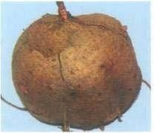 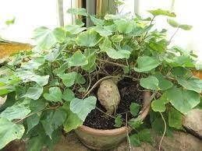

Fig. No.7. Bhumikushmanda Drug

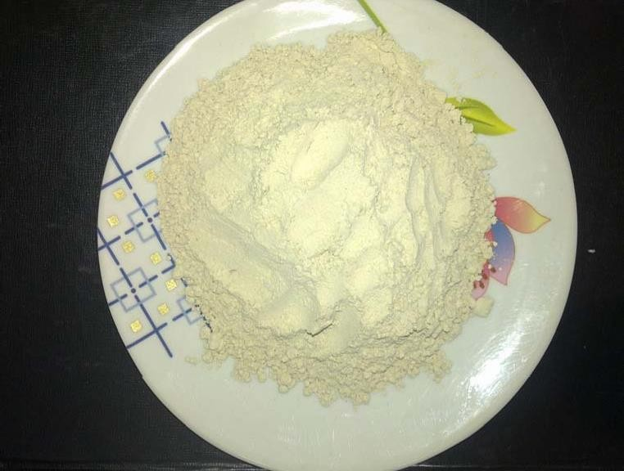

Fig. No.8. Bhumikushmanda Churna



**MATERIAL & METHOD**

# MATERIAL AND METHODOLOGY

The aim of present study is to evaluate efficacy of Bhumikushmaanda churna in cases of Stanyakshaya. For this, Churna of Bhumikushmaanda processed with milk is used. In this study both Ayurvedic and modern subjective and objective parameters of assessments were included. Besides, the results of the clinical study have also been scrutinized from both Ayurvedic as well as Modern point of view, to arrive at important conclusion.

## Source of Data:

The present clinical study was conducted at P.G. Department of Prasooti Tantra of N.K.J. Ayurvedic Medical College and Post Graduate Center, Bidar. 30 patients who required increment of lactation where selected from inpatient and outpatient department of Shree. Siddharudha Charitable Hospital and other private hospitals of Bidar. All patients were screened according to selection criteria and registered for the study. These women were randomly divided into two groups of 15 each.

## Selection of Criteria:

* 1. **Inclusion criteria:**

1. Age group of patient is between 18-35 years.
2. Breast milk quantity less than 300ml/day. (1 oz= 45ml approx)

(It is calculated by quantity of breast-milk per feeding i.e., The research tells us that exclusively breastfed babies take in an average of 25 oz (750 mL) per day between the ages of 1 month and 6 months. Different babies take in

different amounts of milk; a typical range of milk intakes is 19-30 oz per day (570-900 mL per day))

1. Patient from 10th day of delivery.
2. Patients with a previous history of lactational deficiency.

## Exclusion criteria:

* + 1. Patient with congenital abnormalities, breast atrophy, cancers, mastitis, shock, previous menstrual disorders are excluded from the study.
    2. Patients having H/o alcoholism, infectious & systemic diseases.

## Grouping of cases:

30 patients were selected for the study, divided into two equal groups.

**Group A:** Consisting 15 patients were given trial drug treatment, i.e., Churna of Bhumikushmaanda.

**Group B:** Consisting of 15 patients were treated with Standard Ayurvedic treatment.

**Duration:** 3months for both group(Follow-up – On every 15 days).

## Drug:

Churna of Bhumikushmaanda had given bhavana with milk 3 times given orally with milk as anupana.

## Trial procedure:

Each case of both trial and control group was registered for the study. In a specially, designed Research Case Sheet which contains details about her personal data, obstetric data, gynaec data and examination etc.

## Methodology of Trial Drug:

The two were combined to give a lactation score range 0-6. Therapy was then started. Group 1 was treated with Churna of Bhumikushmaanda. The patient is advised to continue this for 3 months and follow-up assessment is maintained on every 15th day.

## Method of Preparation:

Yoga Rathnakara told that Ksheerapaka of vidari has to be given, due to inconveniency and lack of patience to prepare every time patients may discontinue treatment. Hence I changed this method to ksheera bhavita churna, after removing physical impurities in raw material vidari was prepared into fine powder in pulvarisor. Then 3 times Ksheera bhavana given to this churna, and dried.

Dosage : General dose of churna is 1Karsha(10gms) in divided dose, but Ksheerapaka dose is according to Agnibala of patient and it was observed that all patients taken trial drug up to average 4gms in BD dose.

Group II is treated with Standard.

# Criteria of Assessment:

Parameters of assessment are taken according to,

## SUBJECTIVE PARAMETERS:-

1. Stana mlanata: Shushkatwa.

Stanya alpata. Stanya asambhava.

If all the three signs are present it is grade III(+++) If only two signs are present it is grade II(++)

If only one sign is present it is grade I(+)

1. Stanya Ejection: No Ejection -0

|  |  |
| --- | --- |
| Drop by drop | -1 |
| Stream like | -2 |
| Forceful | -3 |

1. Breast feeding Frequency: - Normal is 8-12times/day.

Any reduced frequency of feeding is noted.

Feeding 0-2times/day – 0 Feeding 3-5times/day – 1 Feeding 6-8times/day – 2 Feeding 9-12times/day - 3

1. Pertaining to Baby: - Hunger, Cry, Stools.
2. Mother: - Residual milk in breast after feeding.

## OBJECTIVE PARAMETERS:-

* 1. Weight of the baby (Weekly).

Breastfed infants generally gain weight according to the following guidelines: 0–4 months: 6 oz. per week†

4–6 months: 4-5 oz. per week

6–12 months: 2-4 oz. per week 1 ounce = 0.0283kg

† It is acceptable for some babies to gain 4–5 ounces per week. This average is taken from the lowest weight, not the birth weight.

The average breastfed baby doubles its birth weight in 5–6 months. By one year, a typical breastfed baby will weigh about 2½ times its birth weight. At one year, breastfed babies tend to be leaner than bottle fed babies. By two

years, differences in weight gain and growth between breastfed and formula- fed babies are no longer evident.

* 1. Breast Engorgement was rated on a 4 point scale.
     1. no engorgement
     2. slight engorgement
     3. moderate engorgement, no vedanahara aushadhi required. 3- severe pain, vedanahara aushadhi required.
  2. Milk Ejection:

It was evaluated by manual pressure on the nipple and observations recorded on a 4-point scale.

1. absent secretion.
2. few drops on pressure.
3. moderate secretion on pressure. 3-abundant spontaneous secretion.

The two objective parameters were combined to give a lactation score (range 0-6)

Both milk secretion score and breast engorgement score will be combined to form a lactation score (0-6).A lactation score above 4 indicates good lactation. The time taken to reach a good lactational score in each patient will be recorded.

## Investigation:

Serum prolactin level- The human pituitary glands secretes prolactin [hPRL,

m. wt. 17300 ] serum prolactin can be measured by sorono’s kit or sensitive radio immune as say or by chmeiluminescence method.

## If the lactation score is,

4& above- Treatment is considered as Successful 2-3 - Treatment is considered as Improved

0-1 - Treatment is considered as unsuccessful



**OBSERVATION**

**& RESULT**

# OBSERVATIONS

Thirty patients were selected randomly for the thesis work. All the selected patients were thoroughly examined, diagnosed and selected based on inclusive and exclusive criteria. The assignment revealed the following statistics. As these tables and graphs are self-explanatory, no further descriptions are given.

## Criteria for assessment of statistical significance.

P > 0.05 is – NS (non significant) P > 0.05 and > 0.01 – S (Significant)

P > 0.001 – HS (highly significant)

## Table No. 9: Distribution of 30 patients according to Age:

|  |  |  |  |
| --- | --- | --- | --- |
| Age  **(in years)** | **No. of pts in**  **Group A (Trial)** | **No. of pts in**  **Group B (Standard)** | **Total** |
| **18-23** | 3 | 5 | 8 |
| **24-29** | 10 | 10 | 20 |
| **30-35** | 1 | 1 | 2 |

**Graph no. 1: Distribution of 30 patients according to Age:**

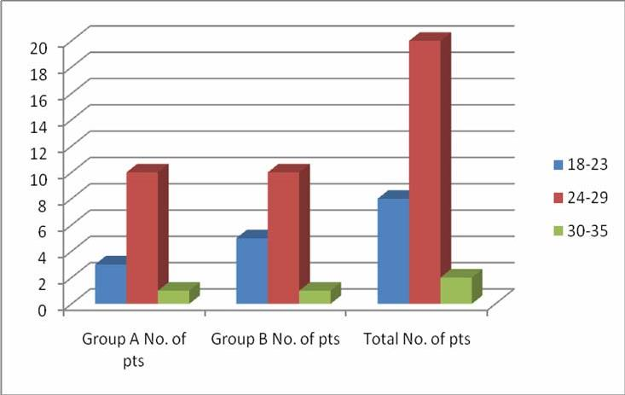

## Table No 10: According to Marital life

|  |  |  |  |
| --- | --- | --- | --- |
| **Marital life (in years** | **No. of pts in Group A (Trial)** | **No. of pts in Group B (Standard)** | **Total** |
| **1 to 5** | 12 | 12 | 24 |
| **6 to 10** | 3 | 3 | 6 |

**Graph no 3: According to Marital life**

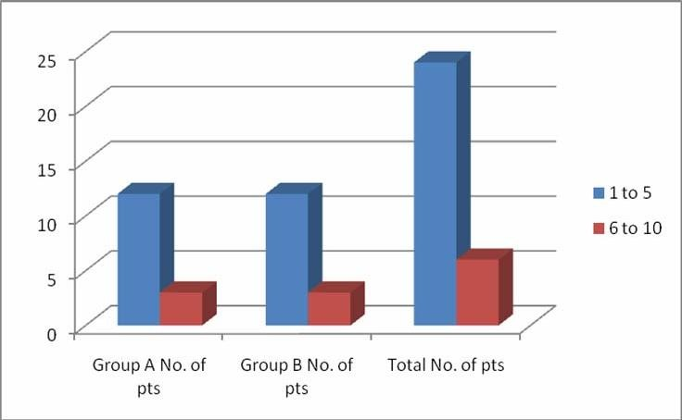

## Table No 11: According to Parity

|  |  |  |  |
| --- | --- | --- | --- |
|  | **No. of pts in Group A (Trial)** | **No. of pts in**  **Group B (Standard)** | **Total** |
| **Parity** |  |
| **Primi** | 8 | 5 | 13 |
| **Multi** | 7 | 10 | 17 |

**Graph no 4: According to Parity**

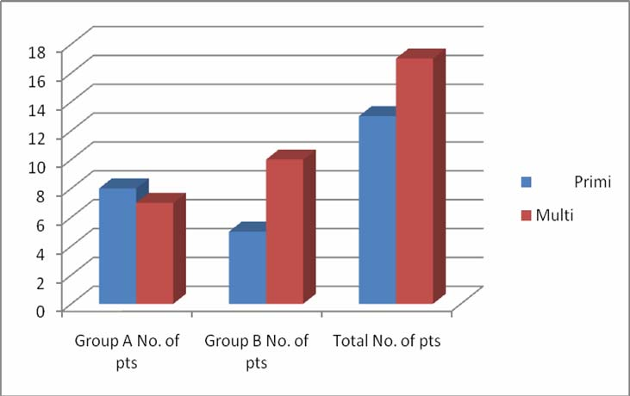

## Table No 12: According to Education

|  |  |  |  |
| --- | --- | --- | --- |
| Education | **No. of pts in Group A (Trial)** | **No. of pts in Group B**  **(Standard)** | **Total** |
| **Educated** | 11 | 9 | 20 |
| **Uneducated** | 4 | 6 | 10 |

**Graph no 5: According to Education**

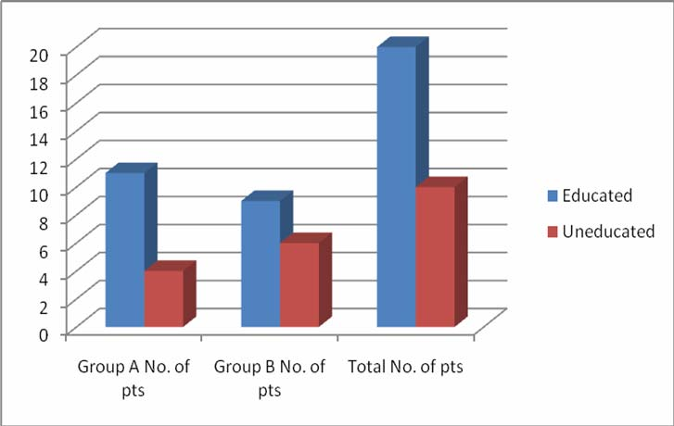

## Table No 13: According to Occupation

|  |  |  |  |
| --- | --- | --- | --- |
|  | **No. of pts in Group A (Trial)** | **No. of pts in Group B (Standard)** | **Total** |
| **Occupation** |  |
| **Labor** | 2 | 2 | 4 |
| **Housewife** | 4 | 3 | 7 |
| **Service** | 10 | 9 | 19 |

**Graph no 6: According to Occupation**

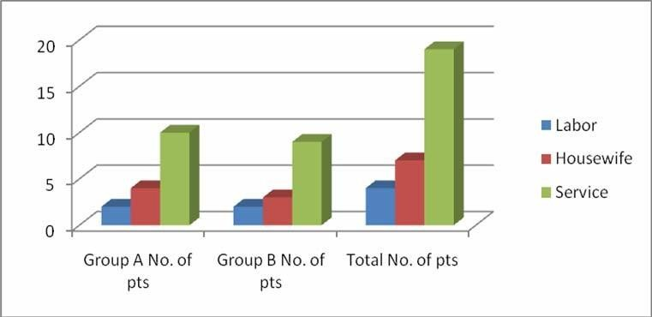

## Table No 14: According to socio-economic status

|  |  |  |  |
| --- | --- | --- | --- |
| **Socio-economic status** | **No. of pts in Group A (Trial)** | **No. of pts in Group B**  **(Standard)** | **Total** |
| **Low income class** | 11 | 5 | 8 |
| **Middle income class** | 1 | 9 | 20 |
| **High income class** | 11 | 1 | 2 |

**Graph no 7: According to socio-economic status**

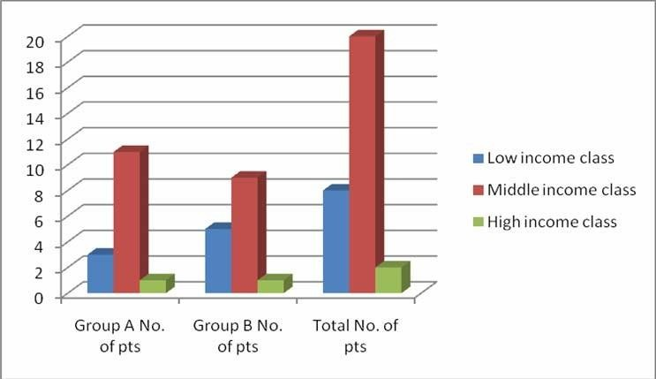

# RESULT

On the basis of observations & result the statistical analysis can be carried out in the following manner.

|  |  |  |
| --- | --- | --- |
| H 0 | : | Bhumikushmanda Churna is not effective. |
| H 1 | : | Bhumikushmanda Churna is effective. |
| X1 | : | Before treatment |
| X2 | : | After treatment |
| SD | = | Standard deviation |
| ‘d’ | = | x2-x1 |
| d | = | Difference between two means. |
| ‘t’ | = | d/S.D.√n |
| n | = | Number of patients |

Bhumikushmanda Churna is compared with Standard by taking 6 parameters. The efficacy of Bhumikushmanda Churna by noting the observations before treatment & after treatment is evaluated. Calculation of mean effect & its standard deviation before treatment & after treatment by using paired ‘t’ test is carried out. The same type of calculations is made for the Standard drug also.

By using unpaired ‘t’ test the trial drug & Standard are compared for their efficacy after treatment. Correlation between the groups before & after treatment is also calculated

## For paired‘t’ test formula used:

‘t’=d/S.D.√n : Where d= € d/n & d=x-y where df=n-1

## Unpaired‘t’ test formula:

‘t’=X1-X2/ √ (n1-1) S21+(n2-1)S22

n1+n2-2 Here df=n1+n2-2

## RESULTS

1. **STATISTICAL ANALYSIS – Assessment of Parameters in Group A&B**

## At First Follow Up

**Trial Group I**

|  |  |  |  |  |  |  |  |  |
| --- | --- | --- | --- | --- | --- | --- | --- | --- |
| **Parameter** | **Mean BT** | **Mean AT** | **% of Improvement** | **SD** | **SEM** | **t** | **P** | **Remarks** |
| **Stana Mlanata** | **1.8** | **1.06** | **31.75** | **0.25** | **0.06** | **14.09** | **<0.001** | **Highly Significant** |
| **Stanya Ejection** | **1.26** | **1.46** | **44.45** | **0.25** | **0.66** | **15.05** | **<0.001** | **Highly Significant** |
| **Breast Feeding** | **1.26** | **1.46** | **26.55** | **0.5** | **0.13** | **4.58** | **<0.001** | **Highly Significant** |
| **Weight of the Baby** | **2.46** | **2.46** | **0** | **0** | **0** | **0** | **<0.10** | **Not Significant** |
| **Breast Engorgement** | **1.26** | **1.46** | **26.55** | **0.5** | **0.131** | **4.58** | **<0.001** | **Highly Significant** |

## Standard Group

|  |  |  |  |  |  |  |  |  |
| --- | --- | --- | --- | --- | --- | --- | --- | --- |
| **Parameter** | **Mean BT** | **Mean AT** | **% of Improvement** | **SD** | **SEM** | **t** | **P** | **Remarks** |
| **Stana Mlanata** | **2.93** | **2** | **31.75** | **0.25** | **0.06** | **14.09** | **<0.001** | **Highly Significant** |
| **Stanya Ejection** | **1.26** | **1.46** | **44.45** | **0.25** | **0.66** | **15.05** | **<0.001** | **Highly Significant** |
| **Breast Feeding** | **2.93** | **2** | **26.55** | **0.5** | **0.13** | **4.58** | **<0.001** | **Highly Significant** |
| **Weight of the Baby** | **2.33** | **2.33** | **0** | **0** | **0** | **0** | **<0.10** | **Not Significant** |
| **Breast Engorgement** | **2.93** | **2** | **26.55** | **0.5** | **0.131** | **4.58** | **<0.001** | **Highly Significant** |

Table No.15. **Comparing the Results at First Follow up**

|  |  |  |  |  |  |  |  |  |
| --- | --- | --- | --- | --- | --- | --- | --- | --- |
| **Groups** | **Mean BT** | **Mean AT** | **% of Improvement** | **SD** | **SEM** | **t** | **P** | **Remarks** |
| **A** | **2.67** | **1.78** | **33.33** | **0.41** | **0.18** | **4.77** | **<0.01** | **Significant** |
| **B** | **2.5** | **2.24** | **10.4** | **0.16** | **0.07** | **3.58** | **<0.05** | **Significant** |

## Comparison of Mean in Group I & Group II after 1st Follow Up: Statistical Analysis of in the Trial group

Mean and Standard error of;

* Mean score of Stana Mlanata before treatment was 1.8 and is reduced to 1.06+0.06 after treatment. t – Value is 14.09 with the significance of p = 0.001 after the treatment.
* Mean score of Stanya Ejection before treatment was 1.26 and is increased to 1.46+0.66 after treatment. t – Value is 15.05 with the significance of p = 0.001 after the treatment.
* Mean score of Breast feeding frequency before treatment was 1.26 and is increased to 1.46+0.13 after treatment. t – Value is 4.58 with the significance of p = 0.001 after the treatment.
* Mean score of Weight of the baby before treatment was 2.46 and is remained same after treatment. t – Value is 0 with the non-significance of p = 0.10 after the treatment.
* Mean score of Breast Engorgement before treatment was 1.26 and is increased to 1.46+0.131 after treatment. t – Value is 4.58 with the significance of p = 0.001 after the treatment.

## In the Standard Group

Mean and Standard error of;

* Mean score of Stana Mlanata before treatment was 2.93 and is reduced to 2+0.06 after treatment. t – Value is 14.09 with the significance of p = 0.001 after the treatment.
* Mean score of Stanya Ejection before treatment was 1.26 and is increased to 1.46+0.66 after treatment. t – Value is 15.05 with the significance of p = 0.001 after the treatment.
* Mean score of Breast feeding frequency before treatment was 2.93 and is increased to 2+0.13 after treatment. t – Value is 4.58 with the significance of p = 0.001 after the treatment.
* Mean score of Weight of the baby before treatment was 2.33 and is remained same after treatment. t – Value is 0 with the non-significance of p = 0.10 after the treatment.
* Mean score of Breast Engorgement before treatment was 2.93 and is increased to 2+0.131 after treatment. t – Value is 4.58 with the significance of p = 0.001 after the treatment.

After comparing the above two groups,group I showed significant result (p> 0.001) on completion of 1st follow up.

## Comparision of Group I and Group II:

Mean score of Group I which is 2.67 before treatment was improved to 1.78+0.18. t – Value is 4.77 with the significance of p = 0.01.

Mean score of Group II which is 2.5 before treatment was improved to 2.24+0.07. t – Value is 3.58 with the significance of p = 0.05.

1. **STATISTICAL ANALYSIS –Assessment of Parameters in Group A&B at**

**Second Follow Up**

## Trial Group I

|  |  |  |  |  |  |  |  |  |
| --- | --- | --- | --- | --- | --- | --- | --- | --- |
| **Parameter** | **Mean BT** | **Mean AT** | **% of Improvement** | **SD** | **SEM** | **t** | **P** | **Remarks** |
| **Stana Mlanata** | **1.8** | **0.33** | **50.1** | **0.63** | **0.16** | **8.95** | **<0.001** | **Highly Significant** |
| **Stanya Ejection** | **1.26** | **2** | **65** | **0.61** | **0.15** | **19.93** | **<0.001** | **Highly Significant** |
| **Breast Feeding** | **1.26** | **2** | **44.24** | **0.65** | **0.16** | **5.91** | **<0.001** | **Highly Significant** |
| **Weight of the Baby** | **2.46** | **2.46** | **0** | **0** | **0** | **0** | **<0.10** | **Not Significant** |
| **Breast Engorgement** | **1.26** | **2** | **44.24** | **0.65** | **0.16** | **5.91** | **<0.001** | **Highly Significant** |

**Standard Group**

|  |  |  |  |  |  |  |  |  |
| --- | --- | --- | --- | --- | --- | --- | --- | --- |
| **Parameter** | **Mean BT** | **Mean AT** | **% of Improvement** | **SD** | **SEM** | **t** | **P** | **Remarks** |
| **Stana Mlanata** | **2.93** | **1.26** | **50.1** | **0.63** | **0.16** | **8.95** | **<0.001** | **Highly Significant** |
| **Stanya Ejection** | **1.26** | **2** | **65** | **0.61** | **0.15** | **19.93** | **<0.001** | **Highly Significant** |
| **Breast Feeding** | **2.93** | **1.26** | **44.24** | **0.65** | **0.16** | **5.91** | **<0.001** | **Highly Significant** |
| **Weight of the Baby** | **2.33** | **2.33** | **0** | **0** | **0** | **0** | **<0.10** | **Not Significant** |
| **Breast Engorgement** | **2.93** | **1.26** | **44.24** | **0.65** | **0.16** | **5.91** | **<0.001** | **Highly Significant** |

Table No.16 **Comparing the Results at second Follow up**

|  |  |  |  |  |  |  |  |  |
| --- | --- | --- | --- | --- | --- | --- | --- | --- |
| **Groups** | **Mean**  **BT** | **Mean**  **AT** | **% of**  **Improvement** | **SD** | **SEM** | **t** | **P** | **Remarks** |
| **A** | **2.67** | **1.24** | **53.55** | **0.54** | **0.24** | **5.8** | **<0.01** | **Significant** |
| **B** | **2.5** | **2.1** | **32.31** | **0.24** | **0.11** | **3.61** | **<0.05** | **Significant** |

.

## Comparison of Mean in Group I & Group II after 2nd Follow Up: Statistical Analysis of in the Trial group

Mean and Standard error of;

* Mean score of Stana Mlanata before treatment was 1.8 and is reduced to 0.33+0.16 after treatment. t – Value is 8.95 with the significance of p = 0.001 after the treatment.
* Mean score of Stanya Ejection before treatment was 1.26 and is increased to 2+0.15 after treatment. t – Value is 19.93 with the significance of p = 0.001 after the treatment.
* Mean score of Breast feeding frequency before treatment was 1.26 and is increased to 2+0.16 after treatment. t – Value is 5.91 with the significance of p = 0.001 after the treatment.
* Mean score of Weight of the baby before treatment was 2.46 and is remained same after treatment. t – Value is 0 with the non-significance of p = 0.10 after the treatment.
* Mean score of Breast Engorgement before treatment was 1.26 and is increased to 2+0.16 after treatment. t – Value is 5.91 with the significance of p = 0.001 after the treatment.

## In the Standard Group

Mean and Standard error of;

* Mean score of Stana Mlanata before treatment was 2.93 and is reduced to 1.26+0.16 after treatment. t – Value is 8.95 with the significance of p = 0.001 after the treatment.
* Mean score of Stanya Ejection before treatment was 1.26 and is increased to 2+0.15 after treatment. t – Value is 19.93 with the significance of p = 0.001 after the treatment.
* Mean score of Breast feeding frequency before treatment was 2.93 and is increased to 1.26+0.16 after treatment. t – Value is 5.91 with the significance of p = 0.001 after the treatment.
* Mean score of Weight of the baby before treatment was 2.33 and is remained same after treatment. t – Value is 0 with the non-significance of p = 0.10 after the treatment.
* Mean score of Breast Engorgement before treatment was 2.93 and is increased to 1.26+0.16 after treatment. t – Value is 5.91 with the significance of p = 0.001 after the treatment.

After comparing the above two groups,group I showed significant result (p> 0.001) on completion of 1st follow up.

## Comparision of Group I and Group II:

Mean score of Group I which is 2.67 before treatment was improved to 1.24+0.24. t – Value is 5.8 with the significance of p = 0.01.

Mean score of Group II which is 2.5 before treatment was improved to 2.5+0.11. t – Value is 3.61 with the significance of p = 0.05.

1. **STATISTICAL ANALYSIS – Assessment of Parameters in Group A&B at**

**Third Follow Up**

## Trial Group I

|  |  |  |  |  |  |  |  |  |
| --- | --- | --- | --- | --- | --- | --- | --- | --- |
| **Parameter** | **Mean**  **BT** | **Mean**  **AT** | **% of**  **Improvement** | **SD** | **SEM** | **t** | **P** | **Remarks** |
| **Stana Mlanata** | **1.8** | **0.2** | **86.34** | **0.5** | **0.12** | **20.15** | **<0.001** | **Highly Significant** |
| **Stanya Ejection** | **1.26** | **1.93** | **88.88** | **0.51** | **0.13** | **19.46** | **<0.001** | **Highly Significant** |
| **Breast Feeding** | **1.26** | **1.93** | **94.24** | **0.59** | **0.15** | **14.77** | **<0.001** | **Highly Significant** |
| **Weight of the Baby** | **2.46** | **2.46** | **0** | **0** | **0** | **0** | **<0.10** | **Not Significant** |
| **Breast Engorgement** | **1.26** | **1.93** | **82.3** | **0.51** | **0.13** | **13.98** | **<0.001** | **Highly Significant** |

**Standard Group**

|  |  |  |  |  |  |  |  |  |
| --- | --- | --- | --- | --- | --- | --- | --- | --- |
| **Parameter** | **Mean BT** | **Mean AT** | **% of Improvement** | **SD** | **SEM** | **t** | **P** | **Remarks** |
| **Stana Mlanata** | **2.93** | **2** | **31.75** | **0.5** | **0.12** | **20.15** | **<0.001** | **Highly Significant** |
| **Stanya Ejection** | **1.26** | **1.93** | **44.45** | **0.51** | **0.13** | **19.46** | **<0.001** | **Highly Significant** |
| **Breast Feeding** | **2.93** | **2** | **26.55** | **0.59** | **0.15** | **14.77** | **<0.001** | **Highly Significant** |
| **Weight of the Baby** | **2.33** | **2.33** | **0** | **0** | **0** | **0** | **<0.10** | **Not Significant** |
| **Breast Engorgement** | **2.93** | **2** | **26.55** | **0.51** | **0.13** | **13.98** | **<0.001** | **Highly Significant** |

Table No.17. **Comparing the Results at Third Follow up**

|  |  |  |  |  |  |  |  |  |
| --- | --- | --- | --- | --- | --- | --- | --- | --- |
| **Groups** | **Mean**  **BT** | **Mean**  **AT** | **% of**  **Improvement** | **SD** | **SEM** | **t** | **P** | **Remarks** |
| **A** | **2.67** | **1.24** | **53.55** | **0.54** | **0.24** | **5.8** | **<0.01** | **Significant** |
| **B** | **2.5** | **2.1** | **32.31** | **0.24** | **0.11** | **3.61** | **<0.05** | **Significant** |

## Comparison of Mean in Group I & Group II after 3rd Follow Up: Statistical Analysis of in the Trial group

Mean and Standard error of;

* Mean score of Stana Mlanata before treatment was 1.8 and is reduced to 0.2+0.12 after treatment. t – Value is 20.15 with the significance of p = 0.001 after the treatment.
* Mean score of Stanya Ejection before treatment was 1.26 and is increased to 1.93+0.13 after treatment. t – Value is 19.46 with the significance of p = 0.001 after the treatment.
* Mean score of Breast feeding frequency before treatment was 1.26 and is increased to 1.93+0.15 after treatment. t – Value is 14.77 with the significance of p = 0.001 after the treatment.
* Mean score of Weight of the baby before treatment was 2.46 and is remained same after treatment. t – Value is 0 with the non-significance of p = 0.10 after the treatment.
* Mean score of Breast Engorgement before treatment was 1.26 and is increased to 1.93+0.13 after treatment. t – Value is 13.98 with the significance of p = 0.001 after the treatment.

## In the Standard Group

Mean and Standard error of;

* Mean score of Stana Mlanata before treatment was 2.93 and is reduced to 2+0.12 after treatment. t – Value is 20.15 with the significance of p = 0.001 after the treatment.
* Mean score of Stanya Ejection before treatment was 1.26 and is increased to 1.93+0.13 after treatment. t – Value is 19.46 with the significance of p = 0.001 after the treatment.
* Mean score of Breast feeding frequency before treatment was 2.93 and is increased to 2+0.15 after treatment. t – Value is 14.77 with the significance of p = 0.001 after the treatment.
* Mean score of Weight of the baby before treatment was 2.33 and is remained same after treatment. t – Value is 0 with the non-significance of p = 0.10 after the treatment.
* Mean score of Breast Engorgement before treatment was 2.93 and is increased to 2+0.13 after treatment. t – Value is 13.98 with the significance of p = 0.001 after the treatment.

After comparing the above two groups, group I showed significant result (p> 0.001) on completion of 1st follow up.

## Comparision of Group I and Group II:

Mean score of Group I which is 2.67 before treatment was improved to 1.24+0.24. t – Value is 5.8 with the significance of p = 0.01.

Mean score of Group II which is 2.5 before treatment was improved to 2.1+0.11. t – Value is 3.61 with the significance of p = 0.05.

1. **STATISTICAL ANALYSIS – Assessment of Parameters in Group A&B at**

**Fourth Follow Up**

## Trial Group I

|  |  |  |  |  |  |  |  |  |
| --- | --- | --- | --- | --- | --- | --- | --- | --- |
| **Parameter** | **Mean**  **BT** | **Mean**  **AT** | **% of**  **Improvement** | **SD** | **SEM** | **t** | **P** | **Remarks** |
| **Stana Mlanata** | **1.8** | **0.33** | **86.34** | **0.5** | **0.12** | **20.15** | **<0.001** | **Highly Significant** |
| **Stanya Ejection** | **1.26** | **2.2** | **88.88** | **0.51** | **0.13** | **19.46** | **<0.001** | **Highly Significant** |
| **Breast Feeding** | **1.26** | **2.2** | **94.24** | **0.59** | **0.15** | **14.77** | **<0.001** | **Highly Significant** |
| **Weight of the Baby** | **2.46** | **2.46** | **0** | **0** | **0** | **0** | **<0.10** | **Not Significant** |
| **Breast Engorgement** | **1.26** | **2.2** | **82.3** | **0.51** | **0.13** | **13.98** | **<0.001** | **Highly Significant** |

**Standard Group**

|  |  |  |  |  |  |  |  |  |
| --- | --- | --- | --- | --- | --- | --- | --- | --- |
| **Parameter** | **Mean BT** | **Mean AT** | **% of Improvement** | **SD** | **SEM** | **t** | **P** | **Remarks** |
| **Stana Mlanata** | **2.93** | **1.26** | **56.99** | **0.5** | **0.12** | **20.15** | **<0.001** | **Highly Significant** |
| **Stanya Ejection** | **1.26** | **2.2** | **74.6** | **0.51** | **0.13** | **19.46** | **<0.001** | **Highly Significant** |
| **Breast Feeding** | **2.93** | **1.26** | **56.9** | **0.59** | **0.15** | **14.77** | **<0.001** | **Highly Significant** |
| **Weight of the Baby** | **2.33** | **2.33** | **0** | **0** | **0** | **0** | **<0.10** | **Not Significant** |
| **Breast Engorgement** | **2.93** | **1.26** | **56.9** | **0.51** | **0.13** | **13.98** | **<0.001** | **Highly Significant** |

Table No. 18. **Comparing the Results at Fourth Follow up**

|  |  |  |  |  |  |  |  |  |
| --- | --- | --- | --- | --- | --- | --- | --- | --- |
| **Groups** | **Mean BT** | **Mean AT** | **% of Improvement** | **SD** | **SEM** | **t** | **P** | **Remarks** |
| **A** | **2.67** | **1.24** | **53.55** | **0.54** | **0.24** | **5.8** | **<0.01** | **Significant** |
| **B** | **2.5** | **2.1** | **32.31** | **0.24** | **0.11** | **3.61** | **<0.05** | **Significant** |

## Comparison of Mean in Group I & Group II after 4th Follow Up: Statistical Analysis of in the Trial group

Mean and Standard error of;

* Mean score of Stana Mlanata before treatment was 1.8 and is reduced to 0.33+0.12 after treatment. t – Value is 20.15 with the significance of p = 0.001 after the treatment.
* Mean score of Stanya Ejection before treatment was 1.26 and is increased to 2.2+0.13 after treatment. t – Value is 19.46 with the significance of p = 0.001 after the treatment.
* Mean score of Breast feeding frequency before treatment was 1.26 and is increased to 2.2+0.15 after treatment. t – Value is 14.77 with the significance of p = 0.001 after the treatment.
* Mean score of Weight of the baby before treatment was 2.46 and is remained same after treatment. t – Value is 0 with the non-significance of p = 0.10 after the treatment.
* Mean score of Breast Engorgement before treatment was 1.26 and is increased to 2.2+0.13 after treatment. t – Value is 13.98 with the significance of p = 0.001 after the treatment.

## In the Standard Group

Mean and Standard error of;

* Mean score of Stana Mlanata before treatment was 2.93 and is reduced to 1.26+0.12 after treatment. t – Value is 20.15 with the significance of p = 0.001 after the treatment.
* Mean score of Stanya Ejection before treatment was 1.26 and is increased to 2.2+0.13 after treatment. t – Value is 19.46 with the significance of p = 0.001 after the treatment.
* Mean score of Breast feeding frequency before treatment was 2.93 and is increased to 1.26+0.15 after treatment. t – Value is 14.77 with the significance of p =

0.001 after the treatment.

* Mean score of Weight of the baby before treatment was 2.33 and is remained same after treatment. t – Value is 0 with the non-significance of p = 0.10 after the treatment.
* Mean score of Breast Engorgement before treatment was 2.93 and is increased to 1.26+0.13 after treatment. t – Value is 13.98 with the significance of p = 0.001 after the treatment.

After comparing the above two groups, group I showed significant result (p> 0.001) on completion of 4th follow up.

## Comparison of Group I and Group II:

Mean score of Group I which is 2.67 before treatment was improved to 1.24+0.24. t – Value is 5.8 with the significance of p = 0.01.

Mean score of Group II which is 2.5 before treatment was improved to 2.1+0.11. t – Value is 3.61 with the significance of p = 0.05.

1. **STATISTICAL ANALYSIS – Assessment of Parameters in Group A&B at**

**Fifth Follow Up**

## Trial Group I

|  |  |  |  |  |  |  |  |  |
| --- | --- | --- | --- | --- | --- | --- | --- | --- |
| **Parameter** | **Mean BT** | **Mean AT** | **% of Improvement** | **SD** | **SEM** | **t** | **P** | **Remarks** |
| **Stana Mlanata** | **1.8** | **0.2** | **86.34** | **0.5** | **0.12** | **20.15** | **<0.001** | **Highly Significant** |
| **Stanya Ejection** | **1.26** | **2.33** | **88.88** | **0.51** | **0.13** | **19.46** | **<0.001** | **Highly Significant** |
| **Breast Feeding** | **1.26** | **2.06** | **94.24** | **0.59** | **0.15** | **14.77** | **<0.001** | **Highly Significant** |
| **Weight of the Baby** | **2.46** | **2.8** | **38.21** | **0.1** | **0.12** | **3.4** | **<0.005** | **Significant** |
| **Breast Engorgement** | **1.26** | **2.33** | **82.3** | **0.51** | **0.13** | **13.98** | **<0.001** | **Highly Significant** |

**Standard Group**

|  |  |  |  |  |  |  |  |  |
| --- | --- | --- | --- | --- | --- | --- | --- | --- |
| **Parameter** | **Mean**  **BT** | **Mean**  **AT** | **% of**  **Improvement** | **SD** | **SEM** | **t** | **P** | **Remarks** |
| **Stana Mlanata** | **2.93** | **2** | **31.75** | **0.5** | **0.12** | **20.15** | **<0.001** | **Highly Significant** |
| **Stanya Ejection** | **1.26** | **2.06** | **63.49** | **0.51** | **0.13** | **19.46** | **<0.001** | **Highly Significant** |
| **Breast Feeding** | **2.93** | **2** | **31.75** | **0.59** | **0.15** | **14.77** | **<0.001** | **Highly Significant** |
| **Weight of the Baby** | **2.33** | **2.73** | **17.16** | **0.1** | **0.12** | **3.4** | **<0.005** | **Significant** |
| **Breast Engorgement** | **2.93** | **2** | **31.75** | **0.51** | **0.13** | **13.98** | **<0.001** | **Highly Significant** |

Table No. 19. **Comparing the Results at Fifth Follow up**

|  |  |  |  |  |  |  |  |  |
| --- | --- | --- | --- | --- | --- | --- | --- | --- |
| **Groups** | **Mean BT** | **Mean AT** | **% of Improvement** | **SD** | **SEM** | **t** | **P** | **Remarks** |
| **A** | **2.67** | **0.32** | **87.81** | **0.53** | **0.23** | **9.83** | **<0.001** | **Highly Significant** |
| **B** | **2.5** | **2.05** | **30.25** | **0.06** | **0.02** | **7.9** | **<0.01** | **Significant** |

## Comparison of Mean in Group I & Group II after 1st Follow Up: Statistical Analysis of in the Trial group

Mean and Standard error of;

* Mean score of Stana Mlanata before treatment was 1.8 and is reduced to 0.2+0.12 after treatment. t – Value is 20.15 with the significance of p = 0.001 after the treatment.
* Mean score of Stanya Ejection before treatment was 1.26 and is increased to 2.33+0.13 after treatment. t – Value is 19.46 with the significance of p = 0.001 after the treatment.
* Mean score of Breast feeding frequency before treatment was 1.26 and is increased to 2.06+0.15 after treatment. t – Value is 14.77 with the significance of p = 0.001 after the treatment.
* Mean score of Weight of the baby before treatment was 2.46 and is increased to 2.8+0.12 after treatment. t – Value is 3.4 with the significance of p = 0.005 after the treatment.
* Mean score of Breast Engorgement before treatment was 1.26 and is increased to 2.33+0.13 after treatment. t – Value is 13.98 with the significance of p = 0.001 after the treatment.

## In the Standard Group

Mean and Standard error of;

* Mean score of Stana Mlanata before treatment was 2.93 and is reduced to 1.26+0.12 after treatment. t – Value is 20.15 with the significance of p = 0.001 after the treatment.
* Mean score of Stanya Ejection before treatment was 1.26 and is increased to 2.06+0.13 after treatment. t – Value is 19.46 with the significance of p = 0.001 after the treatment.
* Mean score of Breast feeding frequency before treatment was 2.93 and is increased to 2+0.15 after treatment. t – Value is 14.77 with the significance of p = 0.001 after the treatment.
* Mean score of Weight of the baby before treatment was 2.33 and is increased to 2.73+0.12 after treatment. t – Value is 3.4 with the significance of p = 0.005 after the treatment.
* Mean score of Breast Engorgement before treatment was 2.93 and is increased to 2+0.13 after treatment. t – Value is 13.98 with the significance of p = 0.001 after the treatment.

After comparing the above two groups, group I showed significant result (p> 0.001) on completion of 5th follow up.

## Comparison of Group I and Group II:

Mean score of Group I which is 2.67 before treatment was improved to 0.32+0.23. t – Value is 9.83 with the significance of p = 0.001.

Mean score of Group II which is 2.5 before treatment was improved to 2.05+0.02. t – Value is 7.9 with the significance of p = 0.01.

1. **STATISTICAL ANALYSIS – Assessment of Parameters in Group A&B at**

**Sixth Follow Up**

## Trial Group I

|  |  |  |  |  |  |  |  |  |
| --- | --- | --- | --- | --- | --- | --- | --- | --- |
| **Parameter** | **Mean**  **BT** | **Mean**  **AT** | **% of**  **Improvement** | **SD** | **SEM** | **t** | **P** | **Remarks** |
| **Stana Mlanata** | **1.8** | **0.2** | **86.34** | **0.5** | **0.12** | **20.15** | **<0.001** | **Highly Significant** |
| **Stanya Ejection** | **1.26** | **2.53** | **88.88** | **0.51** | **0.13** | **19.46** | **<0.001** | **Highly Significant** |
| **Breast Feeding** | **1.26** | **2.06** | **94.24** | **0.59** | **0.15** | **14.77** | **<0.001** | **Highly Significant** |
| **Weight of the Baby** | **2.46** | **2.8** | **38.21** | **0.1** | **0.12** | **3.4** | **<0.005** | **Significant** |
| **Breast Engorgement** | **1.26** | **2.53** | **82.3** | **0.51** | **0.13** | **13.98** | **<0.001** | **Highly Significant** |

**Standard Group**

|  |  |  |  |  |  |  |  |  |
| --- | --- | --- | --- | --- | --- | --- | --- | --- |
| **Parameter** | **Mean BT** | **Mean AT** | **% of Improvement** | **SD** | **SEM** | **t** | **P** | **Remarks** |
| **Stana Mlanata** | **2.93** | **1.26** | **56.9** | **0.5** | **0.12** | **20.15** | **<0.001** | **Highly Significant** |
| **Stanya Ejection** | **1.26** | **2.06** | **63.49** | **0.51** | **0.13** | **19.46** | **<0.001** | **Highly Significant** |
| **Breast Feeding** | **2.93** | **1.26** | **56.9** | **0.59** | **0.15** | **14.77** | **<0.001** | **Highly Significant** |
| **Weight of the Baby** | **2.33** | **2.73** | **17.16** | **0.1** | **0.12** | **3.4** | **<0.005** | **Significant** |
| **Breast Engorgement** | **2.93** | **1.78** | **60.9** | **0.61** | **0.15** | **12.98** | **<0.001** | **Highly Significant** |

Table No. 20. **Comparing the Results at Sixth Follow up**

|  |  |  |  |  |  |  |  |  |
| --- | --- | --- | --- | --- | --- | --- | --- | --- |
| **Groups** | **Mean BT** | **Mean AT** | **% of Improvement** | **SD** | **SEM** | **t** | **P** | **Remarks** |
| **A** | **2.67** | **0.32** | **87.81** | **0.53** | **0.23** | **9.83** | **<0.001** | **Highly Significant** |
| **B** | **2.5** | **1.65** | **66.00** | **0.08** | **0.2** | **7.4** | **<0.01** | **Significant** |

## Comparison of Mean in Group I & Group II after 1st Follow Up: Statistical Analysis of in the Trial group

Mean and Standard error of;

* Mean score of Stana Mlanata before treatment was 1.8 and is reduced to 0.2+0.12 after treatment. t – Value is 20.15 with the significance of p = 0.001 after the treatment.
* Mean score of Stanya Ejection before treatment was 1.26 and is increased to 2.53+0.13 after treatment. t – Value is 19.46 with the significance of p = 0.001 after the treatment.
* Mean score of Breast feeding frequency before treatment was 1.26 and is increased to 2.06+0.15 after treatment. t – Value is 14.77 with the significance of p = 0.001 after the treatment.
* Mean score of Weight of the baby before treatment was 2.46 and is increased to 2.8+0.12 after treatment. t – Value is 3.4 with the significance of p = 0.005 after the treatment.
* Mean score of Breast Engorgement before treatment was 1.26 and is increased to 2.33+0.13 after treatment. t – Value is 13.98 with the significance of p = 0.001 after the treatment.

## In the Standard Group

Mean and Standard error of;

* Mean score of Stana Mlanata before treatment was 2.93 and is reduced to 1.26+0.12 after treatment. t – Value is 20.15 with the significance of p = 0.001 after the treatment.
* Mean score of Stanya Ejection before treatment was 1.26 and is increased to 2.06+0.13 after treatment. t – Value is 19.46 with the significance of p = 0.001 after the treatment.
* Mean score of Breast feeding frequency before treatment was 2.93 and is increased to 1.26+0.15 after treatment. t – Value is 14.77 with the significance of p = 0.001 after the treatment.
* Mean score of Weight of the baby before treatment was 2.33 and is increased to 2.73+0.12 after treatment. t – Value is 3.4 with the significance of p = 0.005 after the treatment.
* Mean score of Breast Engorgement before treatment was 2.93 and is increased to 1.78+0.15 after treatment. t – Value is 12.98 with the significance of p = 0.001 after the treatment.

After comparing the above two groups, group I showed significant result (p> 0.001) on completion of 6th follow up.

## Comparision of Group I and Group II:

Mean score of Group I which is 2.67 before treatment was improved to 0.32+0.23. t – Value is 9.83 with the significance of p = 0.001.

Mean score of Group II which is 2.5 before treatment was improved to 1.65+0.2. t – Value is 7.4 with the significance of p = 0.01.



**DISCUSSION**

# DISCUSSION

Utpatti of Stanya according to Ayurvedic classics can be concluded in 3 points.

1. From Rasa dhatu: Here we have to remember that Stanya and Artava are upadhatus of Rasa. By definition, Upadhatus are those which get nourished by corresponding dhatu and they do not nourish other entities. That means there is no further transformation of that entity and Bhoja clearly indicates that upadhatus are free from Gati, they can’t move anywhere. Many times we fail to ask or some points may be escaped out of our mind while counseling a stanya kshaya patient, which do not yield proper result in treatment. First we have to be clear regarding rasa dhatu; Sushrutacharya in sutra sthana 14th chapter explained the transformation of rasa dhatu without leaving any doubts. Rasa dhatu is the ultimate outcome of food which possess all following criteria;
   * It should include pancha bhoutika constitutes.
   * It should include chaturvidha anna(bhojya, bhakshya, lehya & peya).
   * Shadrasayukta food.
   * Foods constituting dwi-vidha & ashta-vidha veerya.
   * Food which include many properties sufficient to maintain the tridoshic balance.

Such food after digestion becomes two parts viz, Sara and Kitta, the tejo rupa saara bhaga which is micro in size known as Rasa. Hence any defect in above criteria obviously vitiates rasa dhatu and further it vitiates its upadhatus.

1. From Rakta dhatu: According to Kashyapa, after fertilization, some quantity of blood nourishes breast milk in pregnant lady. Hormonal response in Mammogenesis and Lactogenesis can be correlated with production of breast milk

from raktha dhatu; blood is the only media for circulation of hormones and obviously the blood carries the breast milk producing hormones. In this way blood play role in production of breast milk.

1. From Raja: Even though upadhatu cannot nourish other entitiy in the body, the Raja nourish Stanya, it may seem like Shastra viruddha or tantra dosha. But virtually, the actual cause is the left over Raja after formation of garbha goes upward to Stana and there by the action of pitta, colour of raja changes from red to pale white and transformed into Stanya. The ‘Piyusha (Colostrum)’ actually resembles this type of Stanya. Charaka Maharshi in Nidana Sthana Gulma Nidana adhyaya, in the context of Shonita Gulma Laxana told that that lady develops Stanya. Chakrapani commenting on this word told that Stanya exist only due to ‘avarodha of raja’. Anatomically we will find 2 urdhwagami dhamani and 4 adhogami dhamani for shukra vahana in males. In that 2 urdhwagami dhamanis are homologous with stanyavaha dhamani in female, where as 4 adhogami dhamanis are homologous with artava vahi dhamani in female. So there is same one channel for transportation of both stree shukra and artava in female, hence obstruction of artava causes Vimarga gamana of that which reaches Stana ultimately as Stana is the mula sthana of Shukra. There by the action of pitta converts it physically into Stanya, this can be correlated with role of reproductive hormones such as estrogen, progesterone, prolactin, oxytocin, etc in the formation of stanya.

Varieties of modes of therapies are available to correct the lactation. In Ayurveda (In Yoga Rathnakara) Bhumikushmanda ksheerapaka is said to be stanya vriddhikara i.e. Lactogogue. Vidari is drug of choice for Stanya janana. Keeping these aspects in mind, this study has been undertaken. It is an attempt to verify the claim that Bhumikushmanda is a Galactogogue.

A detailed study of literature available both in Ayurveda as well as the modern treatises was carried out. The effect of drug as evident in the clinical trials was, recorded along with detailed data pertaining to the case history.

## Clinical Study:

In this study total 30 patients were taken, dividing them into two groups.

**Group A (Trial group):** 15 Patients treated by the trial drug. i.e. Bhumikushmanda

Churna orally.

**Group B (Standard group):** 15 patients treated by oral Shatavari Churna.

Observations of 30 patients have been presented with the data & recorded in the previous pages. The critical & description note on the data is presented as follows.

Most of the patients belong to 24-29yrs age group (20). In this age group family burden, children and personal strain might have affected the health of the women during pregnancy so may have bad outcome.

In the present study most of the women registered were working women (19). In working women family responsibility, physical work load, stress, and irregular food habits affect their health.

In laborer group less patients(4) approached, they have to bear more physical strain and malnourishment and they live in an unhygienic state and most of them have improper ANC, all this may result in Stanya Kshaya.

The observation made in regard to socio-economic status indicates that most of the patients (20) belong to middle class & (2) in high class.

Most of the patients were educated (20) & all multipara (17) and marital life between (1-5 years) (24). Drug action depends upon the rasa, guna, veerya, and prabhava of drug.

The stanyajanana drugs possess madhura rasa, sneha, guru, sheeta etc. shleshavardhaka properties. (C. S.Su.).

When the parameters are considered:

1. Stana Mlanata: 86.34% patients cured in group A & 56.9% patients cured in Group B. These results shows that both the treatments were effective in increasing lactation but group A was comparatively more effective than group B.
2. Stanya Ejection – 88.88% patients cured in Group A & 63.49% patients cured in Group B. These result shows that both the treatments were effective in increasing lactation, but group A was comparatively more effective than group B.
3. Breast feeding is concerned 94.24% patients were cured in group A & 56.9% in group B. Both the therapies were effective but it is more effective in group A than group B.
4. Weight of the baby is concerned 38.21% patients cured in group A & 17.16% cured in group B both the therapies were effective but if is more effective in group A than group B.
5. Breast Engorgement is considered in group A, 82.3% patients were cured & in group B 60.9% were cured. Both the therapies were effective but it is more effective in Group A than group B.

By the end of 3rd & 4th follow-up only, in most of the patients Stanya Vriddhi was achieved. If the score is between 4& above- Treatment is considered as Successful, 2-3 - Treatment is considered as Improved & 0-1 - Treatment is considered as unsuccessful.

Bhumikushmanda Churna failed to increase lactation in 2 patients and they are advised to continue the therapy. Standard drug(Shatavari Churna) failed to increase lactation in 5 patients.

When the comparison was made between trial & standard, just to find out the efficacy of the trial drug, the trial drug has definitely shown better results as indicated by significant‘t’ value ‘P’ value & thus shown better results than the standard. Though the study has been carried out in less number of patients because of time shortage but it is sure to benefit more number of patients. If the drug can be tested on a large scale, it will be beneficial for patients who need Stanya Vriddhi.



**CONCLUSION**

# CONCLUSION

*Conclusion*

1. Stanya kshaya is the common problem noticed in about 40% patients in our clinical practice.
2. Adequate lactation has been defined as secretion of 300ml (10 ounces) daily by the 5th day and 480ml (16 ounces) by the 10th day. If these amounts are not achieved a baby of normal weight will not be adequately fed and such a situation is termed clinically as lactational deficiency.
3. Goals set by the World Health Organization; Healthy people 2010 included a 70% breast feeding initiation rate, a 50% contribution rate six months after birth and 25% contribution rate 12 months after birth. Keeping these aspects in mind, this study has been undertaken.
4. According to Sushrutha, stanyakshaya occurs due to psychological condition of mother (Krodha, Shoka, Bhaya, Irsha & Avatsalyatwa), Diet regime of mother and physiological condition.
5. Bhumikushmanda is drug of choice for Stanya janana and is cost effective, palatable, no side-effects and absorption is very fast.
6. The drug possesses Madhura Rasa, Guru, Snigdha Guna, Sheeta Virya & Madhura Vipaka, thus by samanya siddhanta it increases stanya.
7. Breast milk is the perfect food for a normal neonate. It is the best gift a mother can give her baby. Breast feeding is the ideal form of infant feeding and is crucial for lifelong health and well being.

Role of Bhumikushmanda Churna in Stanyakshaya

113



**SUMMARY**

# SUMMARY

This study entitled ‘Role of Bhumikushmanda Churna in Stanya kshaya’ has designed under 5 parts.

Part-1 : Conceptual Study

Part-2 : Drug Review.

Part-3 : Clinical Study

Part-4 : Discussion.

Part-5 : Conclusion.

## Part-1: - Conceptual Study:

It comprises the following sections.

## Section-1:

Ayurvedic review: It comprises of anatomy of stana in detail (Stana Shareera) paryaya, definition, formation, utpatti hetu, pradurbha kala, stanya sampat according different Acharyas, stanya dusti, hetu, bheda, laxana and the disease which it causes to the newborn.

## Section-2:

Modern review: It contains anatomy of the breast, changes that occur in breast following pregnancy and during lactation. Physiology and endocrinology of lactation, description of few important hormones which influence lactation. Breast feeding and its benefits to both child & mother.

## Part-2 Drug Review:

Description of the trial drug, with respect to its synonyms, distribution, season, botanical description, rasa, guna, karma, useful part, references of its classical usage,

use according to aromatherapy, as specially with woman’s health is concerned, its medical uses in other countries, its chemical contents.

## Part-3 Clinical Studies:

In this part, aims and objectives, material and methodology, selection criteria of patients, grouping of patients, drug-dose and duration of treatment criteria for assessment of result. Scoring pattern, general observations and effect of therapy in different headings along with total effect of therapy discussed and graphically represented.

## Part-4 Discussions:

Here total report of descriptive discussion based on conceptual study and clinical study are included. Mode of action of drug is also focused here.

## Part-5 Conclusion:

Conclusion drawn at the end of study.

**BIBLIOGRAPHY**

# BIBLIOGRAPHY

1. Atridev. Sushruta Samhita. Commented by Ghanekar Shribaskar Govindaji.

Varanasi. Chaukhambha Vidyabhavan, 1988.

1. Agnivesh. Charaka Samhita. Redacted by Charaka & Dridhabala with Vidyotini Hindi commentary by Pandit Kashinath, Shastry and Dr. Gorakhnath Chaturvedi. Chaukhamba Bharati Academy, Varanasi, UP. Reprint- 1998.
2. Alen H. Decherney, Lauren Nathan. A Lange Medical Book of Current Obstetric and Gynecologic Diagnosis and Treatment. Mc Graw- Hill Companies. International Edition. 9th Edition.
3. Bhela - Bhela-Samhita. Text with English Translation, commentary, and critical notes by Dr. K.H. Krishna Murthy- Chaukhambha Vishvabharati. Oriental Publishers and Distributors. Varanasi. Reprint- 2003.
4. Bhavamishra. Bahvaprakash Nighantu. Edited by Dr. G.S. Pandey and Commentary by Dr. Krishnachandra Chunekar. Chaukhambha Bharati Academy, Varanasi (India). 10th Edition, 1995.
5. Bhavamishra. Bhavaprakash. (Text, English translation, Notes, Appendices, and Index) by Prof. K.R. Srikantha Murthy Chukhambha Krishnadas Academy, Varanasi. Edition 2004.
6. Cunningham, Leveno, Bloom, Hauth, Gilstrap, Wenstrom’s William’s Obstetrics. McGraw- Hill. Medical Publishing Division. 22nd Edtion.
7. Chaudhuri S.K. Concise Medical Physiology. New Central Book Agency (P) Ltd. Calcutta (India). 4th Edition.
8. Dawn. C.S. Textbook of Obstetrics, Neonatology and Reproductive and Child Health Education. Dawn Books, Kolkatta (India). 16th Edition, 2004.
9. Dutta. D.C. Text Book of Obstetrics. Edited by Hiralal Konar. New central Book Agency (P) Ltd. Calcutta (India). 4th Edition 1998.
10. Dwivedi Vishwanatha. Aushadhi Vijnana Shastra. (Ayurvedic Pharmacology).

Sri Bhaidhyanath Ayurveda Bhawan (P) Ltd. Nagapur (India). 3rd Edition 1986.

1. Draftary Shirish. N.and Sudeep Chakravarti. Manual of Obstetrics updated colour edition of the classic Holland and Brews Manual. Elsevier. A division of the Reed Elsevier India (P) Ltd. 2nd Edition.
2. Farroqi. A.A and Shreeramu. B.S. Cultivation of Medicinal and Aromatic Crops. Universities press (India) Ltd. Hyderabad. India. 1st Edition, 2001.
3. Gray’s Anatomy. The Anatomical Basis of Clinical Practice. Elesvier Churchill Livingstone Publication. 39th Edition.
4. Ghai. O.P, Piyush Gupta, V.K. Paul. Ghai Essential Pediatrics. C.B.S. Publishers and Distributors. New Deilhi. (India). 6th Edition.
5. Goodman and Gilman’s. The Pharmacological Basis of Therapeutics. Editor.

Joel. G. Hardman. Lee-E-Limbird. McGrow-Hill Medical Publishing Division. International Edition. 10th Edition.

1. Guyton and Hall. Textbook of Medical Physiology. Published by Elsevier, a division of Reed Elsevier India Private Limited. New Delhi (India). 11th Edition.
2. Hariharaprasada. Tripati. Harita Samhita (With Hindi Commentary) Chaukhambha Krishnadas Academy, Varanasi. 1st Edition 2005.
3. Jharkhandha. Oja and Umapati Mishra. Dhanvantari Nighantu. Chaukhambha Surabharati, Publication. Varanasi. 2nd Edition 1996.
4. Kirtikar and Basu. Indian Medicinal Plants. Text part-II International Book Distributors. Deharadun. India. 3rd Edition 1935.
5. Lala Shaligramaji. Vaishya. Shaligrama Nighantu. Khemaraj Shrikrishnadas Publication. Bombay. India. 1st Edition.
6. Mahajan. B.K. Methods of Biostatistics. Jayee brothers. Mumbai.

Maharashtra. 6th Edition.

1. Narahari Pandit. Raja Nighantu. Edited with ‘Dravyagunaprakarika’ Hindi Commentary by Dr. Indradeo. Tripathi. Krishnadas Academy, Varanasi. 1st Edition.
2. Norman. Jeffcoate. Sir. Principles of Gynaecology. Butterworth World Student Reprints. Butterworth and co. (publishers). 4th Edition 1975.
3. Park. K. Park’s Textbook of Preventive and Social Medicine. M/S. Banarsidar. Bhanot (Publishers). Jabalpur. India. 18th Edition 2005.
4. Prajapati, Purohit, Sharma, Kumar. A Handbook of Medicinal Plants- A complete source Book. Agrobios (India). Agro House, Jodhpur, India. 1st Edition 2003.
5. Sharma. Priyavrata and Sharma. Guru Prasada. Kaideva Nighantu.

Chaukhambha Orientalia, Varanasi. India. 1st Edition 1979.

1. Sharma. P.V. Classical uses of Medicinal Plants. Chaukhambha.

Vishvabharati. Varanasi, India. Reprint year 2004.

1. Sharma. P.V. Dravyaguna Vignyana. Chaukhambha Amarabharathi Prakashana, Varanasi. UP 1998.
2. Sharangadhara. Sharangadhara Samhita- A treatise on Ayurveda. Translated into English by K.R. Srikanta, Murthy. Chaukhambha Orientalia, Golghar, Varanasi, India. 4th Edition 2001.
3. Sri Chakrapanidatta. Chakradatta, with the ‘Bhavathasandipini’ Hindi commentary by Sri Jagadishvaraprasad Tripathi. Chaukhambha Sanskrit series office. Varanasi, India. 5th Edition 1983.
4. Tiwari. P.V. ‘Ayurveda Prasoti Tantra Evam Stree Roga’ Part-I Chaukhambha Orientalia. Delhi. 1st Edition 1990.
5. The Wealth of India- A dictionary of Indian raw materials and industrial products.First supplement series (Raw materials) Vol-4. National Institute of science communication and Information Resourse. Council of scientific and Industrial Reasearch. New Delhi-2003.
6. Vriddha jeevaka: Kashyapa Samhita. Text with English translation and commentary by, P.V. Tewari. Chaukhambha Vishvabharati. Varanasi. 1st Edition, 1996.
7. Vagbhata Acharya. Ashtanga Hridayam. (Text, English translation, Notes, Appendex, Indices) Translated by Prof. K.R.Srikantha. Murthy. Chaukhambha Krishnadas Academy. Varanasi. U.P. India. Reprint 1998.
8. Vagbhata. Acharya. Astanga. Samgraha. (Text, English translation, Notes, Appendex, Indices) Translated by Prof. K.R.Srikantha. Murthy. Chaukhambha Orientalia, Varanasi. 9th Edition 2005.
9. Warrier. P.K and V.P.K. Nambiar and C.Ramankutty. Indian Medical Plants.

A compendium of 500 species vol-3 vaidyaratnam. P.S. Varier’s Arya Vaidya Sala. Kottakkal Orient Logman.

## Internet:

1. [www.](http://www/) ZHONG – YAO.NET Accessed on – 11-2-2010.
2. Top Tropicals.com Accessed on - 28-7-2010.
3. Wiley Interscience.
4. ajog.com
5. bjog.com https:/secure.interscience.wiley.com/ppv/servlet/Buy Article Accessed on - 9/07/2010.



**REFERENCES**

# LIST OF REFFERENCES (AYURVEDIC REVIEW):

1. Sha. S. 5/10

* 1. Sus. S. Sha. 4 (Dalhana)
  2. Gu. Di. Teeka.

4. K. S. Sha. 4/14

1. Sus. S. Sha. 5
2. K. S. Khi. 43 Sus. S. Sha. 9/5

7. C. S. Su. 30

1. Sus. S. Sha. 5/10

A. S. Sha. 6/34

1. Raj. Ni.

10. C. S. Si. 6/3

11. Sus. S . Sha. 6 12. C. Sam. Vi. 8/110

13. B. P. P.K..

14. C. S. Sha. 8/53

15. B. P. P.K. 6/

16. Sus. S. Ni. 10/18

17. B. P. P.K. 4/7-9

18. Y. R. Kshir. Ch.

19. C. S. Sha. 6/23

20. Bhela. Sam. Sha. 5/7

21. Sus. S. Su. 1/20

22. C. S. Chi. 15/17

23. Sha. S. 5/16-17

24. H. Sam. 8/2-4

25. A. S. Sha. 2/33

26. A. S. Sha. 5/98

27. K. S. Khi. 9/20-22

28. A. S. Sha. 2/5-6

29. Bhela. Sam. Su. 17/2

30. Sus. S. Sha. 10/14 31. K. S. Khi. 11/63

A. S. U. 1/11

Sus. S. Sha. 10/14 A. H. U. 1/11-12

32. H. S. 8/11-12

33. B. P. P.K. 4/8-9

34. M. N. 67/3-4

35. A. S. Sha. 5/98

A. H. Sha. 3/80-82 36. C. S. Sha. 8/54

37. C. S. Su. 27/224

38. Sus. S. Sha. 10/25 39. Su. S. Sha. 10/31 40. A. H. U. 2/2

A. S. U. 1/23 41. K. S. Su. 19/26

42. B. P. P.K. 4/23

43. B. P. P.K. 6/23

44. M. N. 67/7

45. H. S. 54/2-6

46. H. S. 8/14-15

47. C. S. Chi. 30/232-236

48. Sus. S. Sha. 10/32-33

49. A. S. U. 2/3

50. M. Ni. 67/5

51. B. P. P.K. 71/116-117

1. Y. R. Balaroga. Chi.
2. C. Sam. Sha. 8/55 Sus. S. Ni. 10/23

A. S. U. 2/4

A. H. U. 2/2-3 M. N. 67/6

B. P. P.K. 4/18

Y. R. Kshir. Chi.

54. C. S. Sha. 8/55 Sus. S. Ni. 10/24 A. S. U. 2/5

A. H. U. 2/3 M. N. 67/6

B. P. P.K. 4/18

Y. R. Kshir. Chi.

55. C. S. Sha. 8/55 Sus. S. Ni. 10/24 A. S. U. 2/6

A. H. U. 2/4

M. N. 67/7.

Y. R. Kshir. Chi.

B. P. P.K. 4/19

56. A. H. U. 2/4

C. S. Sha. 8/55 (Chakrapani teeka) M. N. 67/7, 68/4

Y. R. Kshir. Chi.

B. P. P.K. 4/19, 71/121 57. Sus. S. Ni. 10/24

A. H. U. 2/4 M. N. 67/7

B. P. P.K. 4/19

Y. R. Kshir. Chi.

58. Sus. S. Ni. 10/24

Sus. S. Ni. 10/24 (Dalhana teeka)

M. N. (Madhukosha Vyakhya) 67/7 59. K. S. Su. 19/1-2

60. K. S. Su. 19/3

61. A. S. U. 2/14

62. A. S. U. 2/16

63. C. S. Su. 19/3

C. S. Chi. 30/229-231 64. H. S. 54/1-2

65. Sus. S. Sha. 10/31 66. A. S. U. 1/27

67. A. H. U. 1/19

68. A. H. U. 1/37

69. A. S. U. 1/66

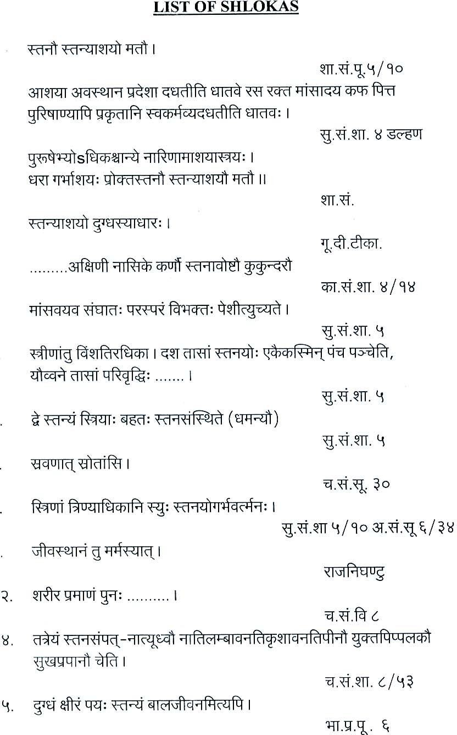

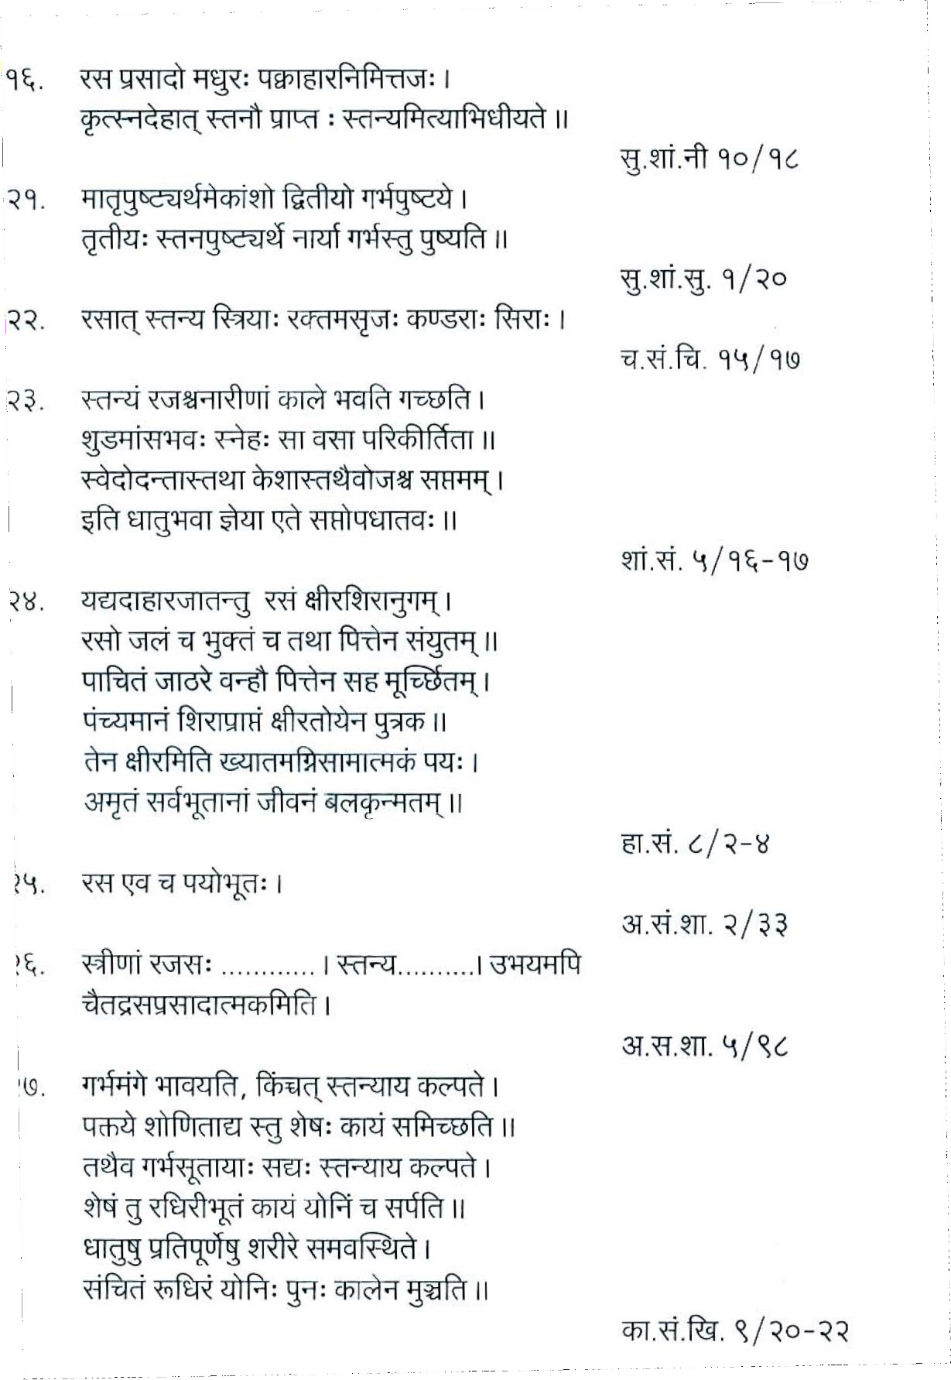

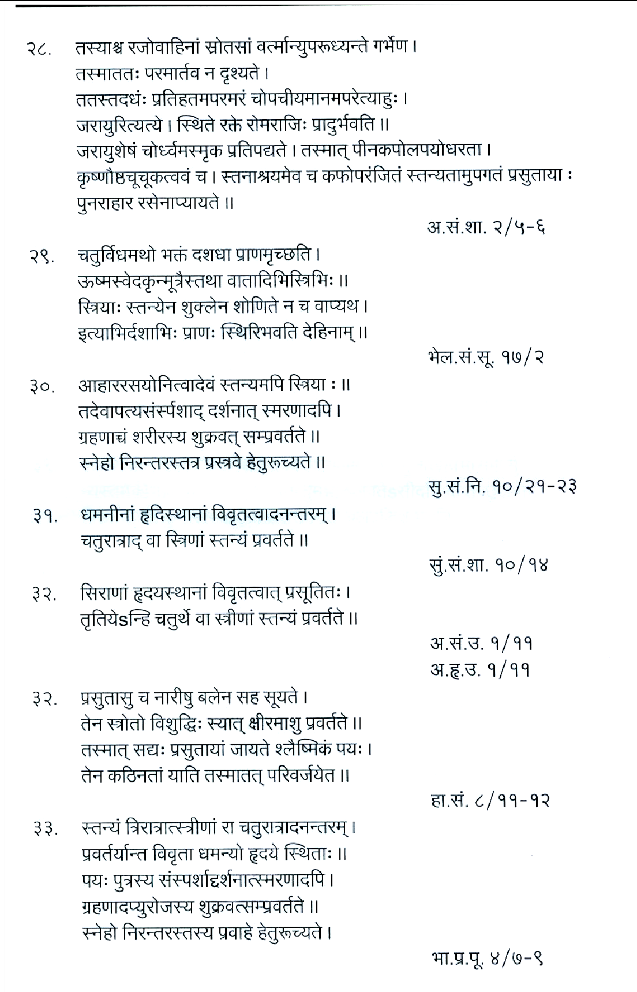

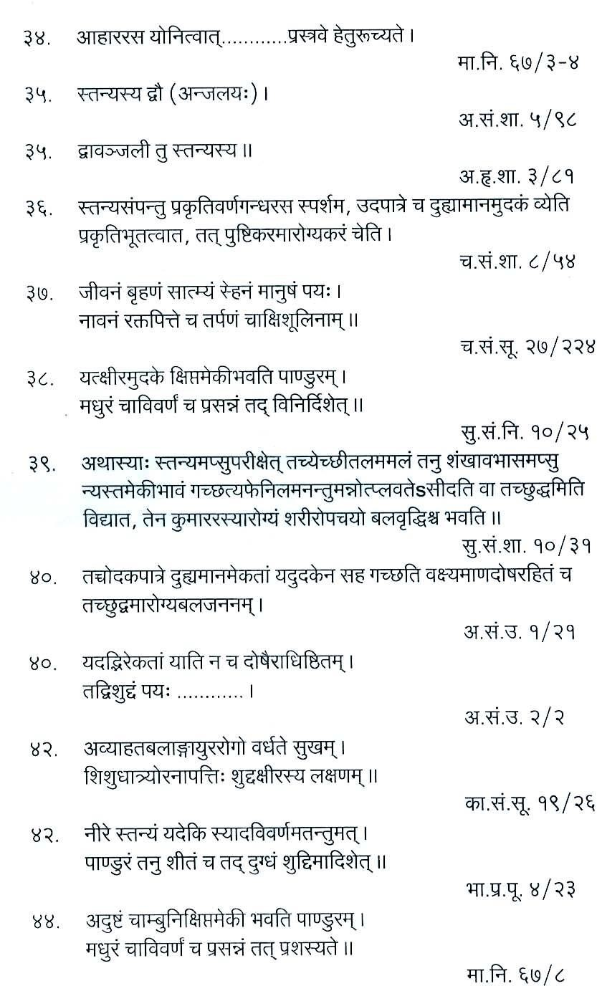

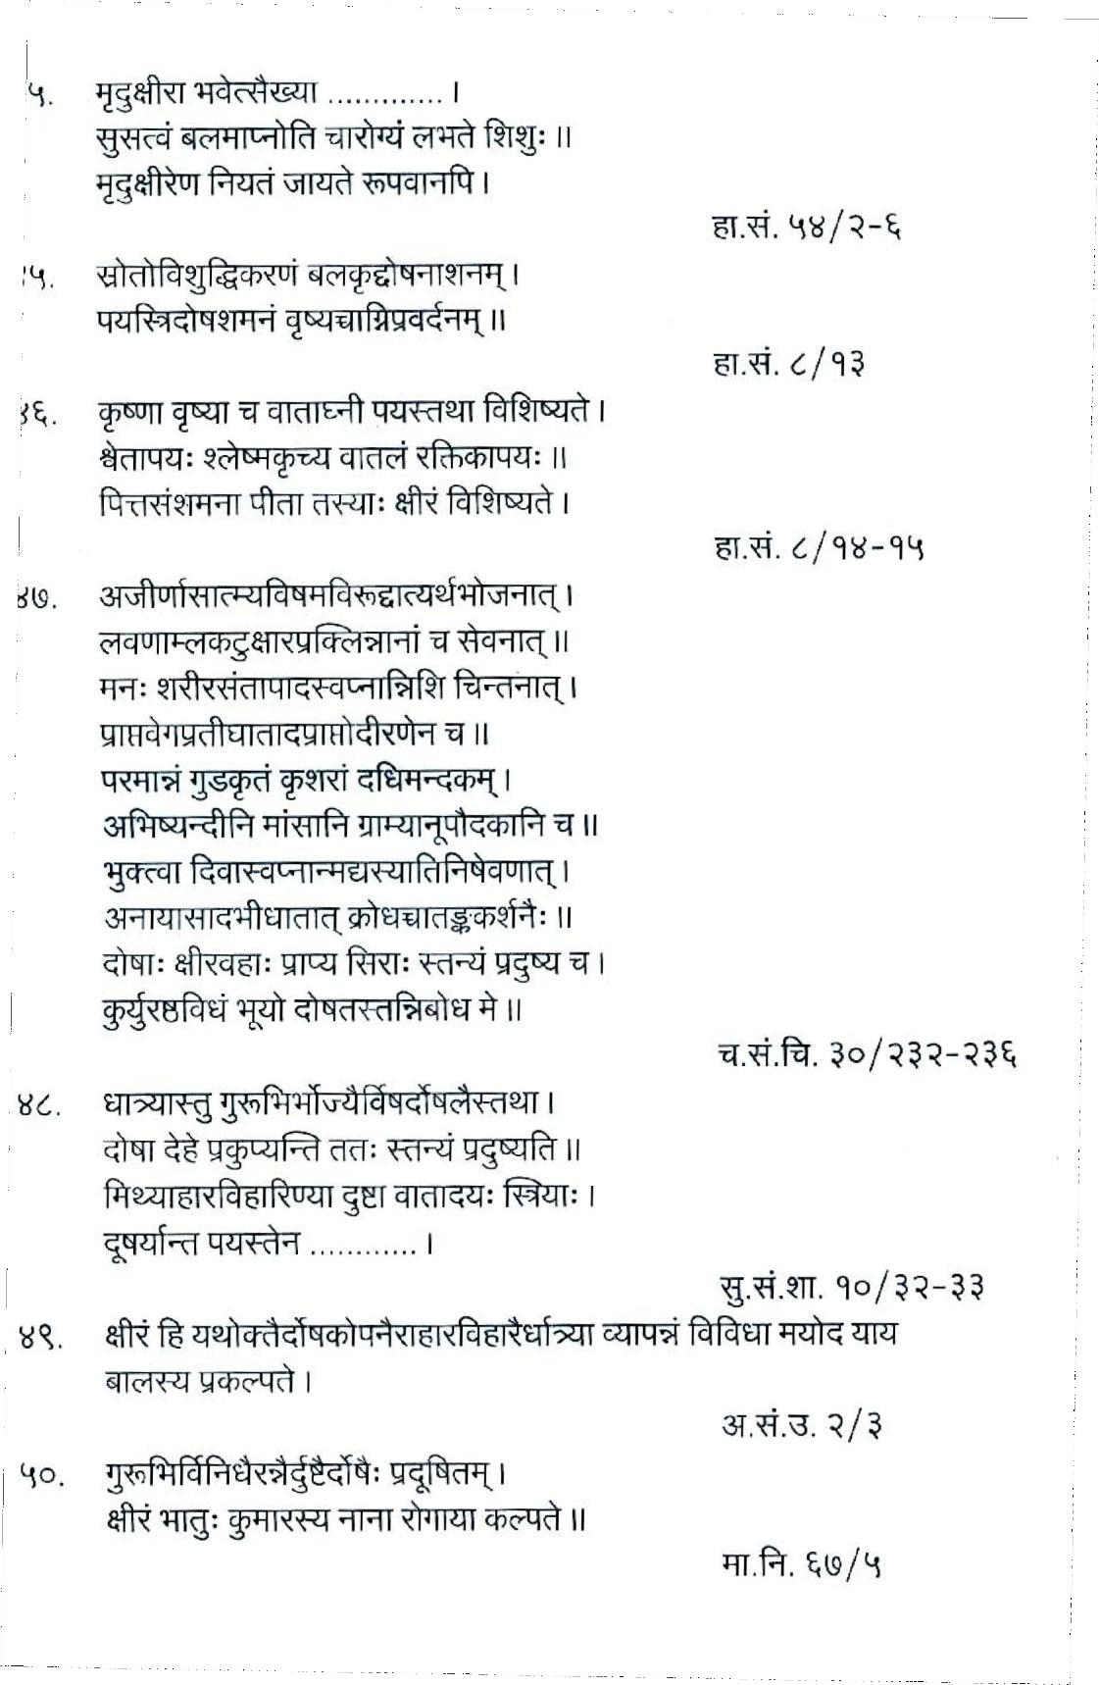

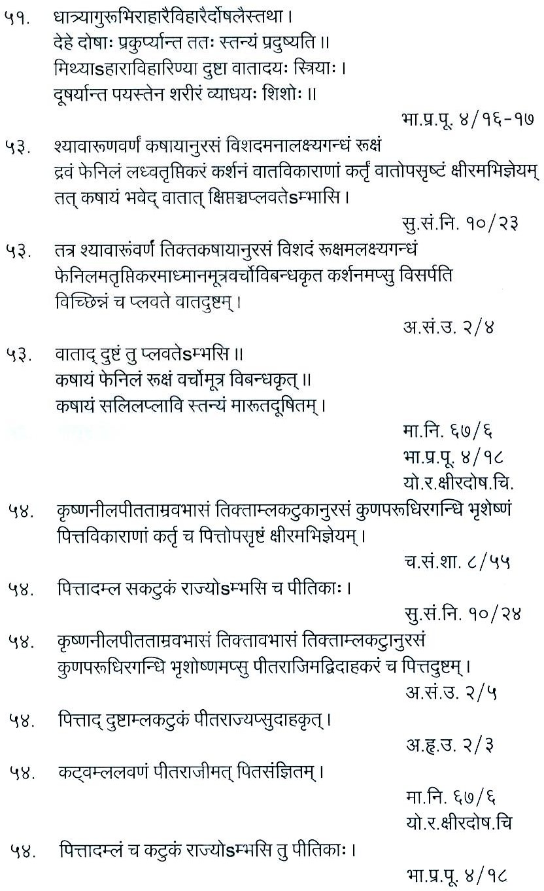

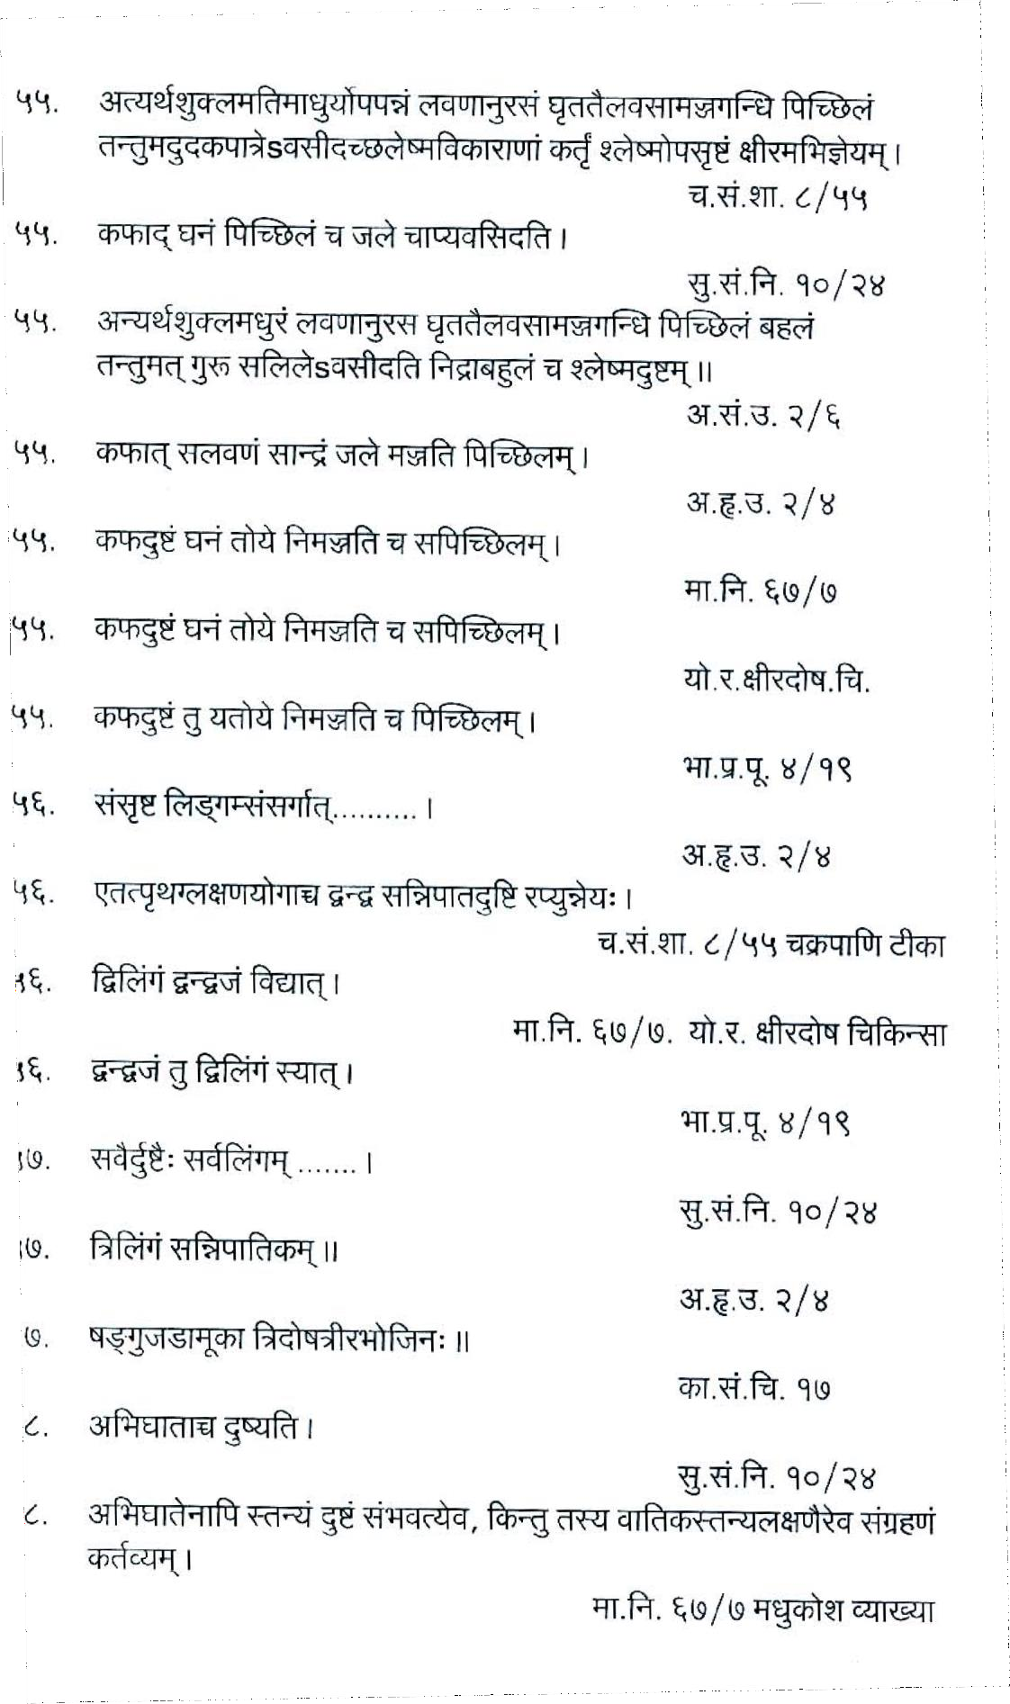

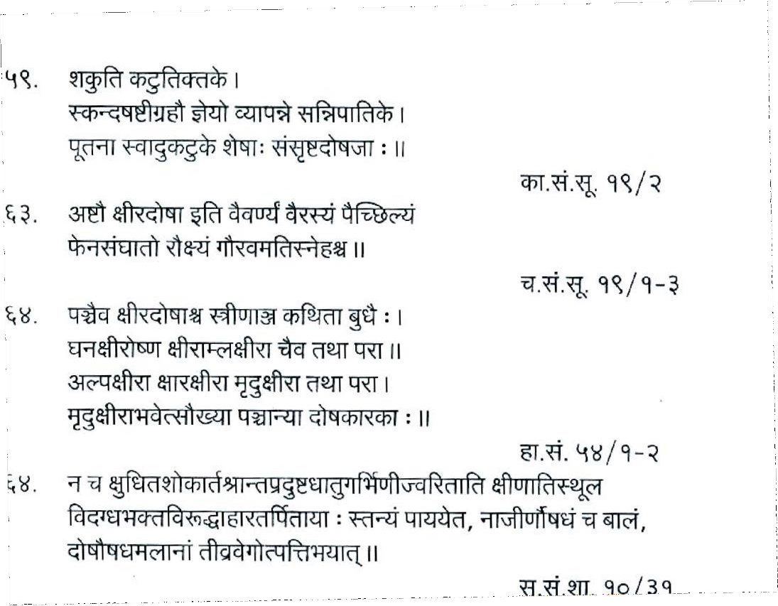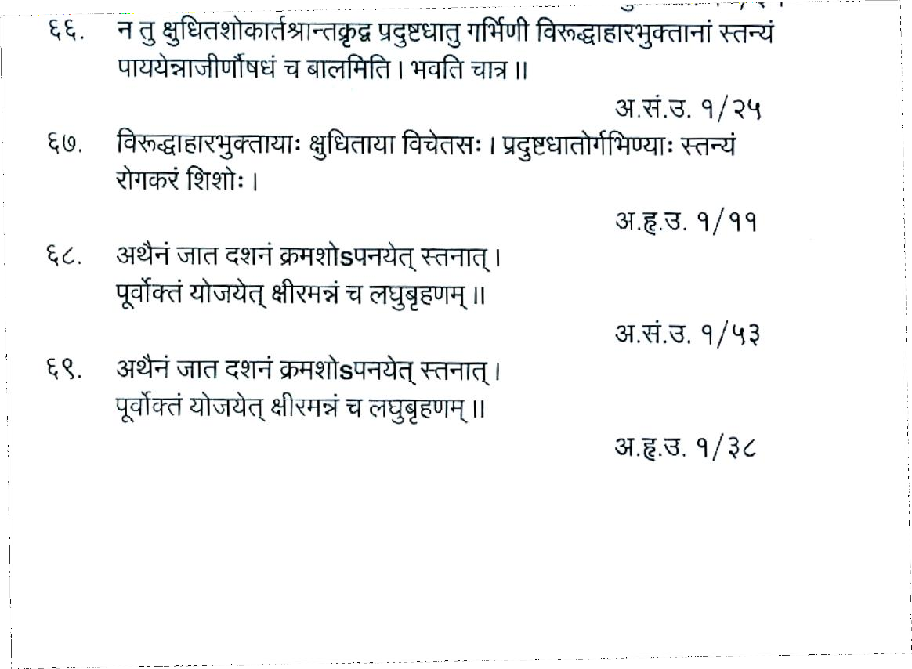

**LIST OF REFFRENCES (MODERN REVIEW)**

1. Lange Current Obstetrics & Gynecology. Diagnosis & Treatment. i. PP-1094-1095
2. D.C. Dutta. Text Book of Obstetrics. PP-157
3. Textbook of Medical Physiology, Arthur. C. Guyton & John. E. Hall, 11th Edition, PP-1038-1041.
4. C.S.Dawn. Pectorial & Practical UG & PG Textbook of Obstetrics, Neonatology, Reproductive & Child Health Care.PP-32-33
5. Goodman & Gillman’s, Pharmacological Basis of Therapeutics. PP-1549- 1552.
6. Concise Medical Physiology.PP-324
7. Guyton & Hall-Text Book of Medical Physiology.PP-520.
8. Internet article, Breastfeeding - Wikipedia, the free encyclopedia.htm.
9. Picciano M (2001). "Nutrient composition of human milk". Pediatr Clin North Am **48** (1): 53–67. [doi](http://en.wikipedia.org/wiki/Digital_object_identifier):[10.1016/S0031-3955(05)70285-6](http://dx.doi.org/10.1016%2FS0031-3955%2805%2970285-6). [PMID 11236733](http://en.wikipedia.org/wiki/PubMed_Identifier).
10. Riordan JM (1997). "The cost of not breastfeeding: a commentary". J Hum Lact **13** (2): 93–97. [doi](http://en.wikipedia.org/wiki/Digital_object_identifier):[10.1177/089033449701300202](http://dx.doi.org/10.1177%2F089033449701300202). [PMID 9233193](http://en.wikipedia.org/wiki/PubMed_Identifier).
11. Bartick M, Reinhold A (2010-04-05). ["The burden of suboptimal](http://pediatrics.aappublications.org/cgi/content/abstract/peds.2009-1616v1) [breastfeeding in the United States: a pediatric cost analysis".](http://pediatrics.aappublications.org/cgi/content/abstract/peds.2009-1616v1) Pediatrics **125** (5): e1048–56. [doi](http://en.wikipedia.org/wiki/Digital_object_identifier):[10.1542/peds.2009-1616](http://dx.doi.org/10.1542%2Fpeds.2009-1616). [PMID 20368314](http://en.wikipedia.org/wiki/PubMed_Identifier). <http://pediatrics.aappublications.org/cgi/content/abstract/peds.2009-1616v1>. "If 90% of US families could comply with medical recommendations to breastfeed exclusively for 6 months, the United States would save $13 billion per year and prevent an excess 911 deaths".
12. Falco M (2010-04-05). ["Study: lack of breastfeeding costs lives, billions of](http://www.cnn.com/2010/HEALTH/04/05/breastfeeding.costs) [dollars".](http://www.cnn.com/2010/HEALTH/04/05/breastfeeding.costs) CNN.

<http://www.cnn.com/2010/HEALTH/04/05/breastfeeding.costs>.

1. Horton S, Sanghvi T, Phillips M, et al. (1996). "Breastfeeding promotion and priority setting in health". Health Policy Plan **11** (2): 156–68. [doi](http://en.wikipedia.org/wiki/Digital_object_identifier):[10.1093/heapol/11.2.156](http://dx.doi.org/10.1093%2Fheapol%2F11.2.156). [PMID 10158457](http://en.wikipedia.org/wiki/PubMed_Identifier).
2. Kramer M, Kakuma R (2002). "Optimal duration of exclusive breastfeeding".

Cochrane Database Syst Rev (1): CD003517. [doi](http://en.wikipedia.org/wiki/Digital_object_identifier):[10.1002/14651858.CD003517](http://dx.doi.org/10.1002%2F14651858.CD003517). [PMID 11869667](http://en.wikipedia.org/wiki/PubMed_Identifier).

1. Baker R (2003). "Human milk substitutes. An American perspective".

Minerva Pediatr **55** (3): 195–207. [PMID 12900706](http://en.wikipedia.org/wiki/PubMed_Identifier).

1. Agostoni C, Haschke F (2003). "Infant formulas. Recent developments and new issues". Minerva Pediatr **55** (3): 181–94. [PMID 12900705](http://en.wikipedia.org/wiki/PubMed_Identifier).
2. World Health Organization. (2003). [Global strategy for infant and young child](http://whqlibdoc.who.int/publications/2003/9241562218.pdf) [feeding.](http://whqlibdoc.who.int/publications/2003/9241562218.pdf) Geneva, Switzerland: [World Health Organization](http://en.wikipedia.org/wiki/World_Health_Organization) and [UNICEF.](http://en.wikipedia.org/wiki/UNICEF) [ISBN](http://en.wikipedia.org/wiki/International_Standard_Book_Number) 9241562218. [http://whqlibdoc.who.int/publications/2003/9241562218.pdf.](http://whqlibdoc.who.int/publications/2003/9241562218.pdf) Retrieved 2009- 09-20.
3. Gartner LM, et al. (2005). ["Breastfeeding and the use of human milk [policy](http://aappolicy.aappublications.org/cgi/content/full/pediatrics%3B115/2/496) [statement](http://aappolicy.aappublications.org/cgi/content/full/pediatrics%3B115/2/496)"]. Pediatrics **115** (2): 496–506. [doi](http://en.wikipedia.org/wiki/Digital_object_identifier):[10.1542/peds.2004-2491](http://dx.doi.org/10.1542%2Fpeds.2004-2491). [PMID 15687461](http://en.wikipedia.org/wiki/PubMed_Identifier). [http://aappolicy.aappublications.org/cgi/content/full/pediatrics;115/2/496](http://aappolicy.aappublications.org/cgi/content/full/pediatrics%3B115/2/496).
4. ["Benefits of Breastfeeding".](http://www.4woman.gov/breastfeeding/index.cfm?page=227) U.S. Department of Health and Human Services. [http://www.4woman.gov/breastfeeding/index.cfm?page=227.](http://www.4woman.gov/breastfeeding/index.cfm?page=227) Retrieved 2009- 02-15.
5. Dewey KG, Heinig MJ, Nommwen LA. Maternal weight-loss patterns during the menstrual cycle. Am J Clin Nutr 1993;58: 162-166
6. Fisher D (2006 November). ["Social drugs and breastfeeding".](http://www.health-e-learning.com/content/view/32/63/) Queensland, Australia: Health e-Learning. [http://www.health-e-](http://www.health-e-learning.com/content/view/32/63/) [learning.com/content/view/32/63/.](http://www.health-e-learning.com/content/view/32/63/)
7. Ip S, Chung M, Raman G, et al. (2007). ["Breastfeeding and maternal and](http://www.ahrq.gov/downloads/pub/evidence/pdf/brfout/brfout.pdf) [infant health outcomes in developed countries".](http://www.ahrq.gov/downloads/pub/evidence/pdf/brfout/brfout.pdf) Evid Rep Technol Assess (Full Rep) (153): 1–186. [PMID 17764214](http://en.wikipedia.org/wiki/PubMed_Identifier). <http://www.ahrq.gov/downloads/pub/evidence/pdf/brfout/brfout.pdf>. Retrieved 2009-09-22.
8. Horta BL, Bahl R, Martines JC, Victora CG (2007). [Evidence on the long-](http://whqlibdoc.who.int/publications/2007/9789241595230_eng.pdf) [term effects of breastfeeding: systematic reviews and meta-analyses.](http://whqlibdoc.who.int/publications/2007/9789241595230_eng.pdf) Geneva, Switzerland: World Health Organization. [ISBN](http://en.wikipedia.org/wiki/International_Standard_Book_Number) 9789241595230. [http://whqlibdoc.who.int/publications/2007/9789241595230_eng.pdf.](http://whqlibdoc.who.int/publications/2007/9789241595230_eng.pdf) Retrieved 2010-04-05.
9. ["Breastfeeding".](http://www.cdc.gov/breastfeeding/) Centers for Disease Control and Prevention. [http://www.cdc.gov/breastfeeding/.](http://www.cdc.gov/breastfeeding/) Retrieved 2007-01-23.
10. Kunz C, Rodriguez-Palmero M, Koletzko B, Jensen R (1999). "Nutritional and biochemical properties of human milk, Part I: General aspects, proteins, and carbohydrates". Clin Perinatol **26** (2): 307–33. [PMID 10394490](http://en.wikipedia.org/wiki/PubMed_Identifier).
11. Rodriguez-Palmero M, Koletzko B, Kunz C, Jensen R (1999). "Nutritional and biochemical properties of human milk: II. Lipids, micronutrients, and bioactive factors". Clin Perinatol **26** (2): 335–59. [PMID 10394491](http://en.wikipedia.org/wiki/PubMed_Identifier).
12. Glass RI, Svennerholm AM, Stoll BJ, et al. (1983). "Protection against cholera in breast-fed children by antibodies in breast milk". N. Engl. J. Med. **308** (23): 1389–92. [PMID 6843632](http://en.wikipedia.org/wiki/PubMed_Identifier).
13. Owen MJ, Baldwin CD, Swank PR, Pannu AK, Johnson DL, Howie VM (1993). "Relation of infant feeding practices, cigarette smoke exposure, and group child care to the onset and duration of otitis media with effusion in the first two years of life". J. Pediatr. **123** (5): 702–11. [doi](http://en.wikipedia.org/wiki/Digital_object_identifier):[10.1016/S0022-](http://dx.doi.org/10.1016%2FS0022-3476%2805%2980843-1) [3476(05)80843-1](http://dx.doi.org/10.1016%2FS0022-3476%2805%2980843-1). [PMID 8229477](http://en.wikipedia.org/wiki/PubMed_Identifier).
14. Dewey KG, Heinig MJ, Nommsen-Rivers LA (1995). "Differences in morbidity between breast-fed and formula-fed infants". J. Pediatr. **126** (5 Pt 1): 696–702. [doi](http://en.wikipedia.org/wiki/Digital_object_identifier):[10.1016/S0022-3476(95)70395-0](http://dx.doi.org/10.1016%2FS0022-3476%2895%2970395-0). [PMID 7751991](http://en.wikipedia.org/wiki/PubMed_Identifier).
15. Blaymore Bier JA, Oliver T, Ferguson A, Vohr BR (2002). "Human milk reduces outpatient upper respiratory symptoms in premature infants during their first year of life". J Perinatol **22** (5): 354–9. [doi](http://en.wikipedia.org/wiki/Digital_object_identifier):[10.1038/sj.jp.7210742](http://dx.doi.org/10.1038%2Fsj.jp.7210742). [PMID 12082468](http://en.wikipedia.org/wiki/PubMed_Identifier).
16. Mårild S, Hansson S, Jodal U, Odén A, Svedberg K (2004). "Protective effect of breastfeeding against urinary tract infection". Acta Paediatr. **93** (2): 164–8. [doi](http://en.wikipedia.org/wiki/Digital_object_identifier):[10.1080/08035250310007402](http://dx.doi.org/10.1080%2F08035250310007402). [PMID 15046267](http://en.wikipedia.org/wiki/PubMed_Identifier).
17. Horne RS, Parslow PM, Ferens D, Watts AM, Adamson TM (2004). ["Comparison of evoked arousability in breast and formula fed infants".](http://www.pubmedcentral.nih.gov/articlerender.fcgi?tool=pmcentrez&artid=1755888) Arch. Dis. Child. **89** (1): 22–5. [PMID 14709496](http://en.wikipedia.org/wiki/PubMed_Identifier).
18. Vennemann MM, Bajanowski T, Brinkmann B, Jorch G, Yücesan K, Sauerland C, Mitchell EA; GeSID Study Group (2009). ["Does breastfeeding](http://pediatrics.aappublications.org/cgi/content/full/123/3/e406) [reduce the risk of sudden infant death syndrome?"](http://pediatrics.aappublications.org/cgi/content/full/123/3/e406). Pediatrics **123** (3): e406–

10. [doi](http://en.wikipedia.org/wiki/Digital_object_identifier):[10.1542/peds.2008-2145](http://dx.doi.org/10.1542%2Fpeds.2008-2145). [PMID 19254976](http://en.wikipedia.org/wiki/PubMed_Identifier).

<http://pediatrics.aappublications.org/cgi/content/full/123/3/e406>.

1. Horwood LJ, Darlow BA, Mogridge N (2001). ["Breast milk feeding and](http://www.pubmedcentral.nih.gov/articlerender.fcgi?tool=pmcentrez&artid=1721196) [cognitive ability at 7-8 years".](http://www.pubmedcentral.nih.gov/articlerender.fcgi?tool=pmcentrez&artid=1721196) Arch. Dis. Child. Fetal Neonatal Ed. **84** (1): F23–7. [doi](http://en.wikipedia.org/wiki/Digital_object_identifier):[10.1136/fn.84.1.F23.](http://dx.doi.org/10.1136%2Ffn.84.1.F23) [PMID 11124919](http://en.wikipedia.org/wiki/PubMed_Identifier).
2. Evenhouse E, Reilly S (2005). ["Improved estimates of the benefits of](http://www.pubmedcentral.nih.gov/articlerender.fcgi?artid=1361236) [breastfeeding using sibling comparisons to reduce selection bias".](http://www.pubmedcentral.nih.gov/articlerender.fcgi?artid=1361236) Health Serv Res **40** (6 Pt 1): 1781–802. [doi](http://en.wikipedia.org/wiki/Digital_object_identifier):[10.1111/j.1475-6773.2005.00453.x](http://dx.doi.org/10.1111%2Fj.1475-6773.2005.00453.x). [PMID 16336548](http://en.wikipedia.org/wiki/PubMed_Identifier). [PMC 1361236.](http://en.wikipedia.org/wiki/PubMed_Central)

[http://www.pubmedcentral.nih.gov/articlerender.fcgi?artid=1361236.](http://www.pubmedcentral.nih.gov/articlerender.fcgi?artid=1361236)

1. Der G, Batty GD, Deary IJ (2006). ["Effect of breast feeding on intelligence in](http://www.pubmedcentral.nih.gov/articlerender.fcgi?tool=pmcentrez&artid=1633819) [children: prospective study, sibling pairs analysis, and meta-analysis".](http://www.pubmedcentral.nih.gov/articlerender.fcgi?tool=pmcentrez&artid=1633819) BMJ **333** (7575): 945. [doi](http://en.wikipedia.org/wiki/Digital_object_identifier):[10.1136/bmj.38978.699583.55](http://dx.doi.org/10.1136%2Fbmj.38978.699583.55). [PMID 17020911](http://en.wikipedia.org/wiki/PubMed_Identifier).
2. Caspi A, Williams B, Kim-Cohen J, et al. (2007). ["Moderation of](http://www.pubmedcentral.nih.gov/articlerender.fcgi?tool=pmcentrez&artid=2141867) [breastfeeding effects on the IQ by genetic variation in fatty acid metabolism".](http://www.pubmedcentral.nih.gov/articlerender.fcgi?tool=pmcentrez&artid=2141867) [Proc. Natl. Acad. Sci. U.S.A.](http://en.wikipedia.org/wiki/Proc._Natl._Acad._Sci._U.S.A) **104** (47): 18860–5. [doi](http://en.wikipedia.org/wiki/Digital_object_identifier):[10.1073/pnas.0704292104](http://dx.doi.org/10.1073%2Fpnas.0704292104). [PMID 17984066](http://en.wikipedia.org/wiki/PubMed_Identifier).
3. Paddock C (6 November 2007). ["IQ boost from breastfeeding linked to](http://www.medicalnewstoday.com/articles/87775.php) [common gene".](http://www.medicalnewstoday.com/articles/87775.php) Medical News Today. [http://www.medicalnewstoday.com/articles/87775.php.](http://www.medicalnewstoday.com/articles/87775.php) Retrieved 20 September 2009.
4. Kramer MS, Aboud F, Mironova E, et al. (2008). ["Breastfeeding and child](http://archpsyc.ama-assn.org/cgi/content/full/65/5/578) [cognitive development: new evidence from a large randomized trial".](http://archpsyc.ama-assn.org/cgi/content/full/65/5/578) Arch Gen Psychiatry **65** (5): 578–84. [doi](http://en.wikipedia.org/wiki/Digital_object_identifier):[10.1001/archpsyc.65.5.578](http://dx.doi.org/10.1001%2Farchpsyc.65.5.578). [PMID 18458209](http://en.wikipedia.org/wiki/PubMed_Identifier). <http://archpsyc.ama-assn.org/cgi/content/full/65/5/578>.
5. Perez-Bravo F, Carrasco E, Gutierrez-Lopez MD, Martinez MT, Lopez G, de los Rios MG (1996). "Genetic predisposition and environmental factors leading to the development of insulin-dependent diabetes mellitus in Chilean children". J. Mol. Med. **74** (2): 105–9. [doi](http://en.wikipedia.org/wiki/Digital_object_identifier):[10.1007/BF00196786](http://dx.doi.org/10.1007%2FBF00196786). [PMID 8820406](http://en.wikipedia.org/wiki/PubMed_Identifier).
6. Owen CG, Martin RM, Whincup PH, Smith GD, Cook DG (2006). "Does breastfeeding influence risk of type 2 diabetes in later life? A quantitative analysis of published evidence". Am. J. Clin. Nutr. **84** (5): 1043–54. [PMID 17093156](http://en.wikipedia.org/wiki/PubMed_Identifier).
7. Mayer-Davis EJ, Dabelea D, Lamichhane AP, et al. (2008). "Breast-feeding and type 2 diabetes in the youth of three ethnic groups: the SEARCh for diabetes in youth case-control study". Diabetes Care **31** (3): 470–5. [doi](http://en.wikipedia.org/wiki/Digital_object_identifier):[10.2337/dc07-1321](http://dx.doi.org/10.2337%2Fdc07-1321). [PMID 18071004](http://en.wikipedia.org/wiki/PubMed_Identifier).
8. Armstrong J, Reilly JJ (2002). "Breastfeeding and lowering the risk of childhood obesity". Lancet **359** (9322): 2003–4. [doi](http://en.wikipedia.org/wiki/Digital_object_identifier):[10.1016/S0140-](http://dx.doi.org/10.1016%2FS0140-6736%2802%2908837-2) [6736(02)08837-2](http://dx.doi.org/10.1016%2FS0140-6736%2802%2908837-2). [PMID 12076560](http://en.wikipedia.org/wiki/PubMed_Identifier).
9. Arenz S, Rückerl R, Koletzko B, von Kries R (2004). "Breast-feeding and childhood obesity--a systematic review". Int. J. Obes. Relat. Metab. Disord. **28** (10): 1247–56. [doi](http://en.wikipedia.org/wiki/Digital_object_identifier):[10.1038/sj.ijo.0802758](http://dx.doi.org/10.1038%2Fsj.ijo.0802758). [PMID 15314625](http://en.wikipedia.org/wiki/PubMed_Identifier).
10. Greer FR, Sicherer SH, Burks AW (2008). "Effects of early nutritional interventions on the development of atopic disease in infants and children: the role of maternal dietary restriction, breastfeeding, timing of introduction of complementary foods, and hydrolyzed formulas". [Pediatrics (journal)](http://en.wikipedia.org/wiki/Pediatrics_(journal)) **121** (1): 183–91. [doi](http://en.wikipedia.org/wiki/Digital_object_identifier):[10.1542/peds.2007-3022](http://dx.doi.org/10.1542%2Fpeds.2007-3022). [PMID 18166574](http://en.wikipedia.org/wiki/PubMed_Identifier).
11. Oddy WH, Holt PG, Sly PD, et al. (1999). ["Association between breast](http://www.pubmedcentral.nih.gov/articlerender.fcgi?tool=pmcentrez&artid=314207) [feeding and asthma in 6 year old children: findings of a prospective birth](http://www.pubmedcentral.nih.gov/articlerender.fcgi?tool=pmcentrez&artid=314207) [cohort study".](http://www.pubmedcentral.nih.gov/articlerender.fcgi?tool=pmcentrez&artid=314207) BMJ **319** (7213): 815–9. [PMID 10496824](http://en.wikipedia.org/wiki/PubMed_Identifier).
12. Pratt HF (1984). "Breastfeeding and eczema". Early Hum. Dev. **9** (3): 283–90. [doi](http://en.wikipedia.org/wiki/Digital_object_identifier):[10.1016/0378-3782(84)90039-2](http://dx.doi.org/10.1016%2F0378-3782%2884%2990039-2). [PMID 6734490](http://en.wikipedia.org/wiki/PubMed_Identifier).
13. Lucas A, Cole TJ (1990). "Breast milk and neonatal necrotising enterocolitis".

Lancet **336** (8730): 1519–23. [doi](http://en.wikipedia.org/wiki/Digital_object_identifier):[10.1016/0140-6736(90)93304-8](http://dx.doi.org/10.1016%2F0140-6736%2890%2993304-8).

[PMID 1979363](http://en.wikipedia.org/wiki/PubMed_Identifier).

1. Kramer MS, Matush L, Vanilovich I, et al. (2007). ["Effect of prolonged and](http://www.pubmedcentral.nih.gov/articlerender.fcgi?tool=pmcentrez&artid=2034727) [exclusive breast feeding on risk of allergy and asthma: cluster randomised](http://www.pubmedcentral.nih.gov/articlerender.fcgi?tool=pmcentrez&artid=2034727) [trial".](http://www.pubmedcentral.nih.gov/articlerender.fcgi?tool=pmcentrez&artid=2034727) BMJ **335** (7624): 815. [doi](http://en.wikipedia.org/wiki/Digital_object_identifier):[10.1136/bmj.39304.464016.AE](http://dx.doi.org/10.1136%2Fbmj.39304.464016.AE). [PMID 17855282](http://en.wikipedia.org/wiki/PubMed_Identifier).
2. Mead MN (2008). ["Contaminants in human milk: weighing the risks against](http://www.ehponline.org/members/2008/116-10/focus.html) [the benefits of breastfeeding".](http://www.ehponline.org/members/2008/116-10/focus.html) Environ Health Perspect **116** (10): A426–34. [doi](http://en.wikipedia.org/wiki/Digital_object_identifier):[10.1289/ehp.116-a426.](http://dx.doi.org/10.1289%2Fehp.116-a426) [PMID 18941560](http://en.wikipedia.org/wiki/PubMed_Identifier). [PMC 2569122](http://en.wikipedia.org/wiki/PubMed_Central). [http://www.ehponline.org/members/2008/116-10/focus.html.](http://www.ehponline.org/members/2008/116-10/focus.html)
3. Akobeng AK, Ramanan AV, Buchan I, Heller RF (2006). ["Effect of breast](http://www.pubmedcentral.nih.gov/articlerender.fcgi?tool=pmcentrez&artid=2083075) [feeding on risk of coeliac disease: a systematic review and meta-analysis of](http://www.pubmedcentral.nih.gov/articlerender.fcgi?tool=pmcentrez&artid=2083075) [observational studies".](http://www.pubmedcentral.nih.gov/articlerender.fcgi?tool=pmcentrez&artid=2083075) Arch. Dis. Child. **91** (1): 39–43. [doi](http://en.wikipedia.org/wiki/Digital_object_identifier):[10.1136/adc.2005.082016](http://dx.doi.org/10.1136%2Fadc.2005.082016). [PMID 16287899](http://en.wikipedia.org/wiki/PubMed_Identifier).
4. Nichols HB, Trentham-Dietz A, Sprague BL, et al (May 2008). ["Effects of](http://www.pubmedcentral.nih.gov/articlerender.fcgi?tool=pmcentrez&artid=2782562) [birth order and maternal age on breast cancer risk: modification by whether](http://www.pubmedcentral.nih.gov/articlerender.fcgi?tool=pmcentrez&artid=2782562) [women had been breast-fed".](http://www.pubmedcentral.nih.gov/articlerender.fcgi?tool=pmcentrez&artid=2782562) Epidemiology **19** (3): 417–23. [doi](http://en.wikipedia.org/wiki/Digital_object_identifier):[10.1097/EDE.0b013e31816a1cff.](http://dx.doi.org/10.1097%2FEDE.0b013e31816a1cff) [PMID 18379425](http://en.wikipedia.org/wiki/PubMed_Identifier).
5. Williams MJ, Williams SM, Poulton R (Feb 2006). ["Breast feeding is related](http://www.pubmedcentral.nih.gov/articlerender.fcgi?tool=pubmed&pubmedid=16415265) [to C reactive protein concentration in adult women".](http://www.pubmedcentral.nih.gov/articlerender.fcgi?tool=pubmed&pubmedid=16415265) J Epidemiol Community Health **60** (2): 146–8. [doi](http://en.wikipedia.org/wiki/Digital_object_identifier):[10.1136/jech.2005.039222.](http://dx.doi.org/10.1136%2Fjech.2005.039222) [PMID 16415265](http://en.wikipedia.org/wiki/PubMed_Identifier). [PMC 2566145](http://en.wikipedia.org/wiki/PubMed_Central). [http://www.pubmedcentral.nih.gov/articlerender.fcgi?tool=pubmed&pubmedi](http://www.pubmedcentral.nih.gov/articlerender.fcgi?tool=pubmed&pubmedid=16415265) [d=16415265](http://www.pubmedcentral.nih.gov/articlerender.fcgi?tool=pubmed&pubmedid=16415265). Retrieved 2009-09-19.
6. Leeson C, Kattenhorn M, Deanfield J, Lucas A (2001). ["Duration of breast](http://www.bmj.com/cgi/reprint/322/7287/643) [feeding and arterial distensibility in early adult life: population based study".](http://www.bmj.com/cgi/reprint/322/7287/643) BMJ **322** (7287): 643–7. [doi](http://en.wikipedia.org/wiki/Digital_object_identifier):[10.1136/bmj.322.7287.643](http://dx.doi.org/10.1136%2Fbmj.322.7287.643). [PMID](http://en.wikipedia.org/wiki/PubMed_Identifier) [11250848](http://en.wikipedia.org/wiki/PubMed_Identifier). [PMC 26543](http://en.wikipedia.org/wiki/PubMed_Central). <http://www.bmj.com/cgi/reprint/322/7287/643>.
7. Feldman S (July-August 2000). ["Nursing Through Pregnancy".](http://www.lalecheleague.org/NB/NBJulAug00p116.html) New Beginnings (La Leche League International) **17** (4): 116–118, 145. [http://www.lalecheleague.org/NB/NBJulAug00p116.html.](http://www.lalecheleague.org/NB/NBJulAug00p116.html) Retrieved 2007-03- 15.
8. Pisacane A, Continisio GI, Aldinucci M, D'Amora S, Continisio P (2005). ["A](http://pediatrics.aappublications.org/cgi/pmidlookup?view=long&pmid=16199676) [controlled trial of the father's role in breastfeeding promotion".](http://pediatrics.aappublications.org/cgi/pmidlookup?view=long&pmid=16199676) Pediatrics **116** (4): e494–8. [doi](http://en.wikipedia.org/wiki/Digital_object_identifier):[10.1542/peds.2005-0479](http://dx.doi.org/10.1542%2Fpeds.2005-0479). [PMID 16199676](http://en.wikipedia.org/wiki/PubMed_Identifier). [http://pediatrics.aappublications.org/cgi/pmidlookup?view=long&pmid=1619](http://pediatrics.aappublications.org/cgi/pmidlookup?view=long&pmid=16199676) [9676](http://pediatrics.aappublications.org/cgi/pmidlookup?view=long&pmid=16199676).
9. Van Willigen J (2002). Applied anthropology: an introduction. Westport, CT: Bergin & Garvey. [ISBN](http://en.wikipedia.org/wiki/International_Standard_Book_Number) 0897898338.
10. Stuart-Macadam P, [Dettwyler K](http://en.wikipedia.org/wiki/Kathy_Dettwyler) (1995). Breastfeeding: biocultural perspectives. Aldine de Gruyter. pp. 131. [ISBN](http://en.wikipedia.org/wiki/International_Standard_Book_Number) 978-0-202-01192-9.
11. Chua S, Arulkumaran S, Lim I, Selamat N, Ratnam S (1994). "Influence of breastfeeding and nipple stimulation on postpartum uterine activity". Br J Obstet Gynaecol **101** (9): 804–5. [PMID 7947531](http://en.wikipedia.org/wiki/PubMed_Identifier).
12. Dewey K, Heinig M, Nommsen L (1993). "Maternal weight-loss patterns during prolonged lactation". Am J Clin Nutr **58** (2): 162–6. [PMID 8338042](http://en.wikipedia.org/wiki/PubMed_Identifier).
13. Lovelady C, Garner K, Moreno K, Williams J (2000). "The effect of weight loss in overweight, lactating women on the growth of their infants". N Engl J Med **342** (7): 449–53. [doi](http://en.wikipedia.org/wiki/Digital_object_identifier):[10.1056/NEJM200002173420701](http://dx.doi.org/10.1056%2FNEJM200002173420701). [PMID 10675424](http://en.wikipedia.org/wiki/PubMed_Identifier).
14. Price C; Robinson S (2004). Birth: Conceiving, Nurturing and Giving Birth to Your Baby. McMillan. pp. 489. [ISBN](http://en.wikipedia.org/wiki/International_Standard_Book_Number) 1-4050-3612-5.

# LIST OF REFFERENCE (DRUG REVIEW)

1. H. Ni. Pushpavarga. PP-155

B. P. Ni. PP-490 and 497

B.P.P.K. 6th Cha. PP-286

1. K.Ni.Aushadhi varga. PP-242
2. R.Ni. Karaveeradi varga
3. Internet. [www.ZHONG-YAO.NET](http://www.zhong-yao.net/) Accessed on. 11-2-2008
4. Aushadhi Vijnana Shastra (Ayurvedic Pharmacology). PP-67
5. Indian Medicinal Plants. Text- patr- II. PP-1514-1515
6. Dravya guna Vijnana. P.V.Sharma. PP-625 B.P.Ni. PP-490 and 497 verse.39-40
7. Madhava dravyaguna. PP-2 verse. 101
8. Sus. Sam. 46

10. K.Ni. Verse. 1471-1472. PP-242 H.Ni. PP-155

1. Somadeva Nigantu
2. Dravya Guna Vijnana. P.V. Sharma. PP-625
3. B.P.Ni. PP-490 and 497 and Indian Medicinal Plants. PP-1514-1515
4. B.P.Ni. PP-490 and 497 and Dha. Ni. PP-234
5. Dha. Ni. PP-234 16. A.H.Su. 24/22

17. Dha. Ni. PP-234 18. C.S.Chi. 10/21

19. A.H.Su. 3/40

1. H.Ni. PP-155 and B.P.Ni. PP-490 and 497
2. B.P.Ni. PP-490and 497 and Dha. Ni. PP-234
3. B.P.Ni. PP-490and 497 and Dha. Ni. PP-234 23. A.H.U. 22/107

24. C.S. Chi. 26/271

25. C.S. Chi. 25/43

26. C.S. Chi. 8/129-130

27. A.H.Chi. 2/26-27

28. R.Ni. PP-8/82 and B.P.P. PP-286 29. B.P.P.K. PP-286

30. B.P.Ni. PP-490 and 497 Dha.Ni. PP-234

Indian Medicinal Plants. PP-1514-1515

31. Dha. Ni. PP-234

32. Cha. Chi. 30/56

33. H.Ni. PP-155, Verse-37 and 38 B.P.Ni. PP-490 and 497

34. B.P.P.K. PP-286

1. Handbook of Medicinal Plants. PP-294-295
2. Handbook of Medicinal Plants. PP-294-295
3. Indian Medicinal Plants. PP-1514-1515
4. Indian Medicinal Plants. PP-1514-1515
5. Indian Medicinal Plants. A compedium of 500 species.

III volume. PP-259

1. Indian Medicinal Plants. III volume. PP-259
2. Indian Medicinal Plants. III volume. PP-259
3. Indian Medicinal Plants. III volume. PP-259
4. Internet. [www.](http://www/) ZHONG-YAO.NET Accessed on 11-2-2008
5. Internet. [www.](http://www/) Top Tropicals.com Accessed on 28-7-2008
6. Internet. [www.](http://www/) Top Tropicals.com Accessed on 28-7-2008
7. Internet. [www.](http://www/) Top Tropicals.com Accessed on 28-7-2008
8. The Wealth of India. Vol-4. PP-3-4
9. The Wealth of India. Vol-4. PP-3-4
10. Handbook of Medicinal Plants. PP-294-295

50. B.P.Ni. PP-490 and 497

1. Chakradatta
2. Internet. [www.](http://www/) Top Tropicals.com Accessed on 28-7-2008



**ANNEXURE**

# RESEARCH PROFORMA

**POST GRADUATE DEPARTMENT OF PRASOOTI TANTRA AND STREE ROGA- 2006-2009**

**SHRI SIDHAROODHA CHARITABLE HOSPITAL BIDAR.** N.K.J.AYURVEDIC MEDICAL COLLEGE & POST GRADUATE RESEARCH CENTER. BIDAR – 585403

## Title of the Topic: Role of the Bhumikushmanda Churna in Stanya Kshaya.

1. **Research particulars:**

## Name of guide: DR.Sukhada Devi.

* 1. **Name of P.G.Scholar: Dr.Satish.J.**

## Case No: - Group trial/Control

1. **Hospital particulars:**
   1. Registration number- O.P.D. No-
   2. Diagnosis- I.P.D. No-
   3. Duration- D.O.A.-
   4. Date- D.O.D**.-**

## Atura Vivara

* 1. Atura nama: (Pt.name)
  2. Vaya (Age):
  3. Education:
  4. Husband name
  5. Vritti (Occupation):
  6. Marital status:
  7. Address:
  8. Religion:
  9. Socioeconomic state:

## Vedana Vrithantha:

* 1. **Pradhana Vedana:**
     1. Stanyakshaya (Decrease in amount of milk)
     2. Stanamlanata (Decrease in size of breast)

## Anubandhi Vedana: i)Generalised : Physical

**Psychological (Manasika):**

## ii)Local :

* Bhaya (Fear)
* Krodha (Anger)
* Shoka (Grief)
* Chinta (Anxiety)
* Avatsalya (Hate towards Baby)

## History of present illness:

1. Prolonged Labour
2. LSCS
3. Elderly primigravida
4. Grand multigravida
5. Pre-term Labour
6. Lactation defect in previous delivery
7. Severe PPH
8. Hyper-emesis Gravidarum

## History of previous illness:

1. Purvotpanna vyadhi
2. Kulaja vrittanta
3. Purva garbhini vrittanta
4. Purva aushadhi sevanam

## Family history:

* 1. Parents: Father/Mother: DM/HTN
  2. Husband: TB/HIV/STD/Hepatitis

## Personal history:

Appetite: Poor/Good

Sleep: Normal/Disturbed/good Habit: Coffee/Tea/Alcohols/Tobacco

Food habit: Vatakara/Pittakara/Kaphakara/Ek rasa/Mishra rasa/

Vegetarian/Non-vegetarian Bowel habit: Regular/Irregular/Constipated Maturation: Normal/Irregular/Constipated

## Menstrual history:

Menstrual cycle: Regular/Irregular Last menstrual period:

## Drug history:

1. **Obstetric history:**

|  |  |  |  |  |  |
| --- | --- | --- | --- | --- | --- |
| **Gravida** | **Para** | **Live** | | **Dead** | **Abortion** |
|  |  | **Age** | **Sex** |  |  |
|  |  |

-Last delivery: Normal vaginal/Caesarean

-Duration:

-Any complications during previous pregnancy related: DM/HTN/Eclampsia/Pre-eclampsia/Malaria, etc.

## Puerperal history:

1. **Examination of the patient:**

## Astavidha rogi pareeksha:

* 1. Nadi:
  2. Mala:
  3. Mootra:
  4. Jihwa:
  5. Shabda:
  6. Sparsha:
  7. Druk:
  8. Akruti:

## Srotas pareeksha:

* 1. Artavavaha srotas:
  2. Stanavaha srotas**:**

## Systemic examination:

* 1. Respiratory system:
  2. Cardiovascular system:
  3. GIT system:

Per abdomen- Inspection:

Palpation: (Involution of the uterus) Auscultation:

## Vital parameter:

* 1. Pulse rate: 2. Blood pressure:

3. Temperature: 4. Respiration rate:

## Local examination of the breasts:

* Size: Normal/ Increased
* Redness: Mild/Moderate/Severe
* Pain: Mild/Moderate/Severe
* Tenderness: Mild/Moderate/Severe
* Nodular mass: Present/Absent
* Secretion of milk: Light/Heavy/Sudden/Continuous
* Frequency of breast Feeding:

## Expressed breast milk (EBM) :( Quantitative/Qualitative measurement of galactopoiesis)

* 1. Subjective - Drop by drop
     + Stream like
     + Forceful
  2. Objective -Quantity in ml/day (Milk production, 4 point scale)
     + (Breast engorgement, 4 point scale)

## Treatment/Drug given:

**Group I - Trial drug treatment:**

* Drug used: Bhumikushmanda Churna.
* Mode of use: Abhyantara Sevana

-Duration of treatment:3 months (Follow-up : on every 15 days).

## Group II - Placebo treatment.

-Mode of use: Standard Ayurvedic Treatment given.

-Duration of treatment:

## Follow-up assessment:

|  |  |  |  |  |  |  |  |
| --- | --- | --- | --- | --- | --- | --- | --- |
|  | **B.T** | **Follow-up** | | | | | |
| **I** | **II** | **III** | **IV** | **V** | **VI** |
| **EBM** |  |  |  |  |  |  |  |
| **(Milk ejection)** |
| **Breast- engorgement.** |  |  |  |  |  |  |  |
| **Stanya pravartana** |  |  |  |  |  |  |  |
| **Tenderness** |  |  |  |  |  |  |  |
| **Odema** |  |  |  |  |  |  |  |
| **Redness** |  |  |  |  |  |  |  |
| **Pain** |  |  |  |  |  |  |  |
| **Tenseness/** |  |  |  |  |  |  |  |
| **Heaviness** |
| **Fever** |  |  |  |  |  |  |  |
| **Discharge pus/blood** |  |  |  |  |  |  |  |
| **Frequency of**  **Feeding** |  |  |  |  |  |  |  |
| **Weight of the**  **Baby** |  |  |  |  |  |  |  |

1. Milk ejection, EBM (Expressed Breast Milk)

It was evaluated by manual pressure on the nipple and observations recorded on a 4-point scale.

1. absent secretion.
2. few drops on pressure.
3. moderate secretion on pressure. 3- abundant spontaneous secretion.
4. Breast- engorgement was rated on a 4-point scale.
5. no engorgement
6. slight engorgement
7. moderate engorgement, no vedanahara aushadhi required. 3- severe pain, vedanahara aushadhi required

.

## Investigation.

-Serum prolactin level

-Before Treatment

-After Treatment

## Result: (Lactational score)

-Cured (≥ 4)

-Improved (2-3)

-No change (0-1)

## Signature of the guide. Signature of the student.